# VISVESVARAYA TECHNOLOGICAL UNIVERSITY

**“JnanaSangama”, Belgaum -590014, Karnataka.**



## LAB REPORT

### on

Machine Learning (23CS6PCMAL)

#### Submitted by

**Aditya Dinesh Netrakar (1BM22CS017)**

#### in partial fulfillment for the award of the degree of

**BACHELOR OF ENGINEERING**

***in***

## COMPUTER SCIENCE AND ENGINEERING



**B.M.S. COLLEGE OF ENGINEERING**

**(Autonomous Institution under VTU)**

## BENGALURU-560019

### Sep-2024 to Jan-2025

**B.M.S. College of Engineering,**

**Bull Temple Road, Bangalore 560019**

(Affiliated To Visvesvaraya Technological University, Belgaum)

**Department of Computer Science and Engineering**



##### CERTIFICATE

This is to certify that the Lab work entitled “Machine Learning (23CS6PCMAL)” carried out by **Aditya Dinesh Netrakar (1BM22CS017),** who is bonafide student of **B.M.S. College of Engineering.** It is in partial fulfillment for the award of **Bachelor of Engineering in Computer Science and Engineering** of the Visvesvaraya Technological University, Belgaum. The Lab report has been approved as it satisfies the academic requirements in respect of an Machine Learning (23CS6PCMAL) work prescribed for the said degree.

Dr. Kavitha Sooda Professor & HOD

Department of CSE, BMSCE

Lakshmi Neelima

Assistant Professor Department of CSE, BMSCE

# Index

|  |  |  |  |
| --- | --- | --- | --- |
| **Sl.**  **No.** | **Date** | **Experiment Title** | **Page No.** |
| 1 | 21-2-2025 | Write a python program to import and export data using Pandas library functions | 1-15 |
| 2 | 3-3-2025 | Demonstrate various data pre-processing techniques for a given dataset | 16-30 |
| 3 | 10-3-2025 | Implement Linear and Multi-Linear Regression algorithm using appropriate dataset | 31-47 |
| 4 | 17-3-2025 | Build Logistic Regression Model for a given dataset | 48-56 |
| 5 | 24-3-2025 | Use an appropriate data set for building the decision tree (ID3) and apply this knowledge to classify a new sample. | 57-65 |
| 6 | 7-4-2025 | Build KNN Classification model for a given dataset. | 66-77 |
| 7 | 21-4-2025 | Build Support vector machine model for a given dataset | 78-88 |
| 8 | 5-5-2025 | Implement Random forest ensemble method on a given dataset. | 89-96 |
| 9 | 5-5-2025 | Implement Boosting ensemble method on a given dataset. | 97-105 |
| 10 | 12-5-2025 | Build k-Means algorithm to cluster a set of data stored in a .CSV file. | 106-112 |
| 11 | 12-5-2025 | Implement Dimensionality reduction using Principal Component Analysis (PCA) method. | 113-140 |

Github Link: https://github.com/Aditya1BM22CS017/6A-ML-Lab-Batch2.git

Program 1

Write a python program to import and export data using Pandas library functions

Screenshot

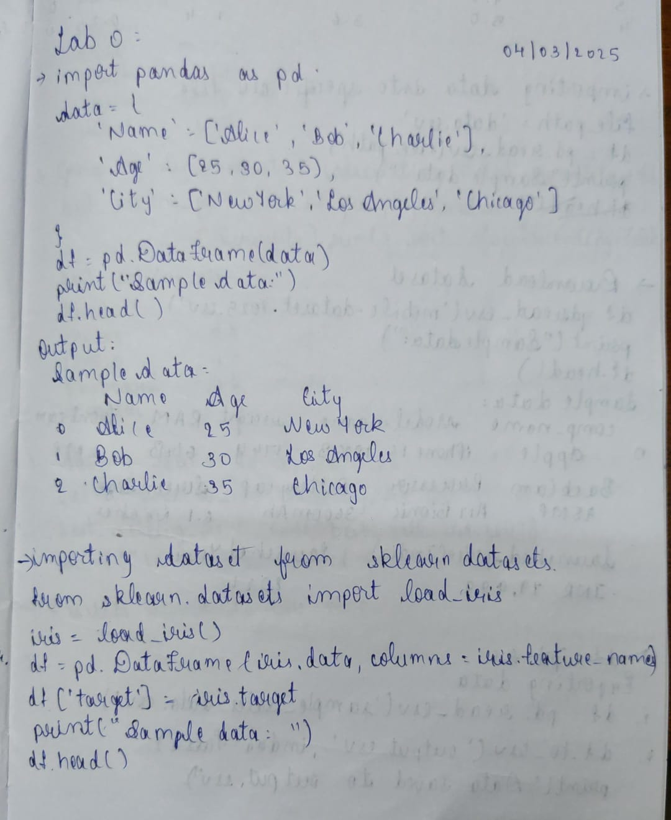

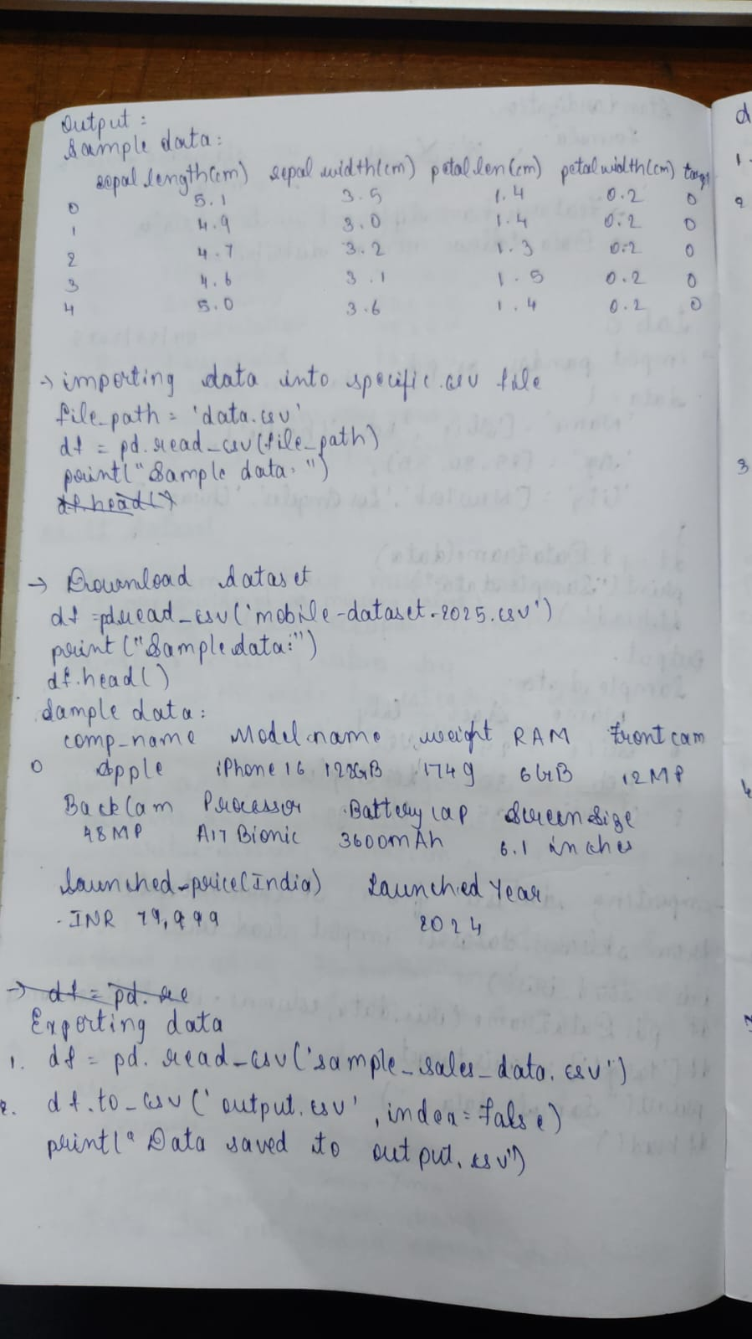

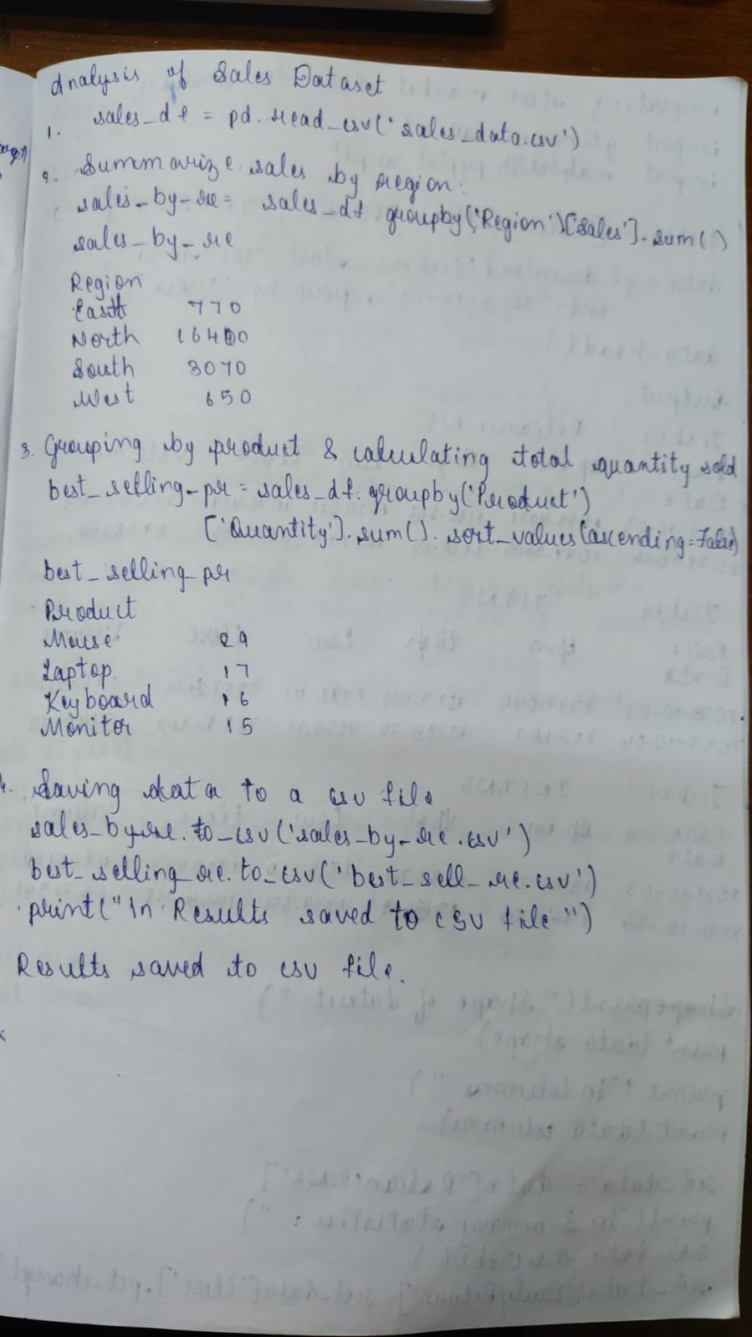

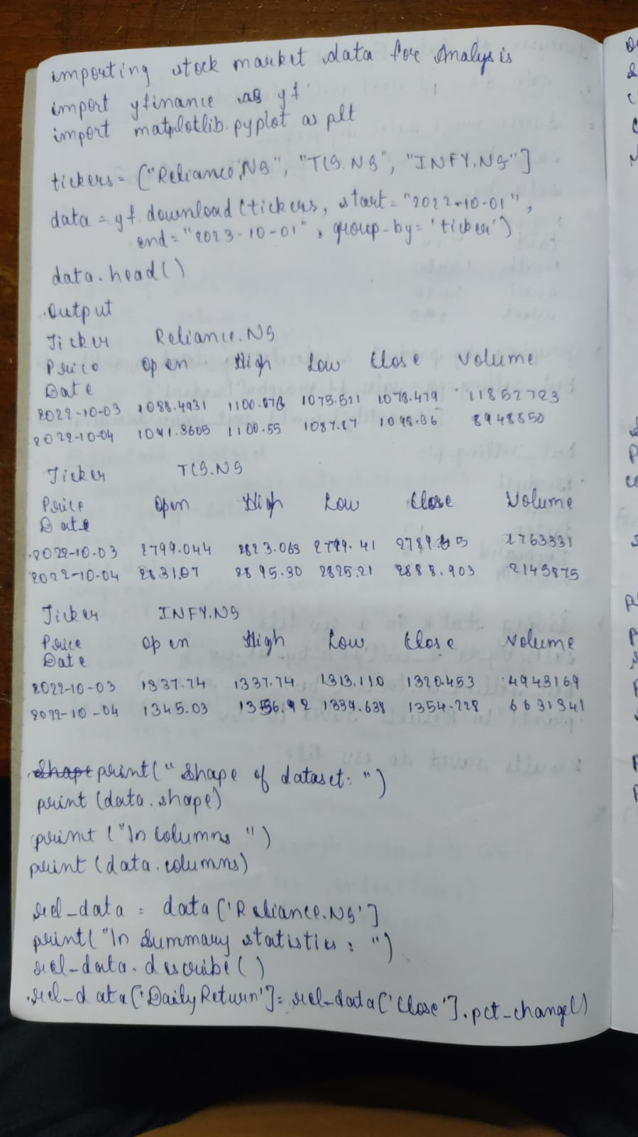

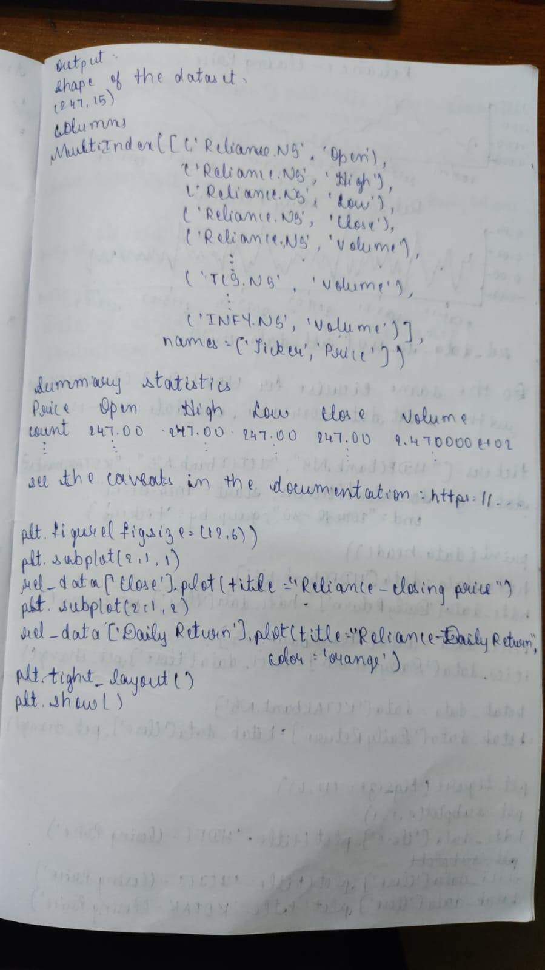

Code:

import pandas as pd

data = {

'Name': ['Alice', 'Bob', 'Charlie', 'David'],

'Age': [25, 30, 35, 40],

'City': ['New York', 'Los Angeles', 'Chicago', 'Houston']

}

df = pd.DataFrame(data)

print("Sample data:")

print(df.head())

Sample data:

Name Age City

0 Alice 25 New York

1 Bob 30 Los Angeles

2 Charlie 35 Chicago

3 David 40 Houston

In [ ]:

from sklearn.datasets import load_iris

iris = load_iris()

df = pd.DataFrame(iris.data, columns=iris.feature_names)

df['target'] = iris.target

print("Sample data:")

print(df.head())

Sample data:

sepal length (cm) sepal width (cm) petal length (cm) petal width (cm) \

0 5.1 3.5 1.4 0.2

1 4.9 3.0 1.4 0.2

2 4.7 3.2 1.3 0.2

3 4.6 3.1 1.5 0.2

4 5.0 3.6 1.4 0.2

target

0 0

1 0

2 0

3 0

4 0

In [ ]:

from sklearn.datasets import load_iris

import pandas as pd

file_path= "data.csv"

df=pd.read_csv(file_path)

print("Sample data: ")

print(df.head())

print("\n")

Sample data:

ID Name Age City

0 1 Alice 25 New York

1 2 Bob 30 Los Angeles

2 3 Charlie 35 Chicago

3 4 David 40 Houston

4 5 Eva 28 Phoenix

In [ ]:

df = pd.read_csv("mobile.csv",encoding='latin-1')

print("Sample data:")

print(df.head())

Sample data:

Company Name Model Name Mobile Weight RAM Front Camera \

0 Apple iPhone 16 128GB 174g 6GB 12MP

1 Apple iPhone 16 256GB 174g 6GB 12MP

2 Apple iPhone 16 512GB 174g 6GB 12MP

3 Apple iPhone 16 Plus 128GB 203g 6GB 12MP

4 Apple iPhone 16 Plus 256GB 203g 6GB 12MP

Back Camera Processor Battery Capacity Screen Size \

0 48MP A17 Bionic 3,600mAh 6.1 inches

1 48MP A17 Bionic 3,600mAh 6.1 inches

2 48MP A17 Bionic 3,600mAh 6.1 inches

3 48MP A17 Bionic 4,200mAh 6.7 inches

4 48MP A17 Bionic 4,200mAh 6.7 inches

Launched Price (Pakistan) Launched Price (India) Launched Price (China) \

0 PKR 224,999 INR 79,999 CNY 5,799

1 PKR 234,999 INR 84,999 CNY 6,099

2 PKR 244,999 INR 89,999 CNY 6,499

3 PKR 249,999 INR 89,999 CNY 6,199

4 PKR 259,999 INR 94,999 CNY 6,499

Launched Price (USA) Launched Price (Dubai) Launched Year

0 USD 799 AED 2,799 2024

1 USD 849 AED 2,999 2024

2 USD 899 AED 3,199 2024

3 USD 899 AED 3,199 2024

4 USD 949 AED 3,399 2024

In [ ]:

*# Reading data from a CSV file*

sales_df = pd.read_csv("sample_sales_data.csv")

In [ ]:

*# Grouping by Region and calculating total sales*

sales_by_region = sales_df.groupby('Region')['Sales'].sum()

print("\nTotal sales by region:")

print(sales_by_region)

Total sales by region:

Region

East 770

North 16400

South 3070

West 650

Name: Sales, dtype: int64

In [ ]:

*# Grouping by Product and calculating total quantity sold*

best_selling_products = sales_df.groupby('Product')['Quantity'].sum().sort_values(ascending=False)

print("\nBest-selling products by quantity:")

print(best_selling_products)

Best-selling products by quantity:

Product

Mouse 29

Laptop 17

Keyboard 16

Monitor 15

Name: Quantity, dtype: int64

In [ ]:

*# Saving the sales by region data to a CSV file*

sales_by_region.to_csv('sales_by_region.csv')

*# Saving the best-selling products data to a CSV file*

best_selling_products.to_csv('best_selling_products.csv')

print("\nAnalysis results saved to CSV files.")

Analysis results saved to CSV files.

In [ ]:

*# Step 1: Import required libraries*

import yfinance as yf

import pandas as pd

import matplotlib.pyplot as plt

tickers = ["RELIANCE.NS", "TCS.NS", "INFY.NS"]

data = yf.download(tickers, start="2022-10-01", end="2023-10-01", group_by='ticker')

print("First 5 rows of the dataset:")

print(data.head())

YF.download() has changed argument auto_adjust default to True

[*********************100%***********************] 3 of 3 completed

First 5 rows of the dataset:

Ticker RELIANCE.NS \

Price Open High Low Close Volume

Date

2022-10-03 1088.493134 1100.076669 1075.521371 1078.479858 11852723

2022-10-04 1091.360592 1100.554607 1087.878645 1098.369873 8948850

2022-10-06 1105.561415 1115.119493 1100.622978 1102.420776 13352162

2022-10-07 1099.029980 1112.343173 1099.029980 1107.086182 7714340

2022-10-10 1094.637648 1100.372591 1086.900123 1095.001831 6329527

Ticker TCS.NS \

Price Open High Low Close Volume

Date

2022-10-03 2799.044599 2823.063066 2779.418577 2789.652100 1763331

2022-10-04 2831.707297 2895.304988 2825.212065 2888.903076 2145875

2022-10-06 2907.454752 2919.604193 2890.118388 2898.996826 1790816

2022-10-07 2894.744206 2901.847047 2858.015696 2864.370605 1939879

2022-10-10 2813.062865 2922.407833 2808.390003 2914.510742 3064063

Ticker INFY.NS

Price Open High Low Close Volume

Date

2022-10-03 1337.743240 1337.743240 1313.110574 1320.453003 4943169

2022-10-04 1345.038201 1356.928245 1339.638009 1354.228149 6631341

2022-10-06 1369.007786 1383.029504 1368.155094 1378.624023 6180672

2022-10-07 1370.286676 1381.181893 1364.412779 1374.881592 3994466

2022-10-10 1351.338576 1387.956005 1351.338576 1385.729614 5274677

In [ ]:

*# Basic Data Exploration*

print("\nShape of the dataset:")

print(data.shape)

print("\nColumn names:")

print(data.columns)

reliance_data = data['RELIANCE.NS']

print("\nSummary statistics for Reliance Industries:")

print(reliance_data.describe())

*# daily returns*

reliance_data['Daily Return'] = reliance_data['Close'].pct_change()

Shape of the dataset:

(247, 15)

Column names:

MultiIndex([('RELIANCE.NS', 'Open'),

('RELIANCE.NS', 'High'),

('RELIANCE.NS', 'Low'),

('RELIANCE.NS', 'Close'),

('RELIANCE.NS', 'Volume'),

( 'TCS.NS', 'Open'),

( 'TCS.NS', 'High'),

( 'TCS.NS', 'Low'),

( 'TCS.NS', 'Close'),

( 'TCS.NS', 'Volume'),

( 'INFY.NS', 'Open'),

( 'INFY.NS', 'High'),

( 'INFY.NS', 'Low'),

( 'INFY.NS', 'Close'),

( 'INFY.NS', 'Volume')],

names=['Ticker', 'Price'])

Summary statistics for Reliance Industries:

Price Open High Low Close Volume

count 247.000000 247.000000 247.000000 247.000000 2.470000e+02

mean 1147.548566 1156.216094 1137.195378 1146.522438 1.316652e+07

std 65.890225 66.850133 65.752470 66.687258 6.754099e+06

min 1008.159038 1010.434788 992.228728 1001.900696 3.370033e+06

25% 1098.882005 1103.399363 1084.795044 1097.357117 8.717141e+06

50% 1147.435205 1155.036230 1138.787343 1147.253174 1.158959e+07

75% 1196.261444 1203.625226 1184.985050 1195.064575 1.530302e+07

max 1288.076701 1299.910648 1273.056728 1293.470215 5.708188e+07

PROGRAM 2

Demonstrate various data pre-processing techniques for a given dataset

Screenshot

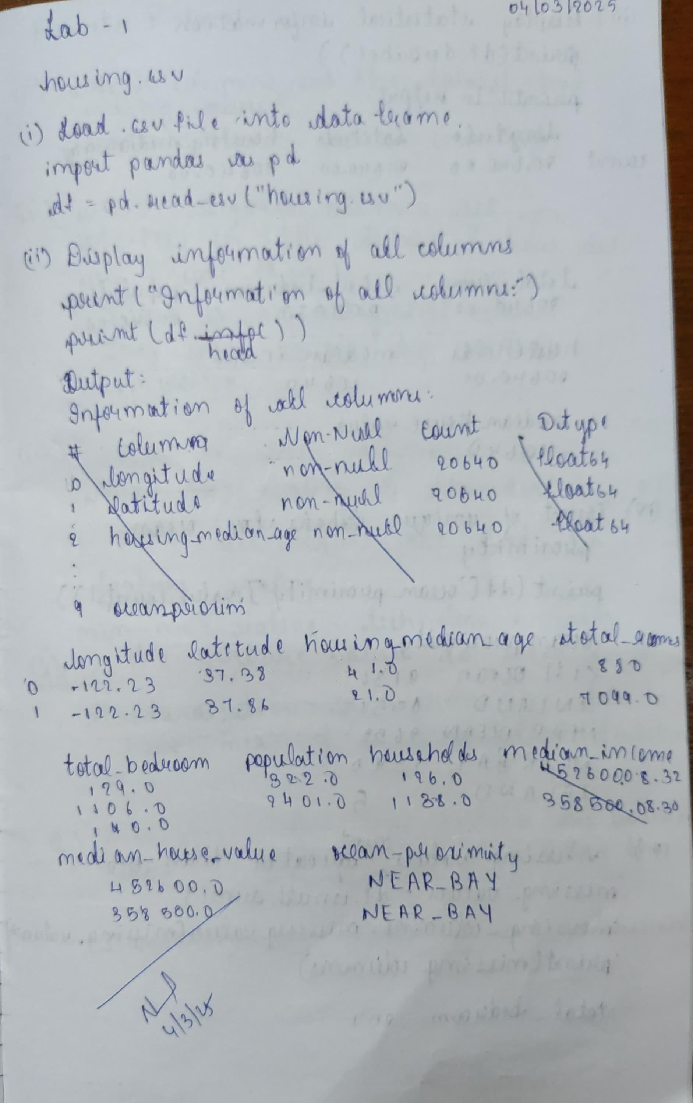

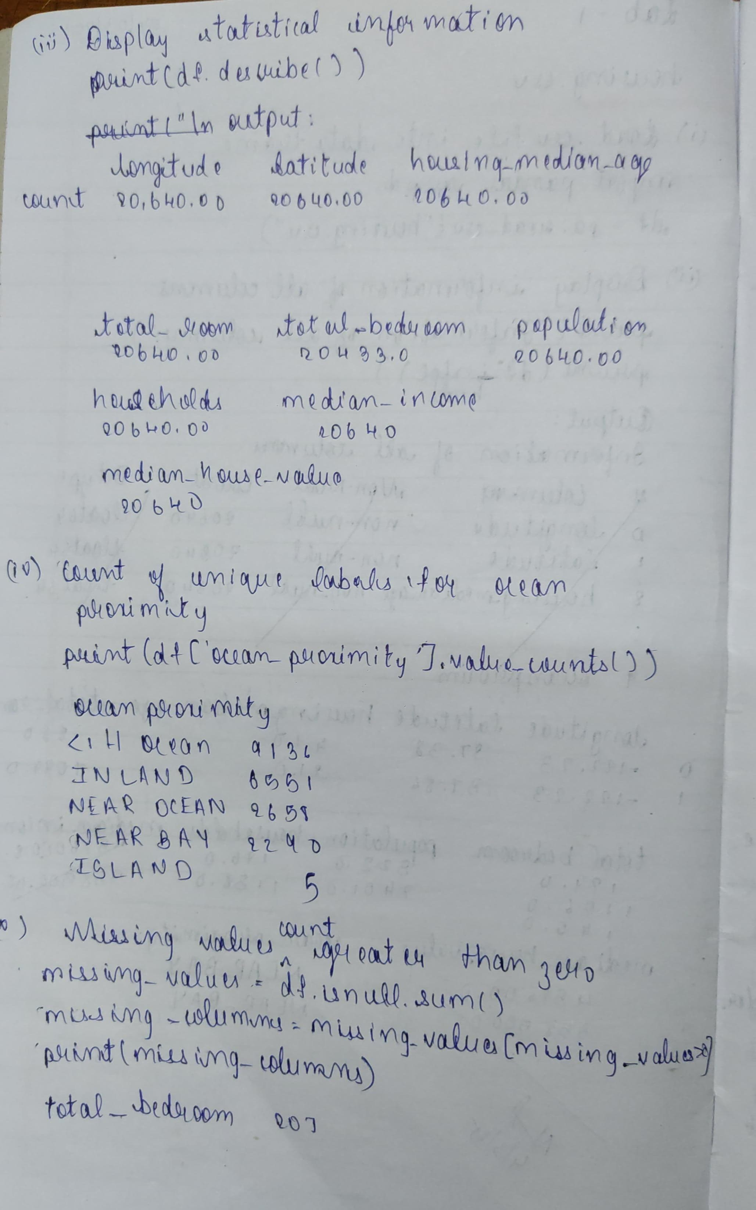

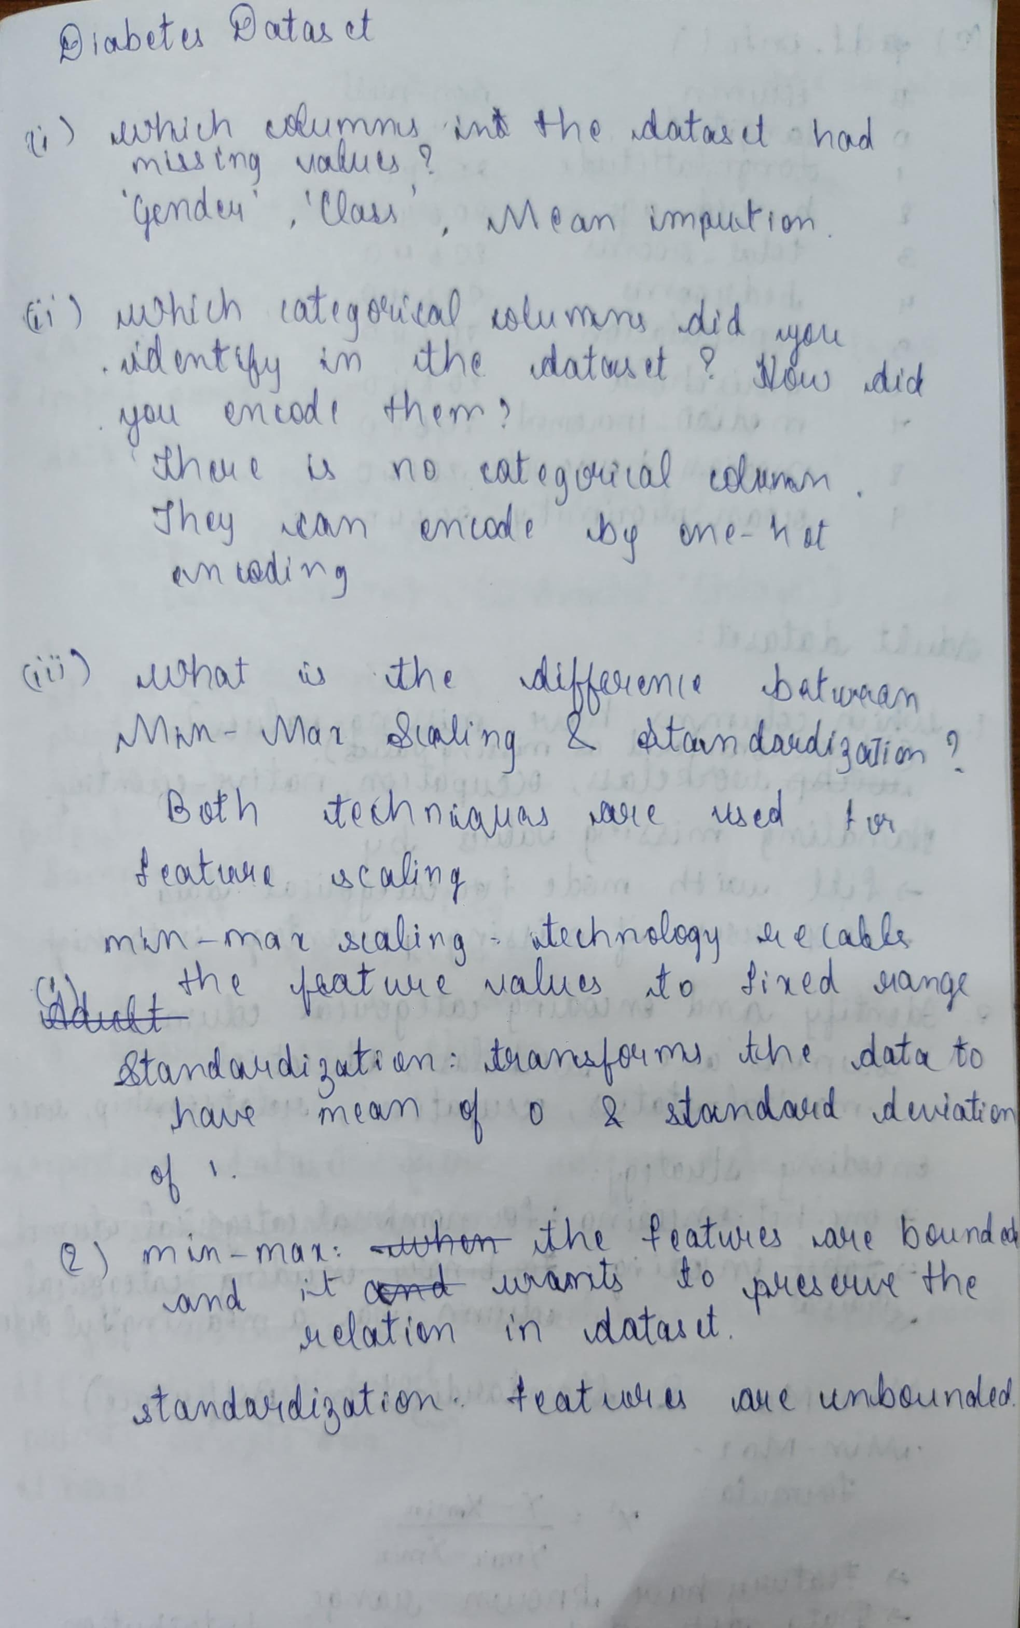

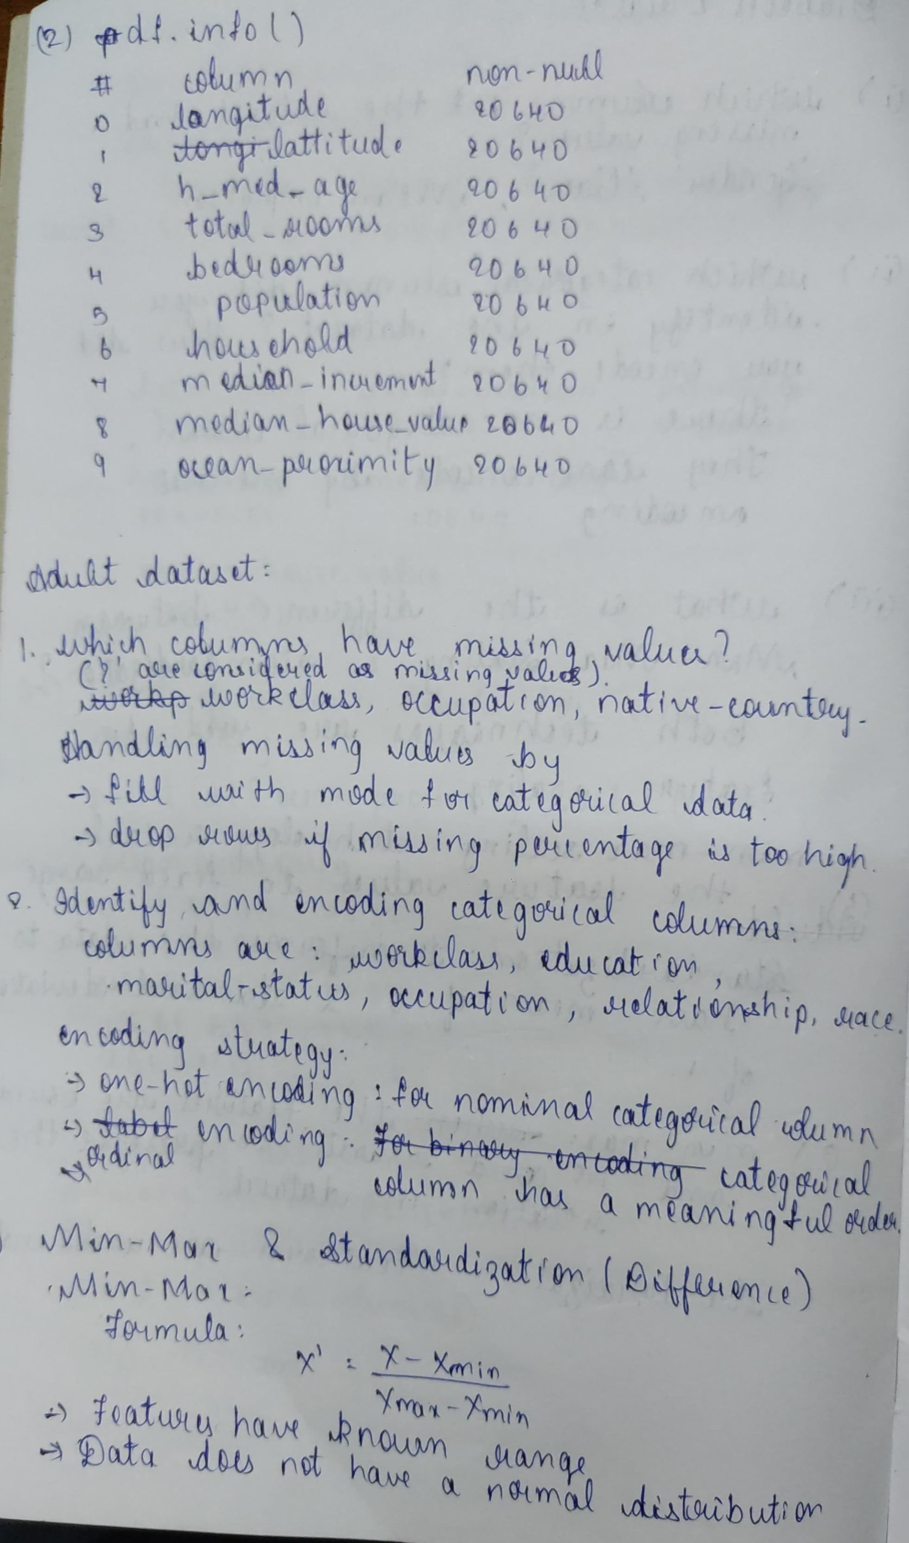

Code

*# Housing database*

import pandas as pd

df = pd.read_csv("housing.csv")

print("Information of all columns:")

print(df.info())

Information of all columns:

<class 'pandas.core.frame.DataFrame'>

RangeIndex: 20640 entries, 0 to 20639

Data columns (total 10 columns):

# Column Non-Null Count Dtype

--- ------ -------------- -----

0 longitude 20640 non-null float64

1 latitude 20640 non-null float64

2 housing_median_age 20640 non-null float64

3 total_rooms 20640 non-null float64

4 total_bedrooms 20433 non-null float64

5 population 20640 non-null float64

6 households 20640 non-null float64

7 median_income 20640 non-null float64

8 median_house_value 20640 non-null float64

9 ocean_proximity 20640 non-null object

dtypes: float64(9), object(1)

memory usage: 1.6+ MB

None

In [9]:

print("\nStatistical information of numerical columns:")

print(df.describe())

*# count of unique labels for the Ocean Proximity column*

print("\nCount of unique labels in 'Ocean Proximity' column:")

print(df['ocean_proximity'].value_counts())

*# Display attributes with missing values count greater than zero*

print("\nAttributes with missing values:")

missing_values = df.isnull().sum()

missing_columns = missing_values[missing_values > 0]

print(missing_columns)

Statistical information of numerical columns:

longitude latitude housing_median_age total_rooms \

count 20640.000000 20640.000000 20640.000000 20640.000000

mean -119.569704 35.631861 28.639486 2635.763081

std 2.003532 2.135952 12.585558 2181.615252

min -124.350000 32.540000 1.000000 2.000000

25% -121.800000 33.930000 18.000000 1447.750000

50% -118.490000 34.260000 29.000000 2127.000000

75% -118.010000 37.710000 37.000000 3148.000000

max -114.310000 41.950000 52.000000 39320.000000

total_bedrooms population households median_income \

count 20433.000000 20640.000000 20640.000000 20640.000000

mean 537.870553 1425.476744 499.539680 3.870671

std 421.385070 1132.462122 382.329753 1.899822

min 1.000000 3.000000 1.000000 0.499900

25% 296.000000 787.000000 280.000000 2.563400

50% 435.000000 1166.000000 409.000000 3.534800

75% 647.000000 1725.000000 605.000000 4.743250

max 6445.000000 35682.000000 6082.000000 15.000100

median_house_value

count 20640.000000

mean 206855.816909

std 115395.615874

min 14999.000000

25% 119600.000000

50% 179700.000000

75% 264725.000000

max 500001.000000

Count of unique labels in 'Ocean Proximity' column:

ocean_proximity

<1H OCEAN 9136

INLAND 6551

NEAR OCEAN 2658

NEAR BAY 2290

ISLAND 5

Name: count, dtype: int64

Attributes with missing values:

total_bedrooms 207

dtype: int64

In [6]:

*# Adult database*

import pandas as pd

import numpy as np

from sklearn.impute import SimpleImputer

from sklearn.preprocessing import MinMaxScaler, StandardScaler, LabelEncoder

file_path = "adult.csv"

df = pd.read_csv(file_path)

*# Handling Missing Values*

df.replace("?", np.nan, inplace=True)

num_imputer = SimpleImputer(strategy="mean")

df[df.select_dtypes(include=['number']).columns] = num_imputer.fit_transform(df.select_dtypes(include=['number']))

cat_imputer = SimpleImputer(strategy="most_frequent")

df[df.select_dtypes(include=['object']).columns] = cat_imputer.fit_transform(df.select_dtypes(include=['object']))

*# Step 4: Handling Categorical Data- encoding*

label_encoders = {}

for col in df.select_dtypes(include=['object']).columns:

le = LabelEncoder()

df[col] = le.fit_transform(df[col])

label_encoders[col] = le

*# Handling Outliers*

Q1 = df.quantile(0.25)

Q3 = df.quantile(0.75)

IQR = Q3 - Q1

df = df[~((df < (Q1 - 1.5 * IQR)) | (df > (Q3 + 1.5 * IQR))).any(axis=1)]

*# Data Transformation*

*# Normalization*

min_max_scaler = MinMaxScaler()

df_minmax = pd.DataFrame(min_max_scaler.fit_transform(df), columns=df.columns)

*# Standardization: z-score*

standard_scaler = StandardScaler()

df_standard = pd.DataFrame(standard_scaler.fit_transform(df), columns=df.columns)

*# Display Processed Data*

print("\nProcessed Adult Income Dataset (Min-Max Scaled):")

print(df_minmax.head())

print("\nProcessed Adult Income Dataset (Standard Scaled):")

print(df_standard.head())

Processed Adult Income Dataset (Min-Max Scaled):

age workclass fnlwgt education educational-num marital-status \

0 0.344262 0.0 0.188277 0.555556 0.363636 0.333333

1 0.114754 0.0 0.881156 1.000000 0.454545 0.666667

2 0.147541 0.0 0.169156 0.555556 0.363636 0.666667

3 0.672131 0.0 0.708251 0.555556 0.363636 0.333333

4 0.131148 0.0 0.475807 0.333333 0.727273 0.333333

occupation relationship race gender capital-gain capital-loss \

0 0.307692 0.0 0.0 1.0 0.0 0.0

1 0.538462 0.8 0.0 0.0 0.0 0.0

2 0.000000 0.2 0.0 0.0 0.0 0.0

3 0.692308 0.0 0.0 1.0 0.0 0.0

4 0.692308 0.0 0.0 1.0 0.0 0.0

hours-per-week native-country income

0 0.894737 0.0 0.0

1 0.368421 0.0 0.0

2 0.315789 0.0 0.0

3 0.105263 0.0 0.0

4 0.368421 0.0 0.0

Processed Adult Income Dataset (Standard Scaled):

age workclass fnlwgt education educational-num marital-status \

0 0.220179 0.0 -1.022983 -0.151256 -0.654083 -0.398228

1 -0.955630 0.0 2.234629 1.457372 -0.073261 0.828047

2 -0.787657 0.0 -1.112882 -0.151256 -0.654083 0.828047

3 1.899906 0.0 1.421707 -0.151256 -0.654083 -0.398228

4 -0.871644 0.0 0.328856 -0.955571 1.669207 -0.398228

occupation relationship race gender capital-gain capital-loss \

0 -0.420679 -1.044582 0.0 0.770972 0.0 0.0

1 0.305840 1.629927 0.0 -1.297064 0.0 0.0

2 -1.389371 -0.375955 0.0 -1.297064 0.0 0.0

3 0.790186 -1.044582 0.0 0.770972 0.0 0.0

4 0.790186 -1.044582 0.0 0.770972 0.0 0.0

hours-per-week native-country income

0 2.312838 0.0 0.0

1 -0.329781 0.0 0.0

2 -0.594043 0.0 0.0

3 -1.651090 0.0 0.0

4 -0.329781 0.0 0.0

In [5]:

*# Diabetes databse*

from sklearn.impute import SimpleImputer

from sklearn.preprocessing import MinMaxScaler, StandardScaler

*# 2: Load the Diabetes dataset*

file_path = "Dataset of Diabetes .csv"

df = pd.read_csv(file_path)

*# 3: Handling Missing Values (Replacing NaNs with mean)*

df_numeric = df.select_dtypes(include=['number']).copy()

*# 'mean' strategy*

imputer = SimpleImputer(strategy="mean")

*# Apply the imputer to fill missing values*

df_numeric.iloc[:, :] = imputer.fit_transform(df_numeric)

*# Merge*

df[df_numeric.columns] = df_numeric

*# Step 4: Handling Outliers*

*# Calculate quartiles and IQR for numeric columns*

Q1 = df_numeric.quantile(0.25)

Q3 = df_numeric.quantile(0.75)

IQR = Q3 - Q1

*# filter*

df = df[~((df_numeric < (Q1 - 1.5 * IQR)) | (df_numeric > (Q3 + 1.5 * IQR))).any(axis=1)]

*# Step 5: Data Transformation*

*# Min-Max Normalization*

min_max_scaler = MinMaxScaler()

df_minmax = pd.DataFrame(min_max_scaler.fit_transform(df_numeric), columns=df_numeric.columns)

*# Standardization (Z-score normalization)*

standard_scaler = StandardScaler()

df_standard = pd.DataFrame(standard_scaler.fit_transform(df_numeric), columns=df_numeric.columns)

*# Step 6: Display Processed Data*

print("\nProcessed Diabetes Dataset (Min-Max Scaled):")

print(df_minmax.head())

print("\nProcessed Diabetes Dataset (Standard Scaled):")

print(df_standard.head())

Processed Diabetes Dataset (Min-Max Scaled):

ID No_Pation AGE Urea Cr HbA1c Chol \

0 0.627034 0.000237 0.508475 0.109375 0.050378 0.264901 0.407767

1 0.918648 0.000452 0.101695 0.104167 0.070529 0.264901 0.359223

2 0.524406 0.000634 0.508475 0.109375 0.050378 0.264901 0.407767

3 0.849812 0.001160 0.508475 0.109375 0.050378 0.264901 0.407767

4 0.629537 0.000452 0.220339 0.171875 0.050378 0.264901 0.475728

TG HDL LDL VLDL BMI

0 0.044444 0.226804 0.114583 0.011461 0.173913

1 0.081481 0.092784 0.187500 0.014327 0.139130

2 0.044444 0.226804 0.114583 0.011461 0.173913

3 0.044444 0.226804 0.114583 0.011461 0.173913

4 0.051852 0.061856 0.177083 0.008596 0.069565

Processed Diabetes Dataset (Standard Scaled):

ID No_Pation AGE Urea Cr HbA1c Chol \

0 0.672140 -0.074747 -0.401144 -0.144781 -0.382672 -1.334983 -0.509436

1 1.641852 -0.069940 -3.130017 -0.212954 -0.115804 -1.334983 -0.893730

2 0.330868 -0.065869 -0.401144 -0.144781 -0.382672 -1.334983 -0.509436

3 1.412950 -0.054126 -0.401144 -0.144781 -0.382672 -1.334983 -0.509436

4 0.680463 -0.069939 -2.334096 0.673299 -0.382672 -1.334983 0.028576

TG HDL LDL VLDL BMI

0 -1.035084 1.810756 -1.085457 -0.369958 -1.124622

1 -0.678063 -0.158692 -0.457398 -0.342649 -1.326239

2 -1.035084 1.810756 -1.085457 -0.369958 -1.124622

3 -1.035084 1.810756 -1.085457 -0.369958 -1.124622

4 -0.963680 -0.613180 -0.547121 -0.397267 -1.729472

PROGRAM 3

Implement Linear and Multi-Linear Regression algorithm using appropriate dataset

Screenshot

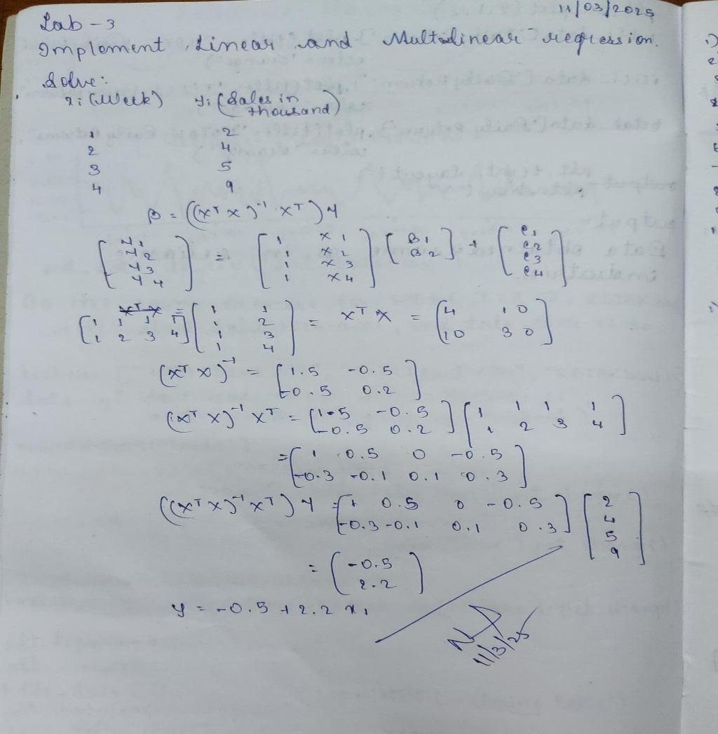

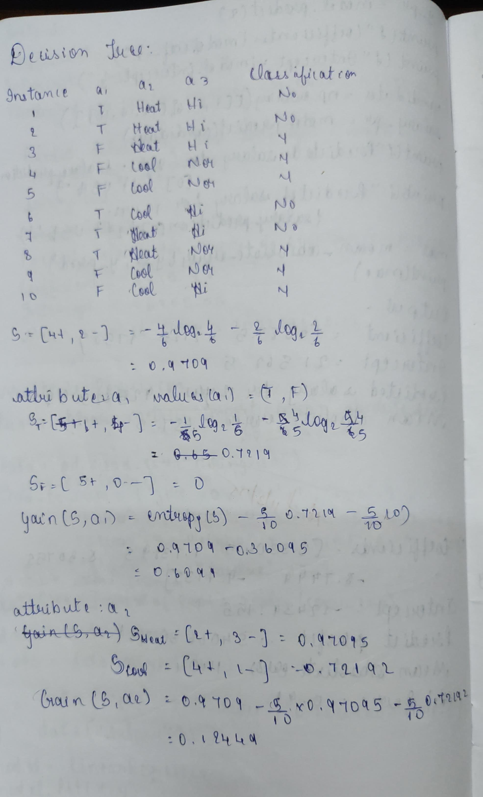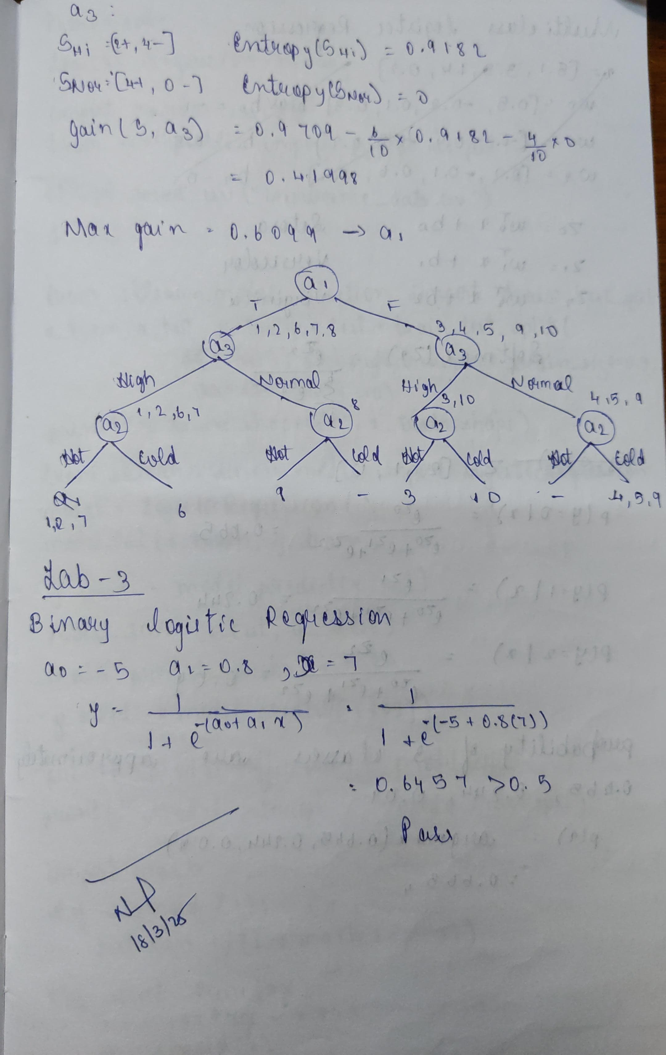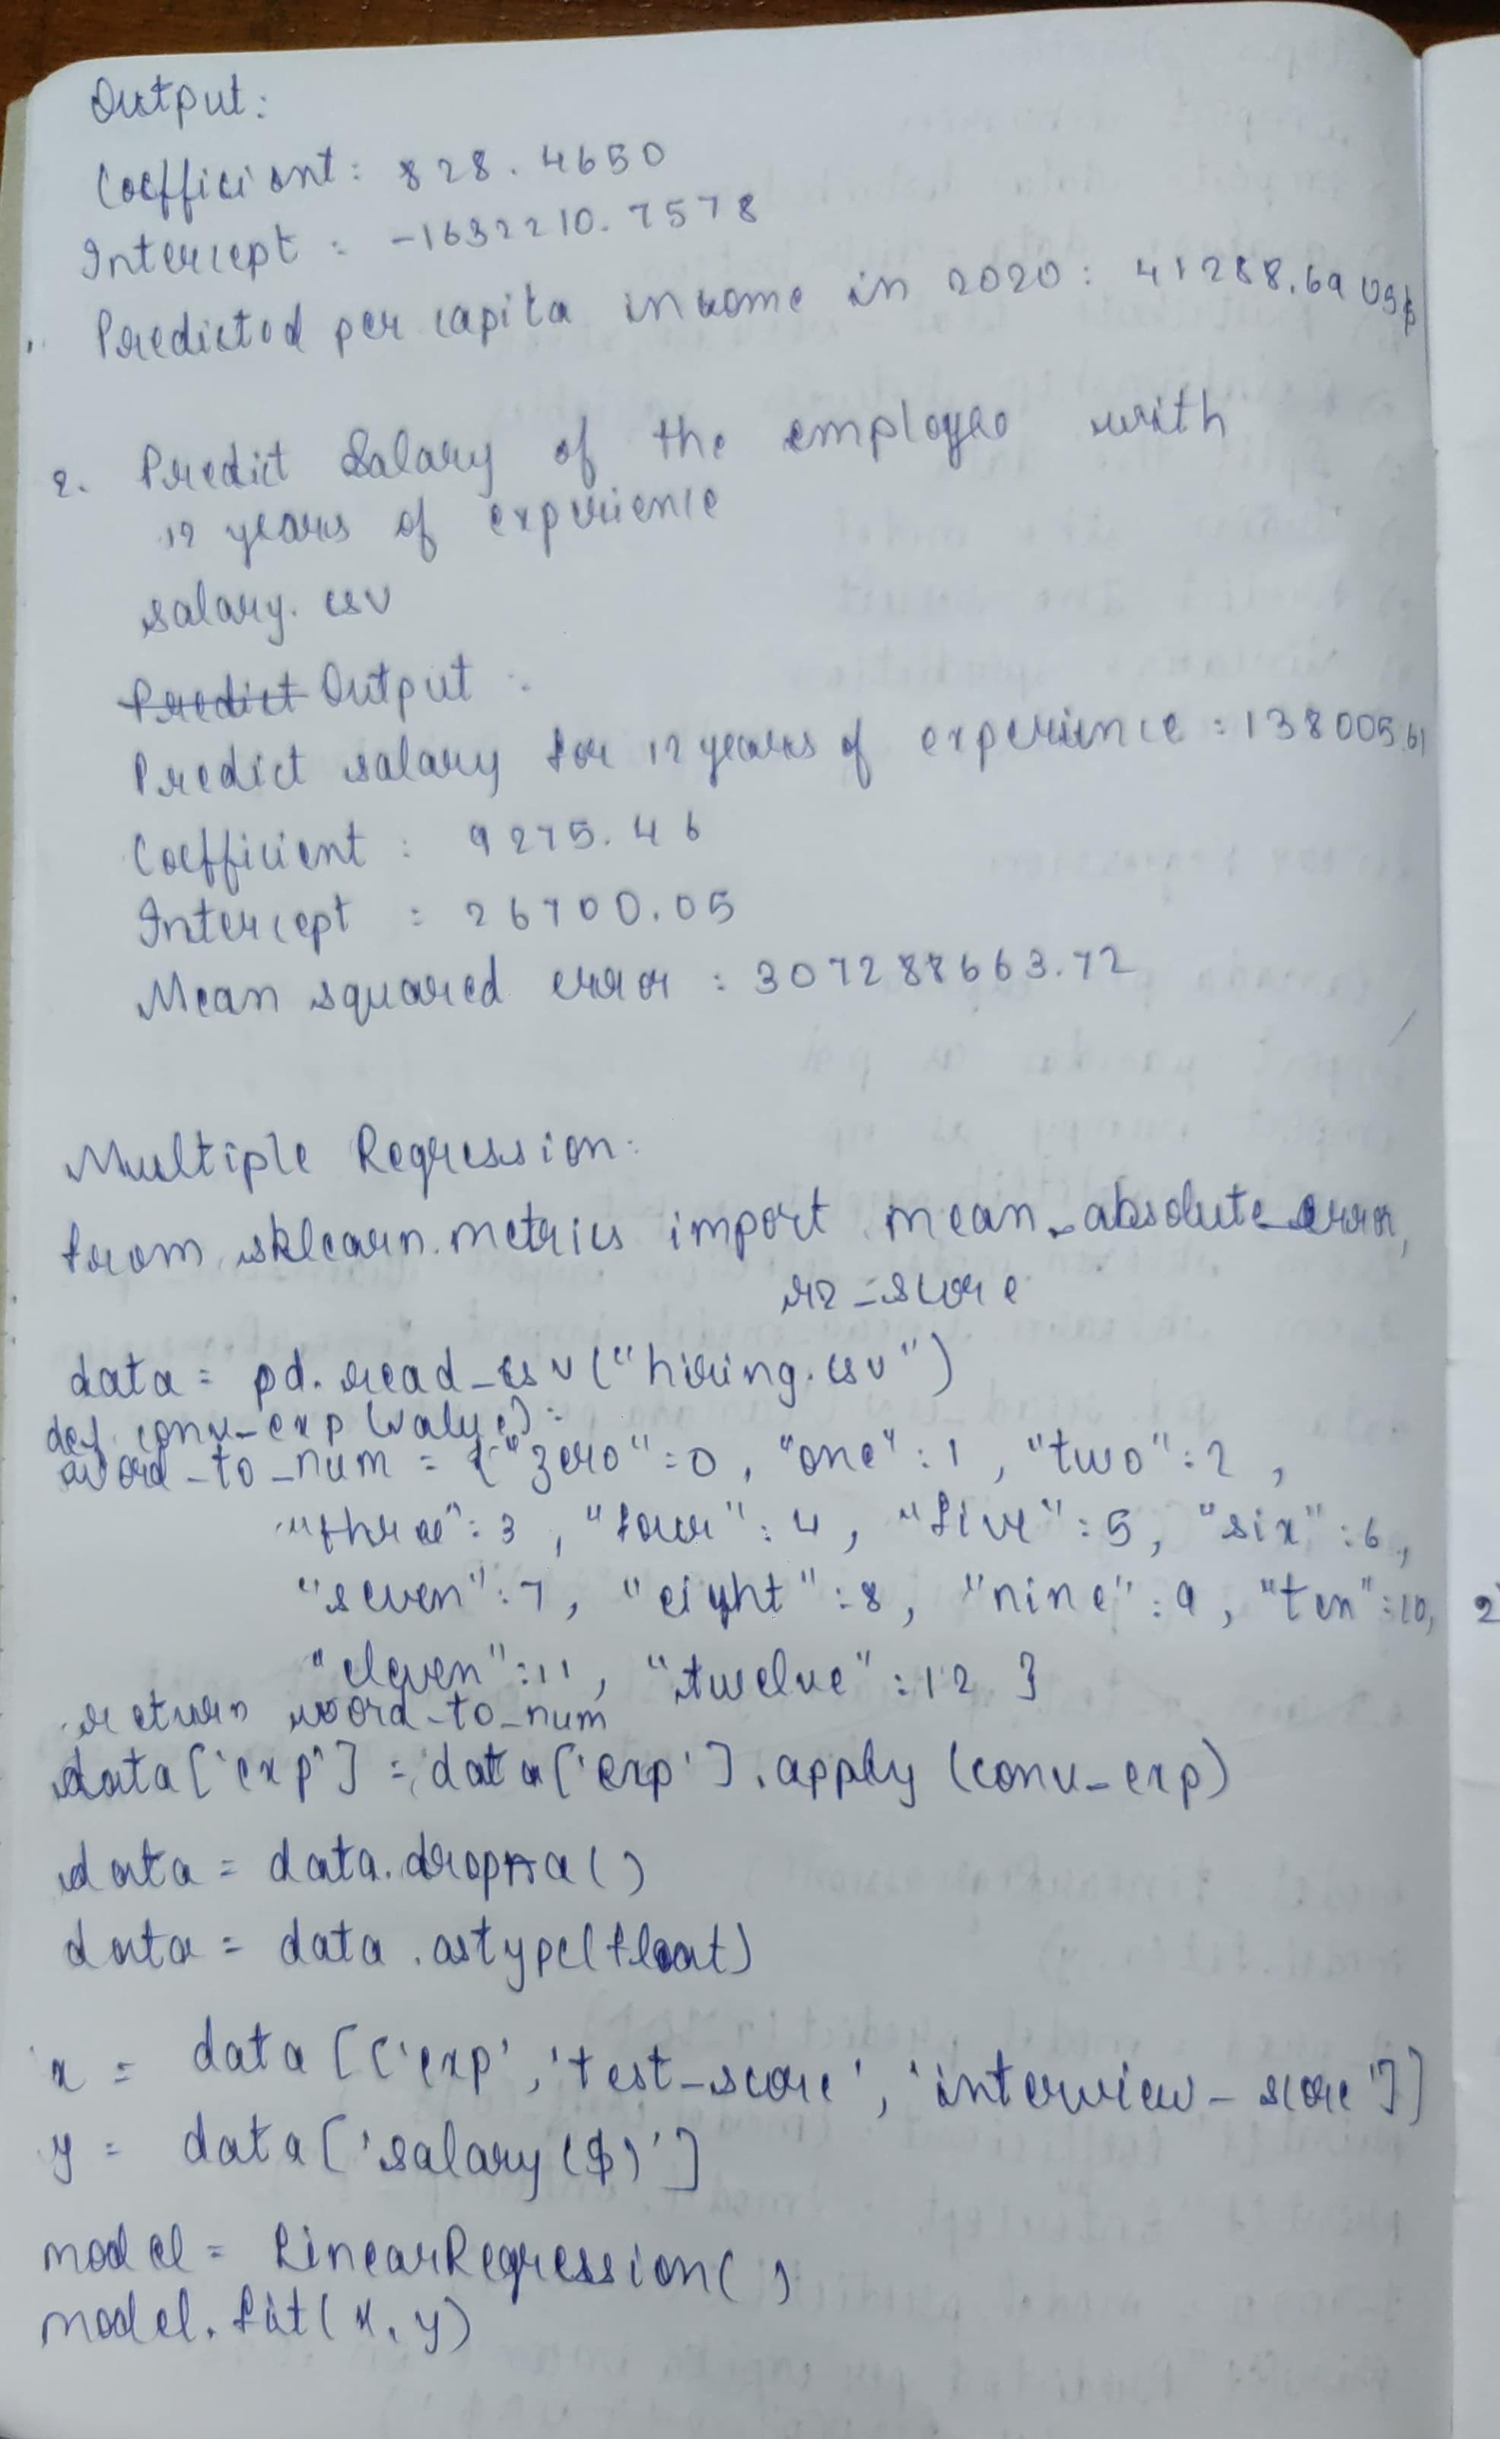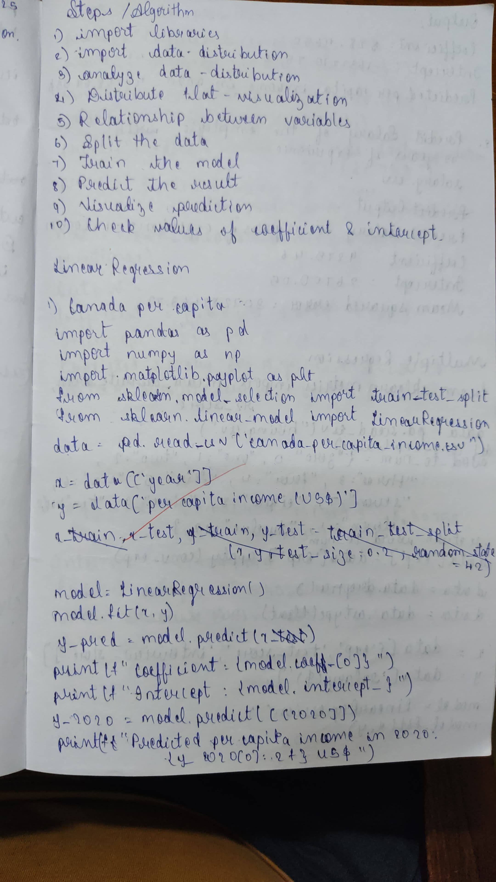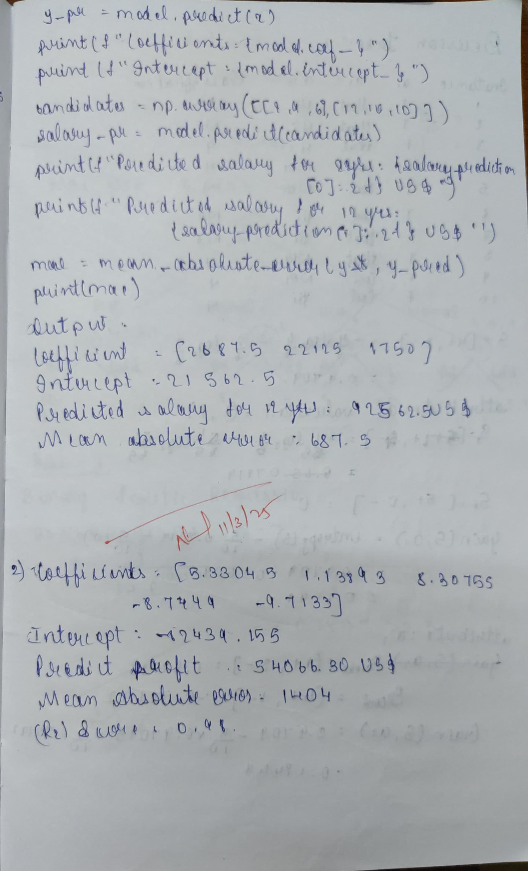

Code

import pandas as pd

import numpy as np

from sklearn import linear_model

import matplotlib.pyplot as plt

df = pd.read_csv('housing_area_price.csv')

print(df.head())

*# Commented out IPython magic to ensure Python compatibility.*

*# %matplotlib inline*

plt.xlabel('area')

plt.ylabel('price')

plt.scatter(df.area,df.price,color='red',marker='+')

new_df = df.drop('price',axis='columns')

new_df

price = df.price

price

*# Create linear regression object*

reg = linear_model.LinearRegression()

reg.fit(new_df,price)

"""(1) Predict price of a home with area = 3300 sqr ft"""

reg.predict([[3300]])

print(reg.coef_)

print(reg.intercept_)

"""Y = m * X + b (m is coefficient and b is intercept)"""

3300*135.78767123 + 180616.43835616432

"""(1) Predict price of a home with area = 5000 sqr ft"""

print(reg.predict([[5000]]))

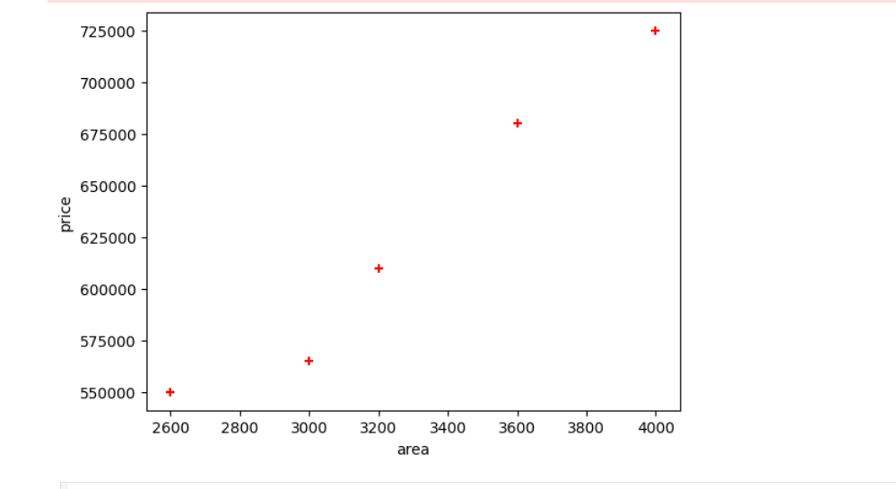

import pandas as pd

import numpy as np

import matplotlib.pyplot as plt

from sklearn.model_selection import train_test_split

from sklearn.linear_model import LinearRegression

*# Load the dataset*

data = pd.read_csv("canada_per_capita_income.csv")

*# Analyze data distribution*

print(data.describe())

print(data.info())

*# Distribution plot visualization*

plt.scatter(data['year'], data['per capita income (US$)'], color='blue', label='Actual Data')

plt.xlabel("Year")

plt.ylabel("Per Capita Income (US$)")

plt.title("Year vs Per Capita Income in Canada")

plt.show()

*# Relationship between variables*

X = data[['year']]

y = data['per capita income (US$)']

*# Split the data (80% training, 20% testing)*

X_train, X_test, y_train, y_test = train_test_split(X, y, test_size=0.2, random_state=42)

*# Train the model*

model = LinearRegression()

model.fit(X, y)

*# Predict the results*

y_pred = model.predict(X_test)

*# Visualize prediction*

plt.scatter(X_test, y_test, color='blue', label='Actual')

plt.plot(X_test, y_pred, color='red', label='Predicted')

plt.xlabel("Year")

plt.ylabel("Per Capita Income (US$)")

plt.title("Prediction of Per Capita Income")

plt.show()

*# Check values of coefficient and intercept*

print(f"Coefficient: {model.coef_[0]}")

print(f"Intercept: {model.intercept_}")

*# Predict per capita income for 2020*

y_2020 = model.predict([[2020]])

print(f"Predicted per capita income in 2020: {y_2020[0]:.2f} US$")

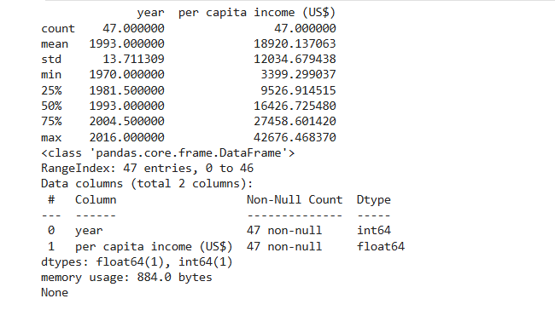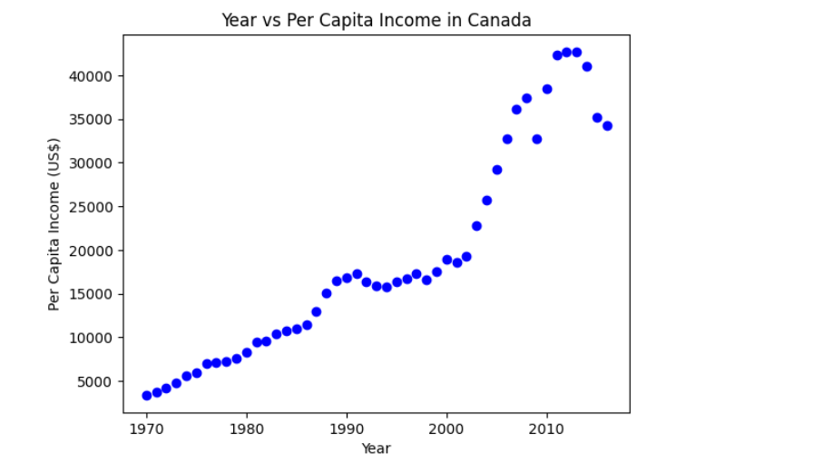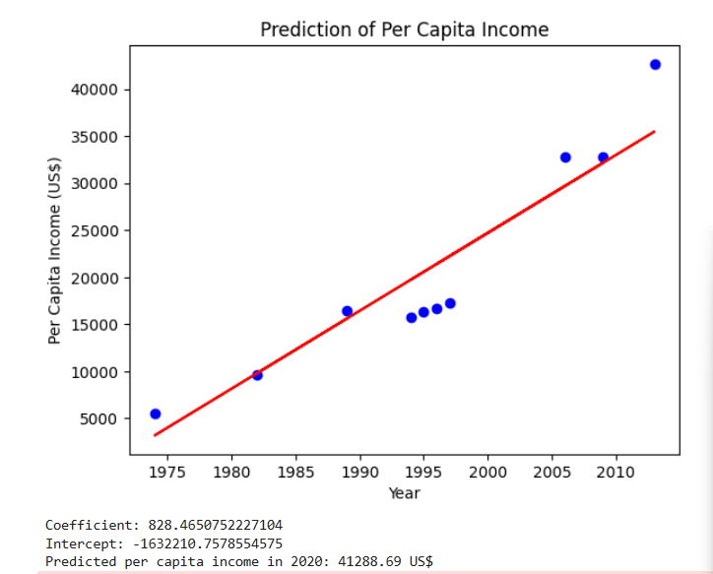

import pandas as pd

import numpy as np

import matplotlib.pyplot as plt

from sklearn.model_selection import train_test_split

from sklearn.linear_model import LinearRegression

from sklearn.preprocessing import OneHotEncoder

from sklearn.metrics import mean_absolute_error, mean_squared_error, r2_score

*# Load the dataset*

data = pd.read_csv("1000_Companies.csv")

*# Handle missing values by removing rows with NaN*

data = data.dropna()

*# Encode categorical variable (State) using OneHotEncoder*

encoder = OneHotEncoder(drop='first', sparse_output=False)

state_encoded = encoder.fit_transform(data[['State']])

state_encoded_df = pd.DataFrame(state_encoded, columns=encoder.get_feature_names_out(['State']))

*# Concatenate encoded state data with original dataset*

data = pd.concat([data.drop(['State'], axis=1), state_encoded_df], axis=1)

*# Analyze data distribution*

print(data.describe())

print(data.info())

*# Define independent (X) and dependent (y) variables*

X = data[['R&D Spend', 'Administration', 'Marketing Spend'] + list(state_encoded_df.columns)]

y = data['Profit']

*# Split the data (80% training, 20% testing)*

X_train, X_test, y_train, y_test = train_test_split(X, y, test_size=0.2, random_state=42)

*# Train the model*

model = LinearRegression()

model.fit(X_train, y_train)

*# Predict the results*

y_pred = model.predict(X_test)

*# Visualize prediction*

plt.scatter(y_test, y_pred, color='blue', label='Actual vs Predicted')

plt.xlabel("Actual Profit")

plt.ylabel("Predicted Profit")

plt.title("Profit Prediction")

plt.legend()

plt.show()

*# Check values of coefficients and intercept*

print(f"Coefficients: {model.coef_}")

print(f"Intercept: {model.intercept_}")

*# Predict profit for given candidate dynamically*

state_names = encoder.get_feature_names_out(['State'])

florida_encoded = (state_names == "State_Florida").astype(int)

candidate_features = np.array([91694.48, 515841.3, 11931.24] + list(florida_encoded)).reshape(1, -1)

profit_prediction = model.predict(candidate_features)

print(f"Predicted profit for given candidate: {profit_prediction[0]:.2f} US$")

*# Calculate errors*

mae = mean_absolute_error(y_test, y_pred)

mse = mean_squared_error(y_test, y_pred)

r2 = r2_score(y_test, y_pred)

print(f"Mean Absolute Error (MAE): {mae:.2f}")

print(f"Mean Squared Error (MSE): {mse:.2f}")

print(f"R-squared (R2) Score: {r2:.2f}")

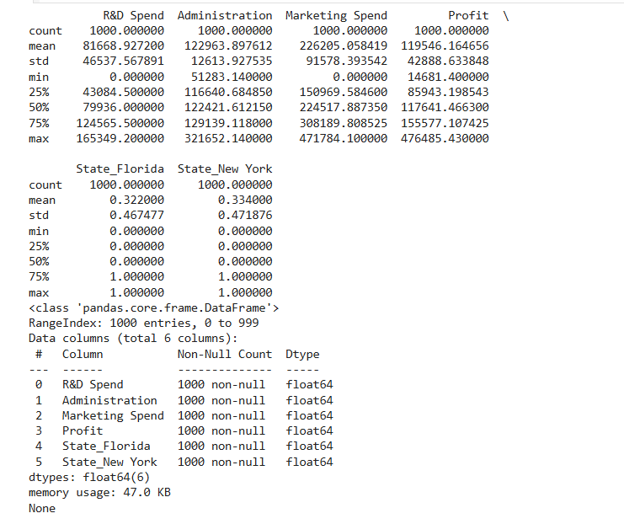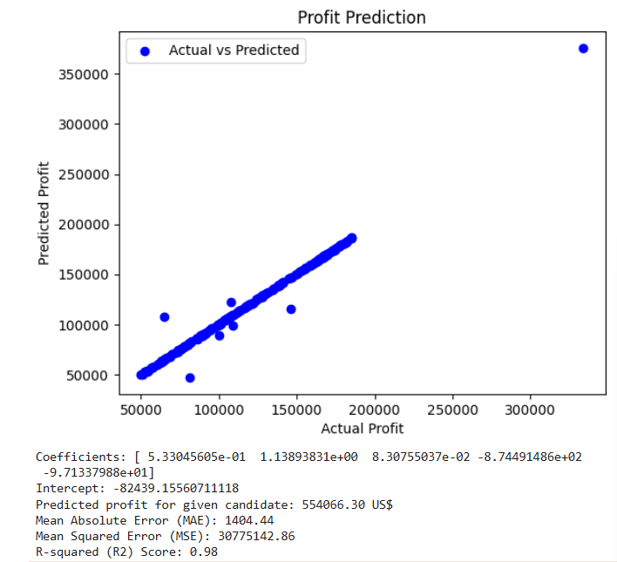

PROGRAM 4 Build Logistic Regression Model for a given dataset

Screenshot

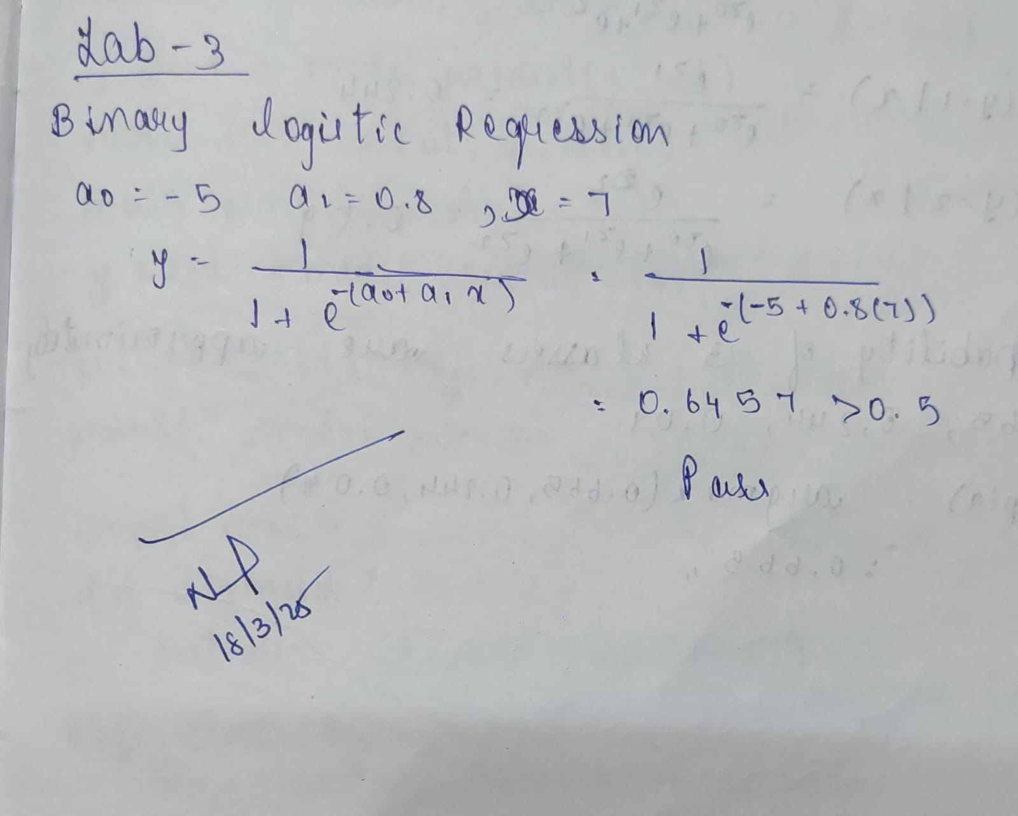

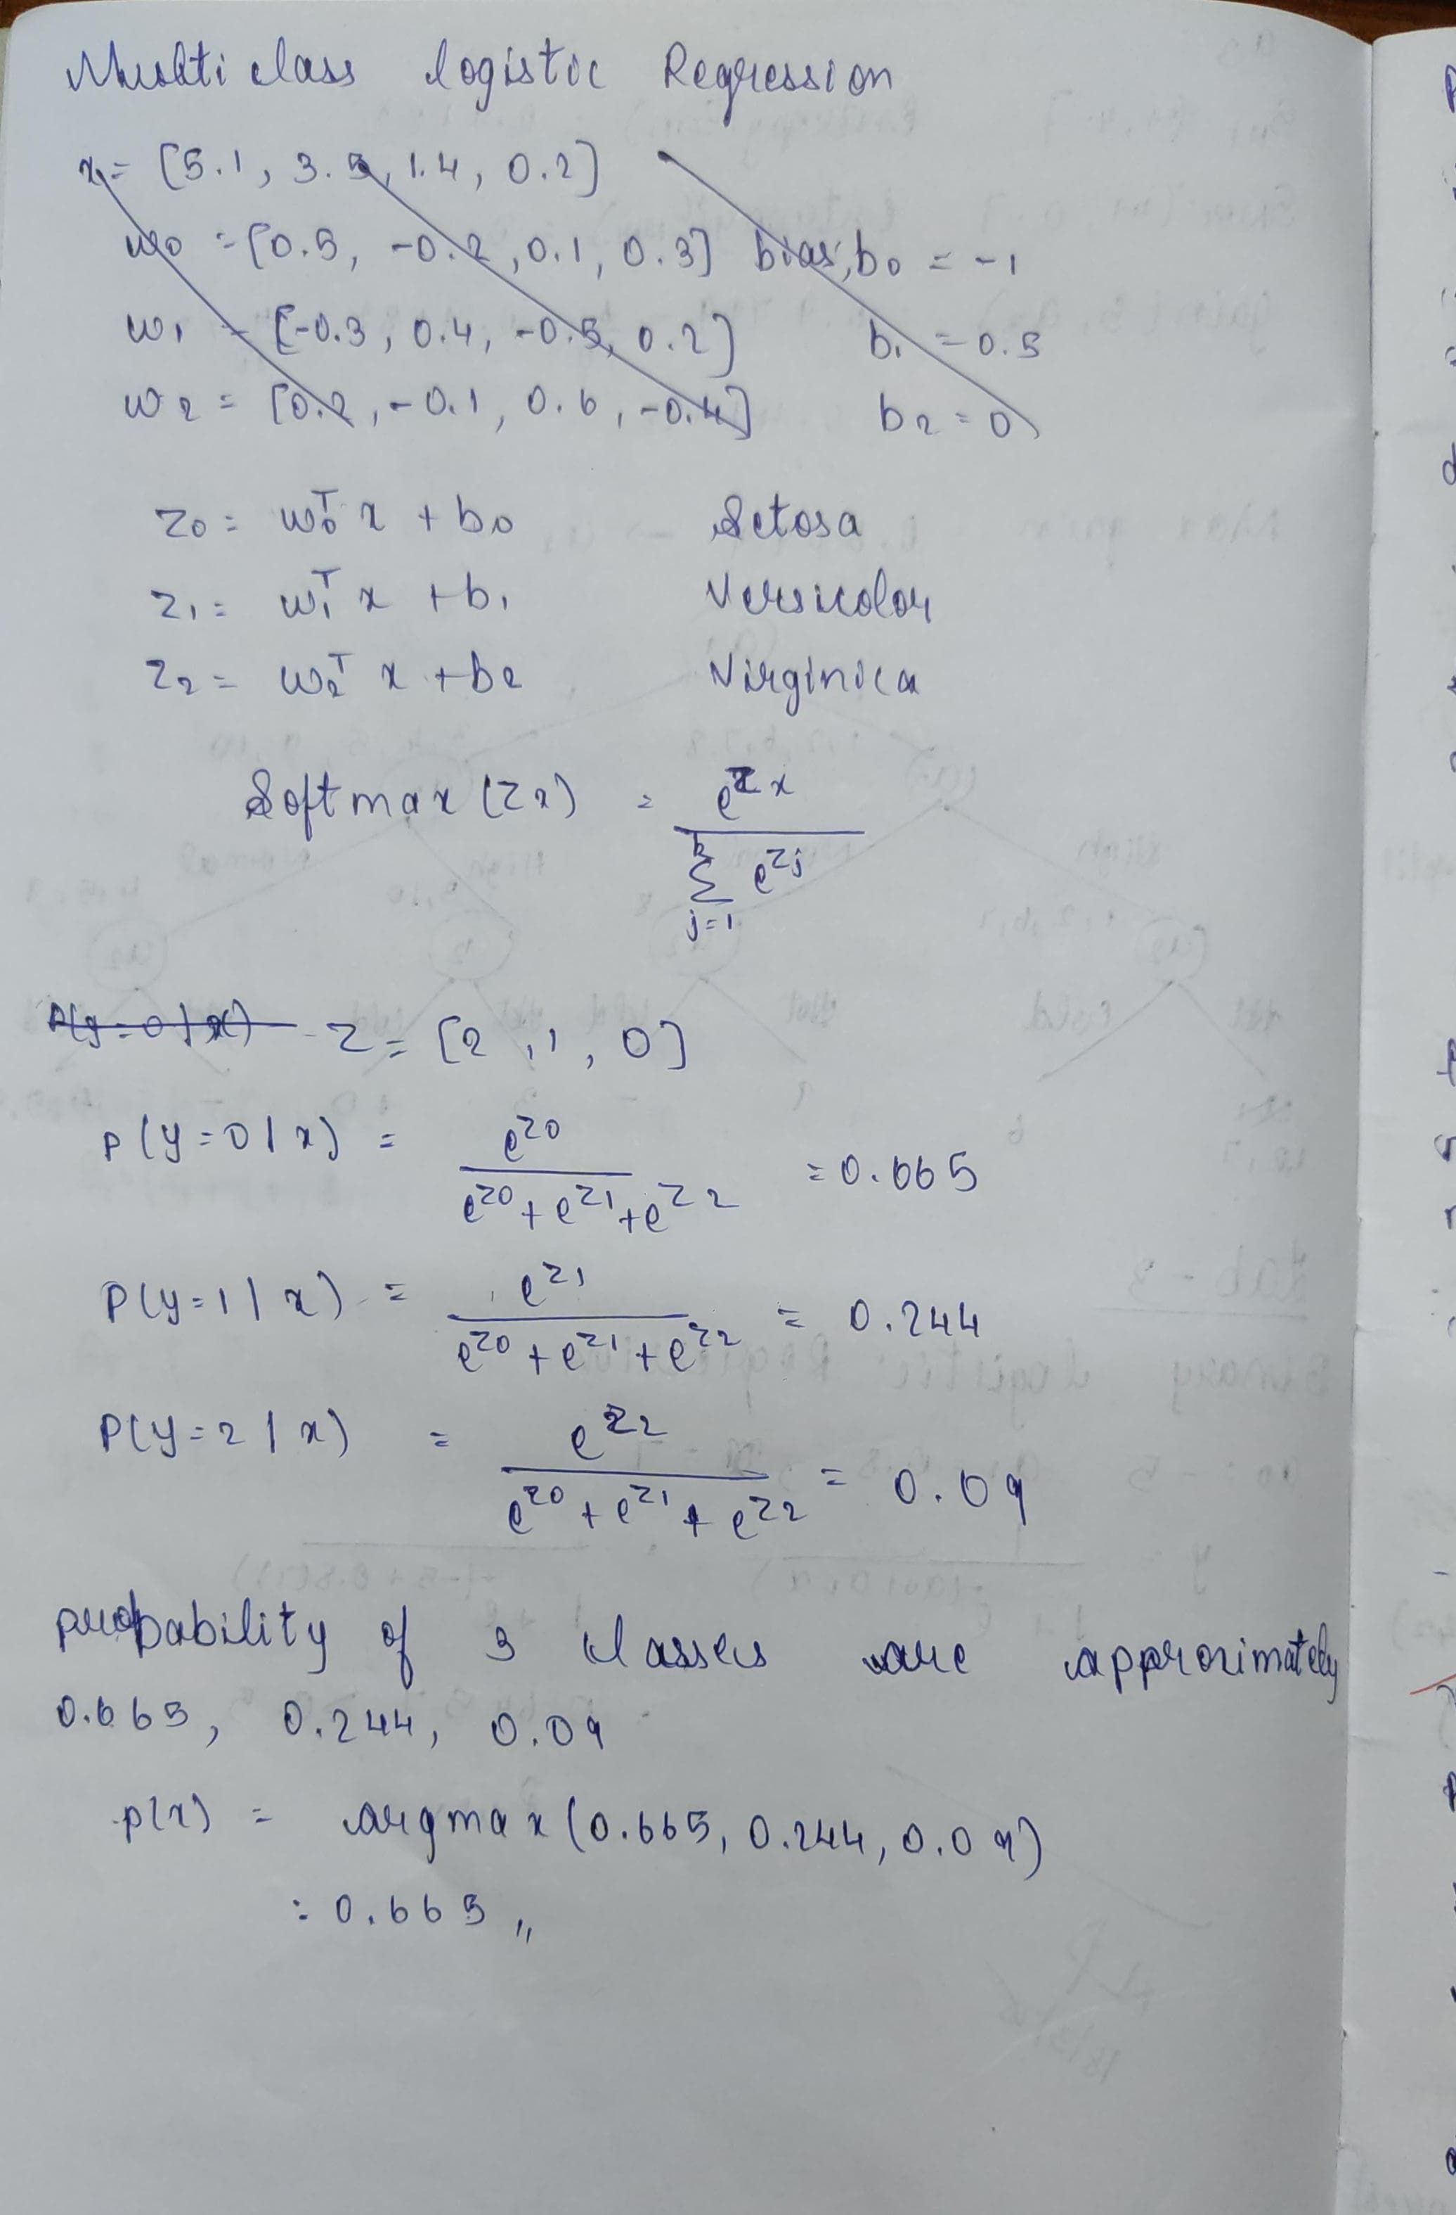

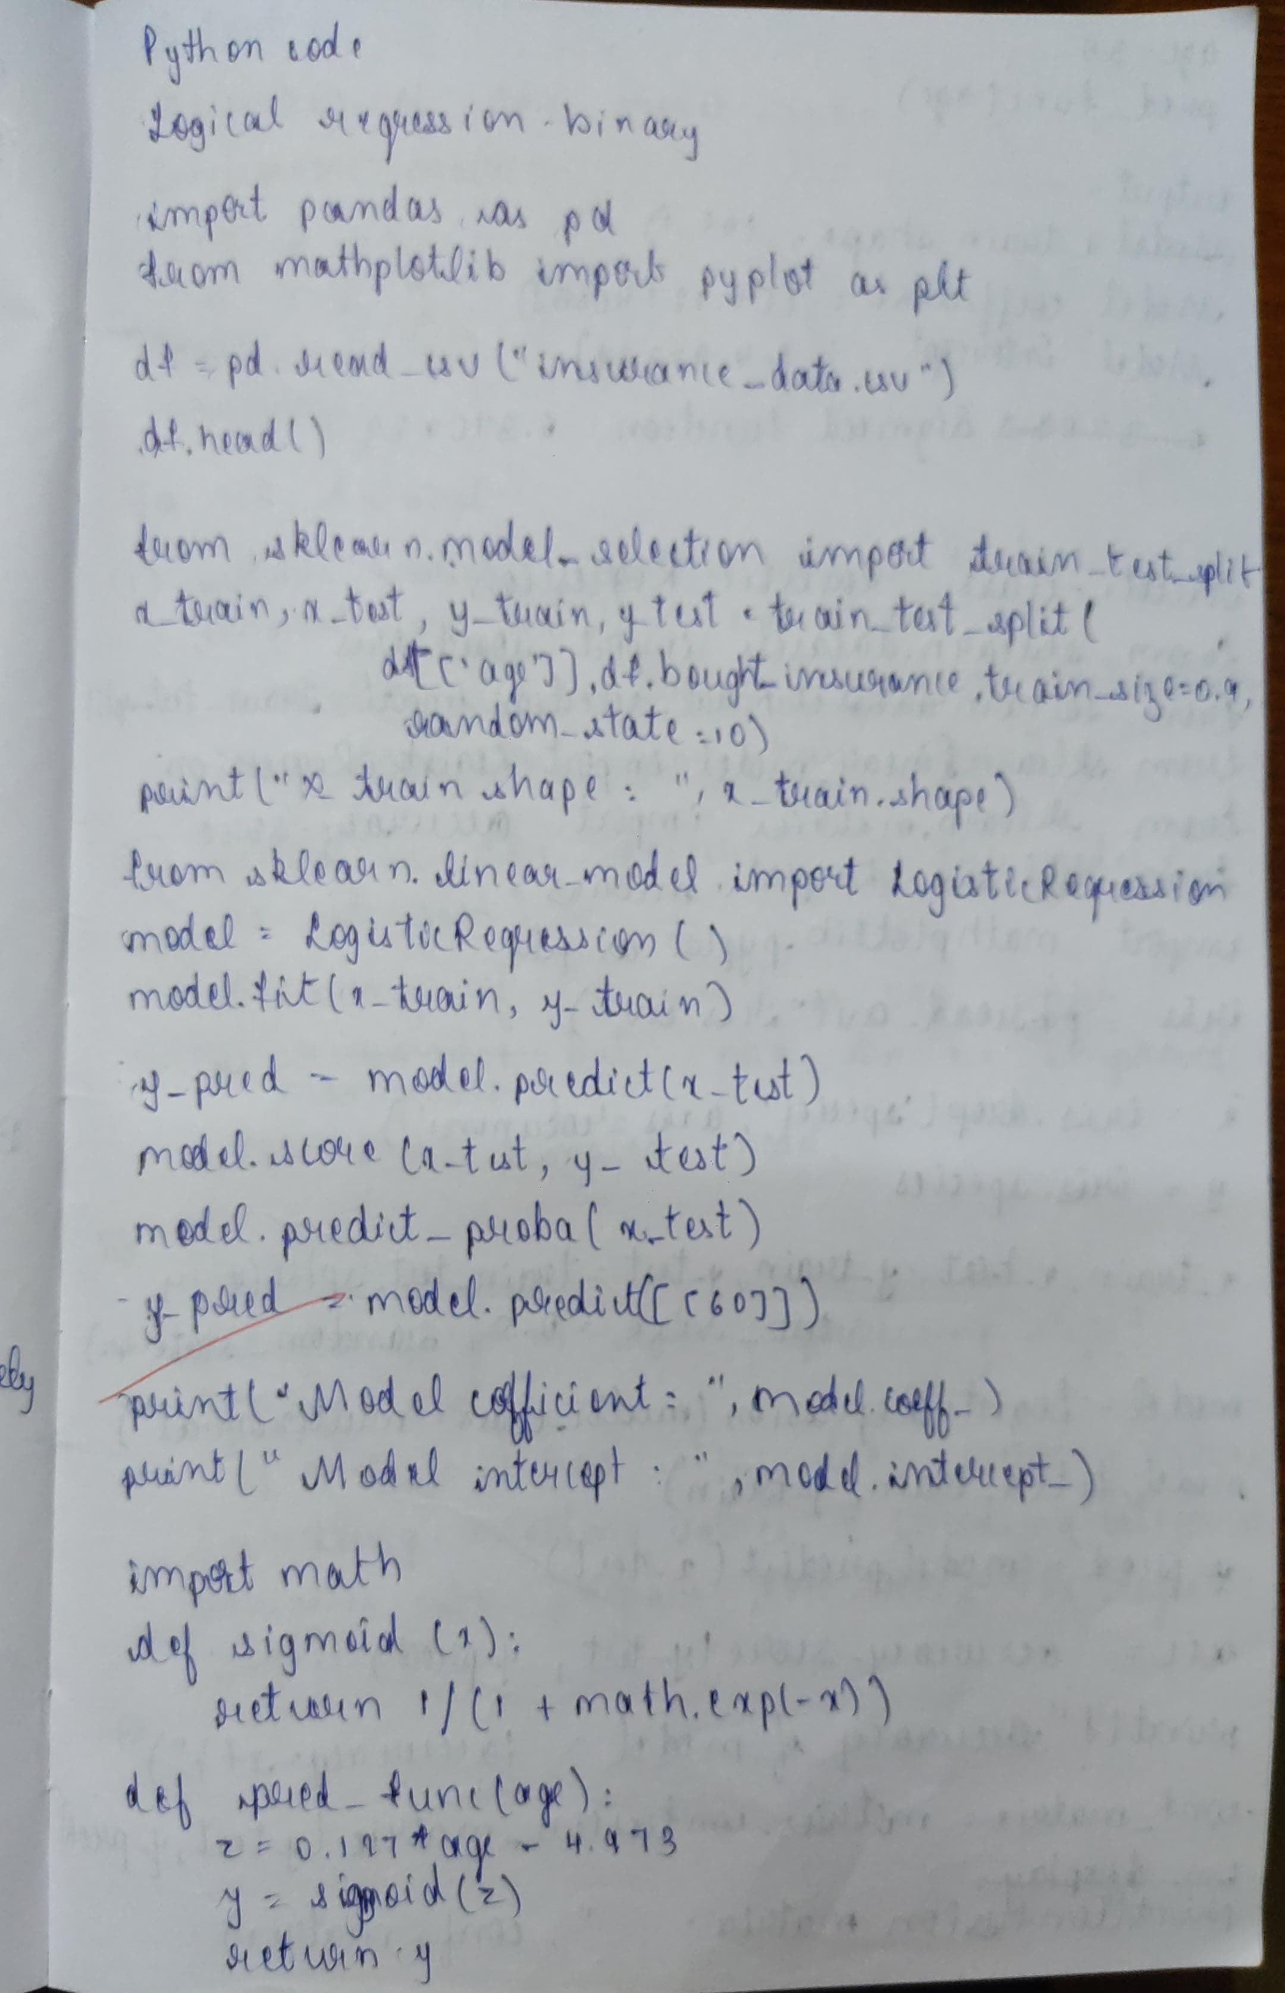

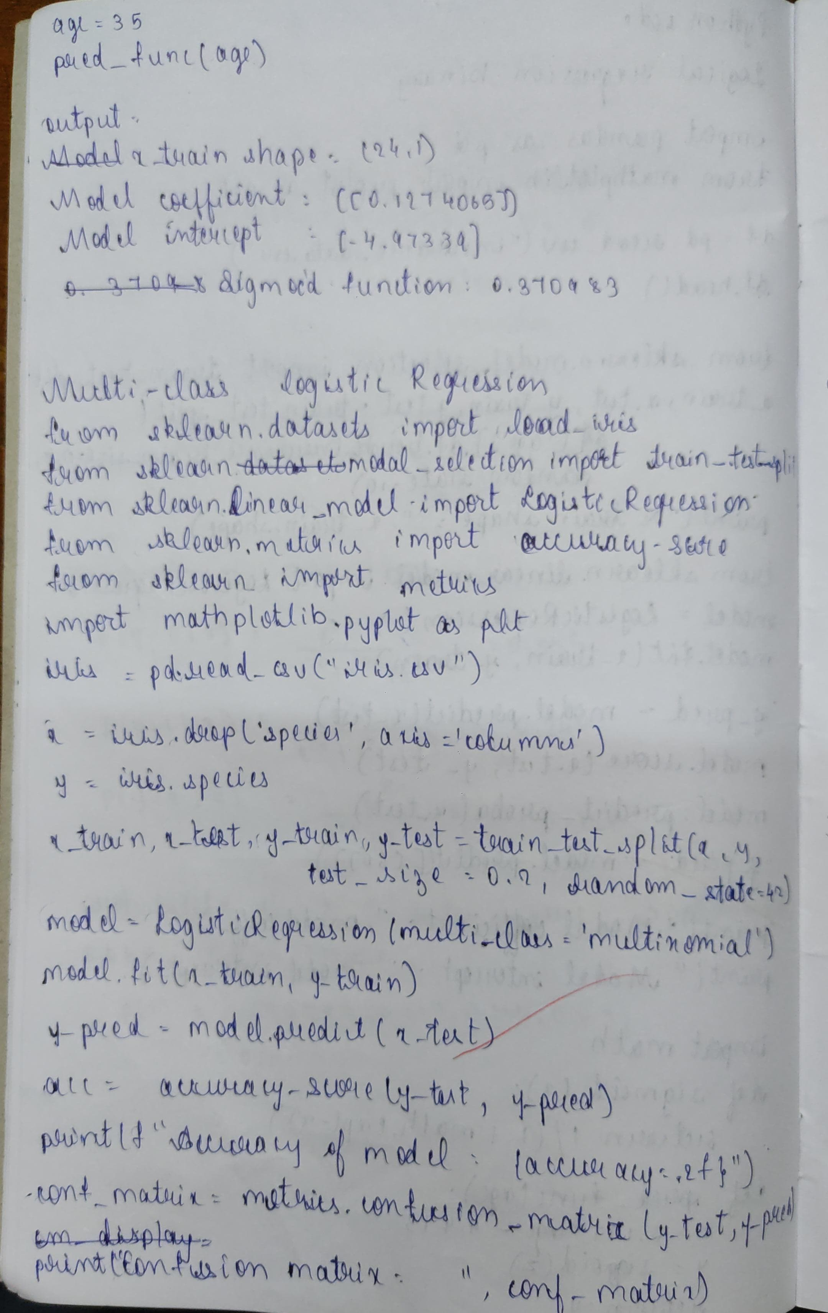

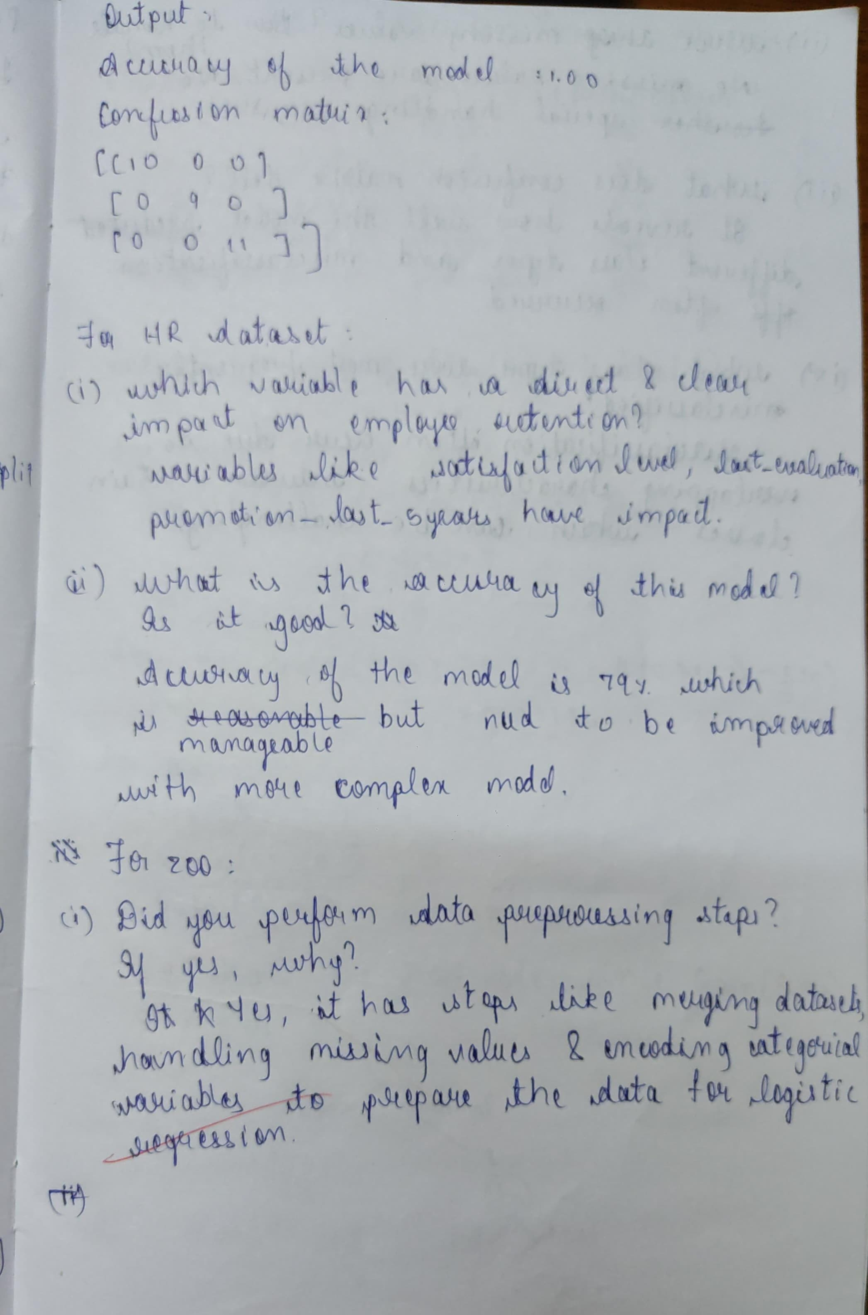

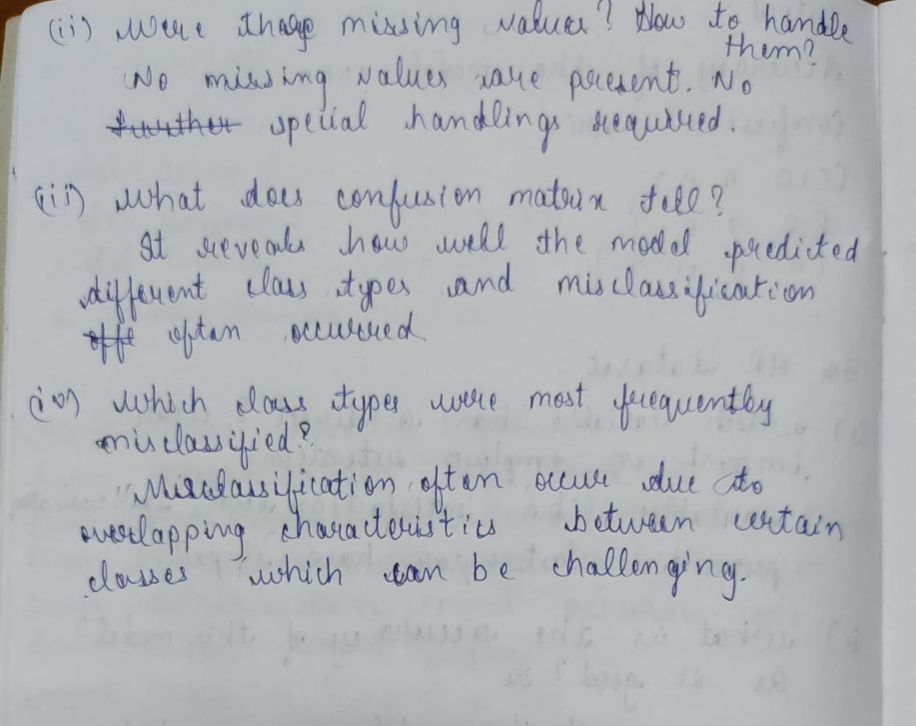

Code

import pandas as pd

import numpy as np

df=pd.read_csv("/content/HR_comma_sep.csv")

df.head(3)

print(df.isnull().sum())

print(df.groupby('left').mean(numeric_only=True))

print(df.groupby('salary').mean(numeric_only=True))

import matplotlib.pyplot as plt

pd.crosstab(df.salary,df.left).plot(kind='bar')

plt.title('Employee Retention vs Salary')

plt.xlabel('Salary')

plt.ylabel('Number of Employees')

plt.show()

pd.crosstab(df.Department,df.left).plot(kind='bar')

plt.title('Employee Retention vs Department')

plt.xlabel('Department')

plt.ylabel('Number of Employees')

plt.show()

salary_dummies = pd.get_dummies(df.salary, prefix="salary")

dept_dummies = pd.get_dummies(df.Department, prefix="dept")

df_with_dummies = pd.concat([df, salary_dummies, dept_dummies], axis=1)

df_with_dummies = df_with_dummies.drop(['salary', 'Department'], axis=1)

X_features = ['satisfaction_level', 'last_evaluation', 'number_project', 'average_montly_hours', 'time_spend_company', 'Work_accident', 'promotion_last_5years'] + list(salary_dummies.columns) + list(dept_dummies.columns)

X = df_with_dummies[X_features]

y = df_with_dummies.left

from sklearn.model_selection import train_test_split

X_train, X_test, y_train, y_test = train_test_split(X, y, test_size=0.3, random_state=0)

from sklearn.linear_model import LogisticRegression

model = LogisticRegression()

model.fit(X_train, y_train)

from sklearn.metrics import accuracy_score

y_pred = model.predict(X_test)

accuracy = accuracy_score(y_test, y_pred)

print("Accuracy of the model:", accuracy)

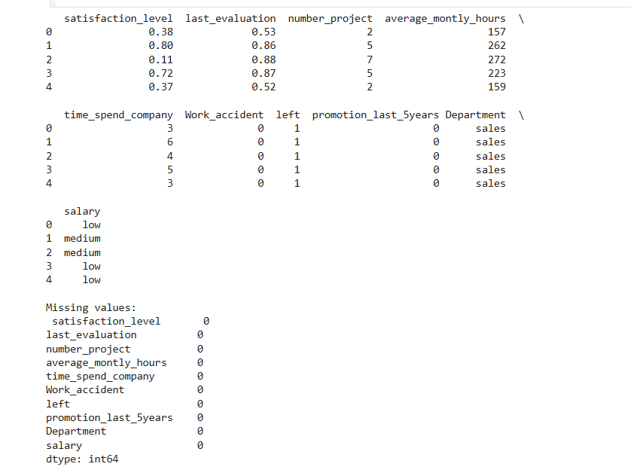

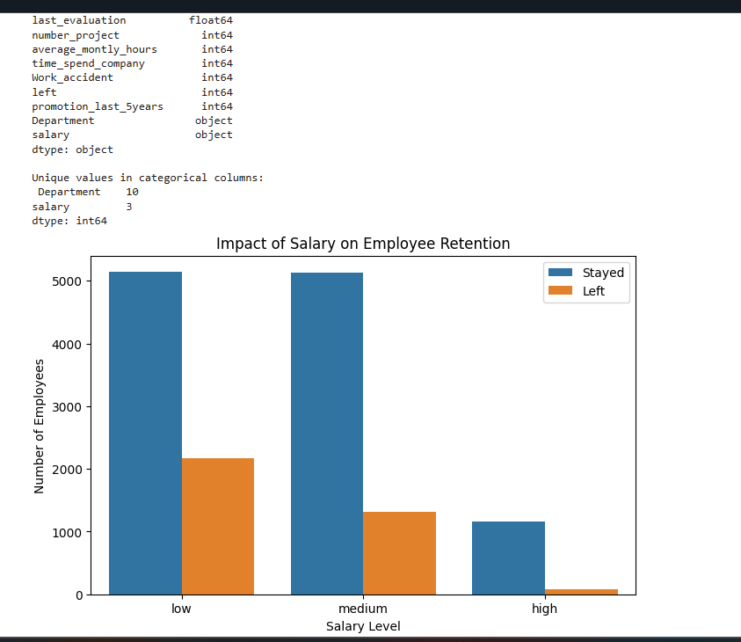

PROGRAM 5

Use an appropriate data set for building the decision tree (ID3) and apply this knowledge to classify a new sample.

Screenshot

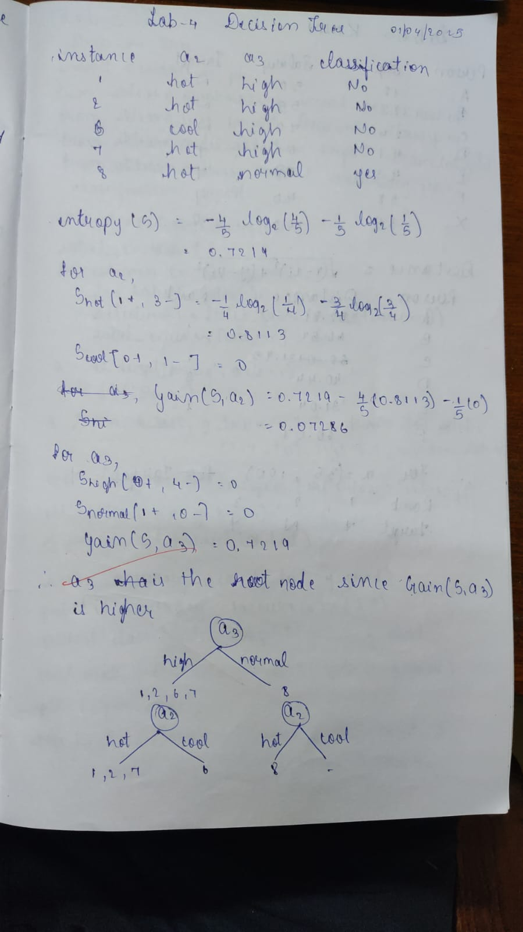

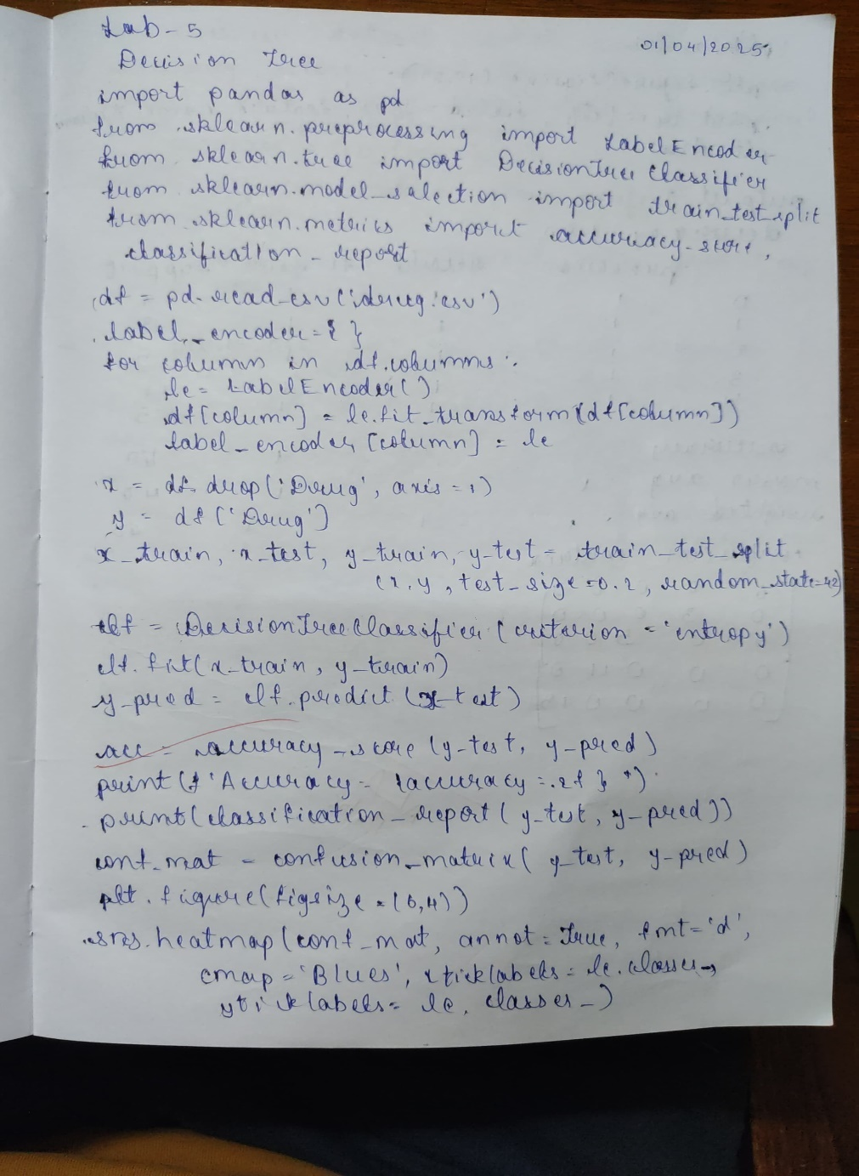

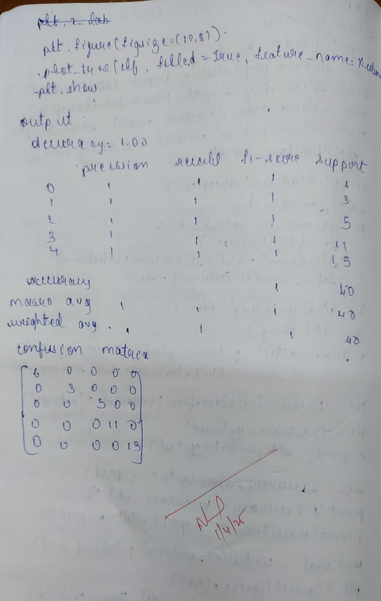

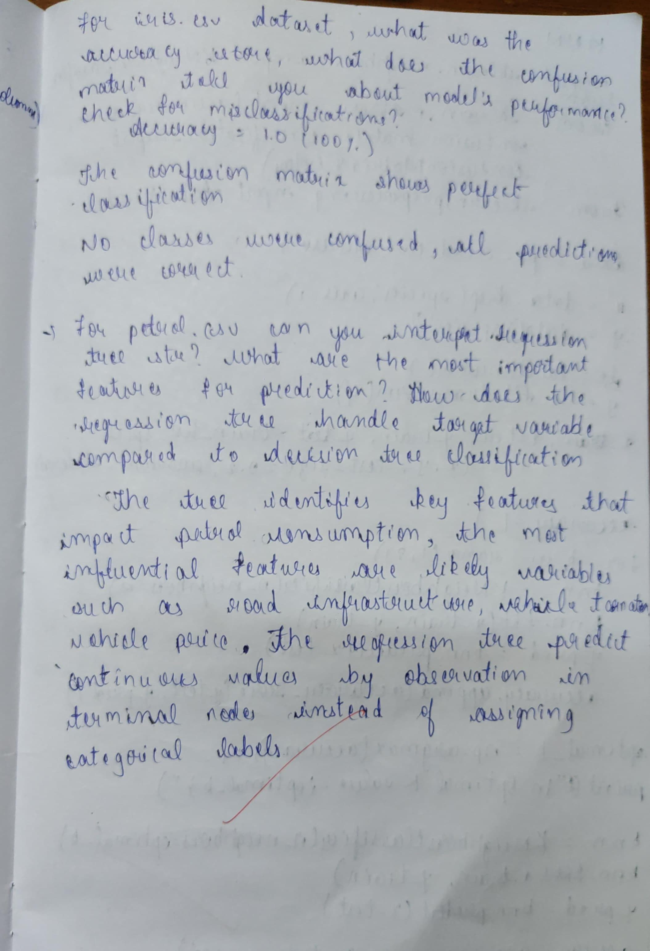

Code

from sklearn.datasets import load_iris

from sklearn.model_selection import train_test_split

from sklearn.tree import DecisionTreeClassifier

from sklearn.metrics import accuracy_score, confusion_matrix

from sklearn import tree

import matplotlib.pyplot as plt

iris = load_iris()

X = iris.data

y = iris.target

X_train, X_test, y_train, y_test = train_test_split(X, y, test_size=0.2, random_state=42)

clf = DecisionTreeClassifier()

clf.fit(X_train, y_train)

y_pred = clf.predict(X_test)

accuracy = accuracy_score(y_test, y_pred)

conf_matrix = confusion_matrix(y_test, y_pred)

print("Accuracy:", accuracy)

print("Confusion Matrix:\n", conf_matrix)

plt.figure(figsize=(12, 8))

tree.plot_tree(clf, feature_names=iris.feature_names, class_names=iris.target_names, filled=True)

plt.show()

from sklearn.datasets import load_iris

from sklearn.model_selection import train_test_split

from sklearn.tree import DecisionTreeClassifier

from sklearn.metrics import accuracy_score, confusion_matrix

from sklearn import tree

import matplotlib.pyplot as plt

iris = load_iris()

X = iris.data

y = iris.target

X_train, X_test, y_train, y_test = train_test_split(X, y, test_size=0.2, random_state=42)

clf = DecisionTreeClassifier()

clf.fit(X_train, y_train)

y_pred = clf.predict(X_test)

accuracy = accuracy_score(y_test, y_pred)

conf_matrix = confusion_matrix(y_test, y_pred)

print("Accuracy:", accuracy)

print("Confusion Matrix:\n", conf_matrix)

plt.figure(figsize=(12, 8))

tree.plot_tree(clf, feature_names=iris.feature_names, class_names=iris.target_names, filled=True)

plt.show()

import pandas as pd

from sklearn.model_selection import train_test_split

from sklearn.tree import DecisionTreeRegressor

from sklearn.metrics import mean_absolute_error, mean_squared_error

import numpy as np # import numpy

data = pd.read_csv("petrol_consumption.csv")

X = data[['Petrol_tax', 'Average_income', 'Paved_Highways',

'Population_Driver_licence(%)']]

y = data['Petrol_Consumption']

X_train, X_test, y_train, y_test = train_test_split(

X, y, test_size=0.2, random_state=42)

regressor = DecisionTreeRegressor()

regressor.fit(X_train, y_train)

y_pred = regressor.predict(X_test)

mae = mean_absolute_error(y_test, y_pred)

mse = mean_squared_error(y_test, y_pred)

rmse = np.sqrt(mse)

print("Mean Absolute Error:", mae)

print("Mean Squared Error:", mse)

print("Root Mean Squared Error:", rmse)

from sklearn.tree import plot_tree

import matplotlib.pyplot as plt

plt.figure(figsize=(15, 10))

# Assuming 'data' is your original pandas DataFrame

plot_tree(regressor, feature_names=data[['Petrol_tax', 'Average_income', 'Paved_Highways', 'Population_Driver_licence(%)']].columns, filled=True, rounded=True)

plt.show()

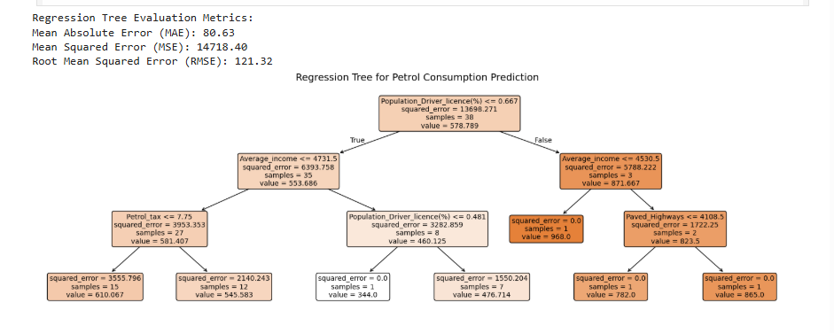

PROGRAM 6

Build KNN Classification model for a given dataset.

Screenshot

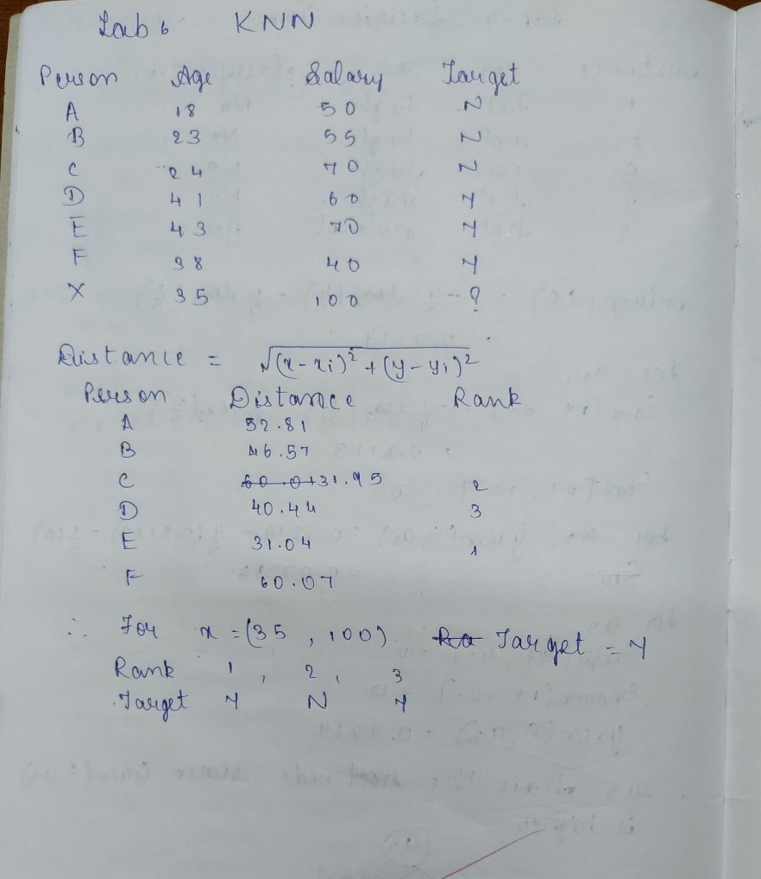

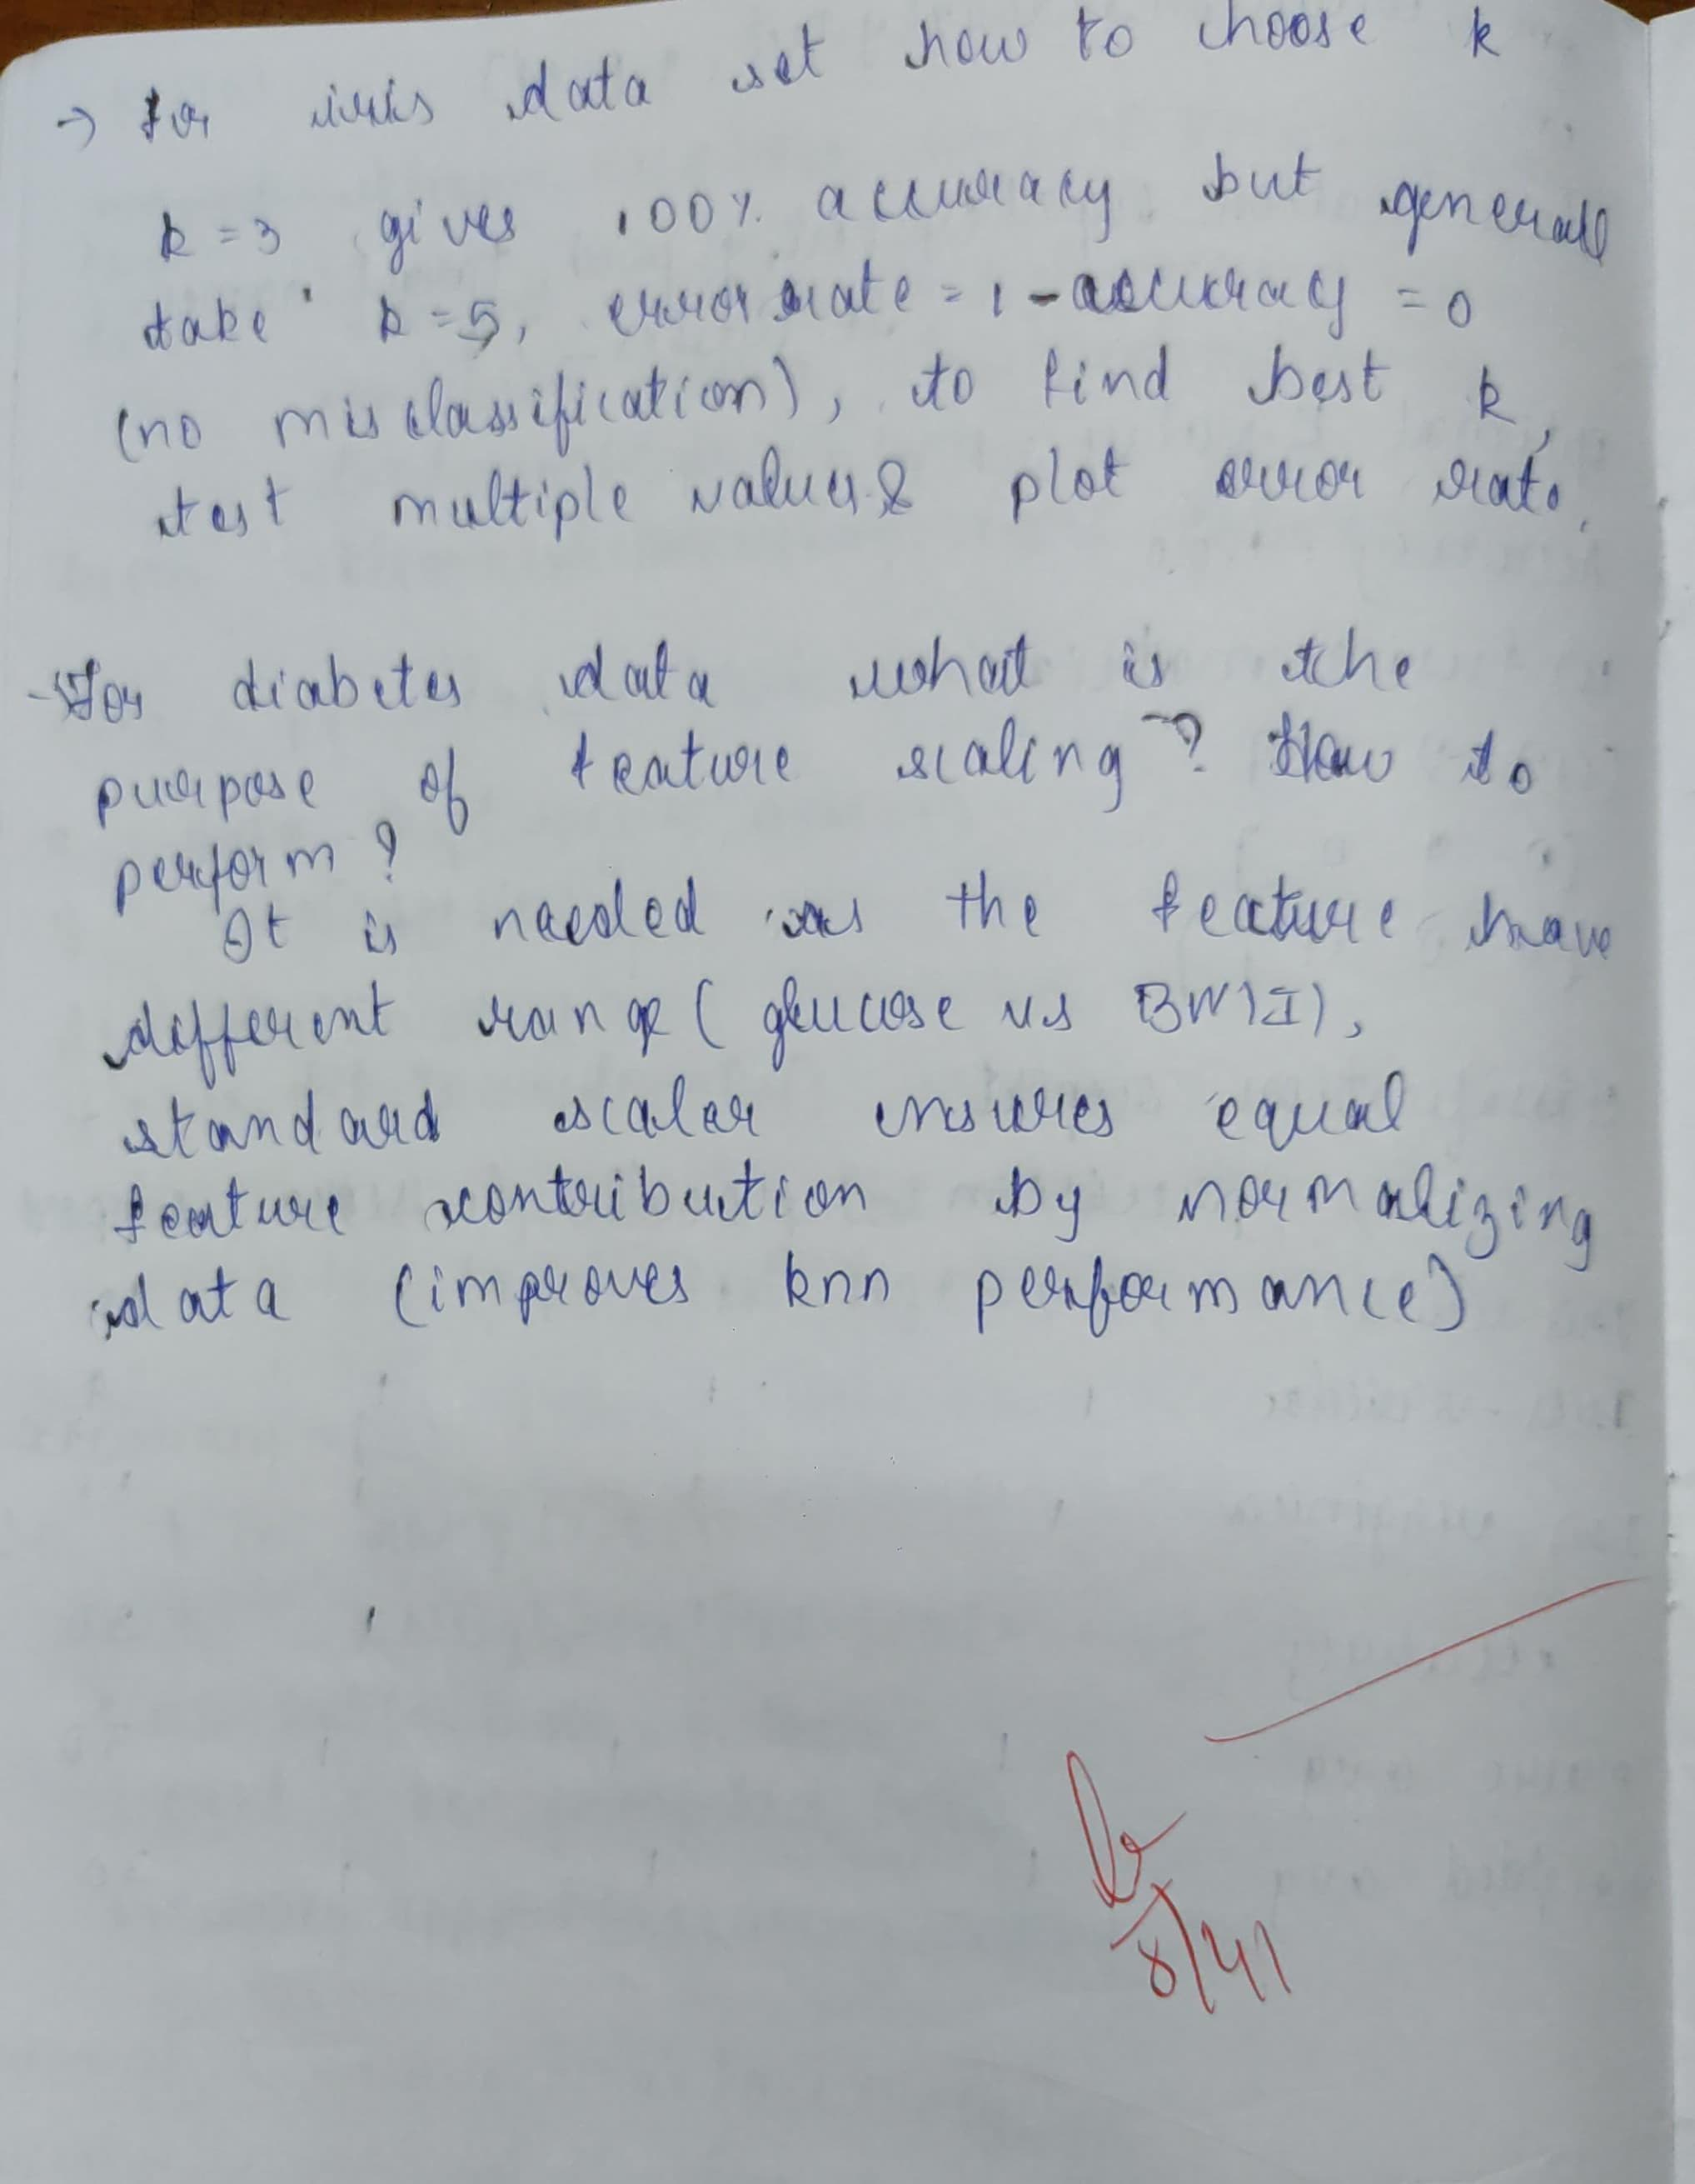

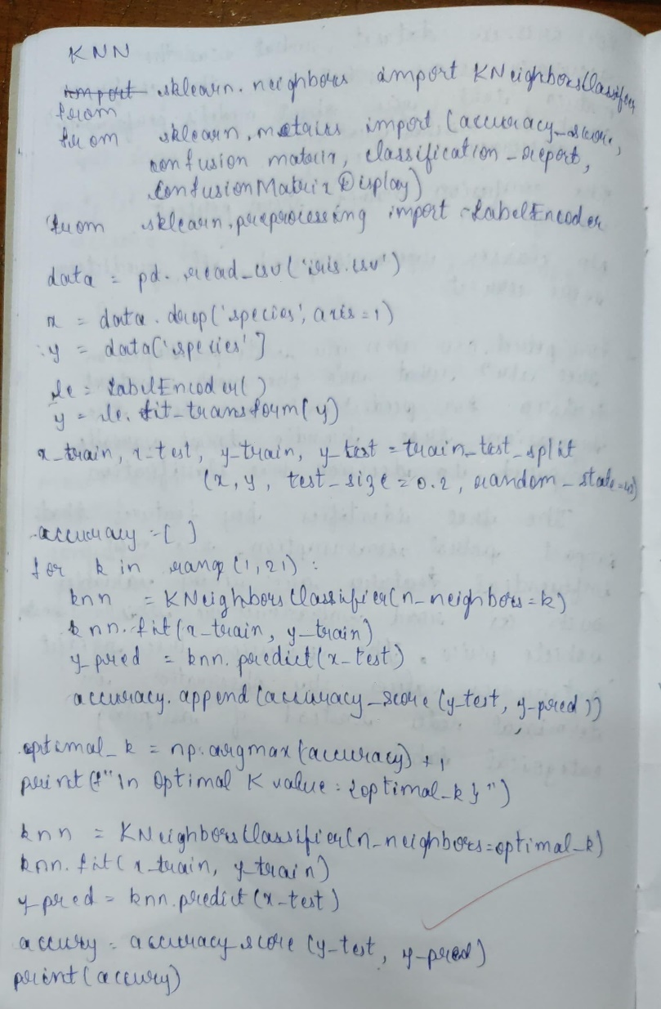

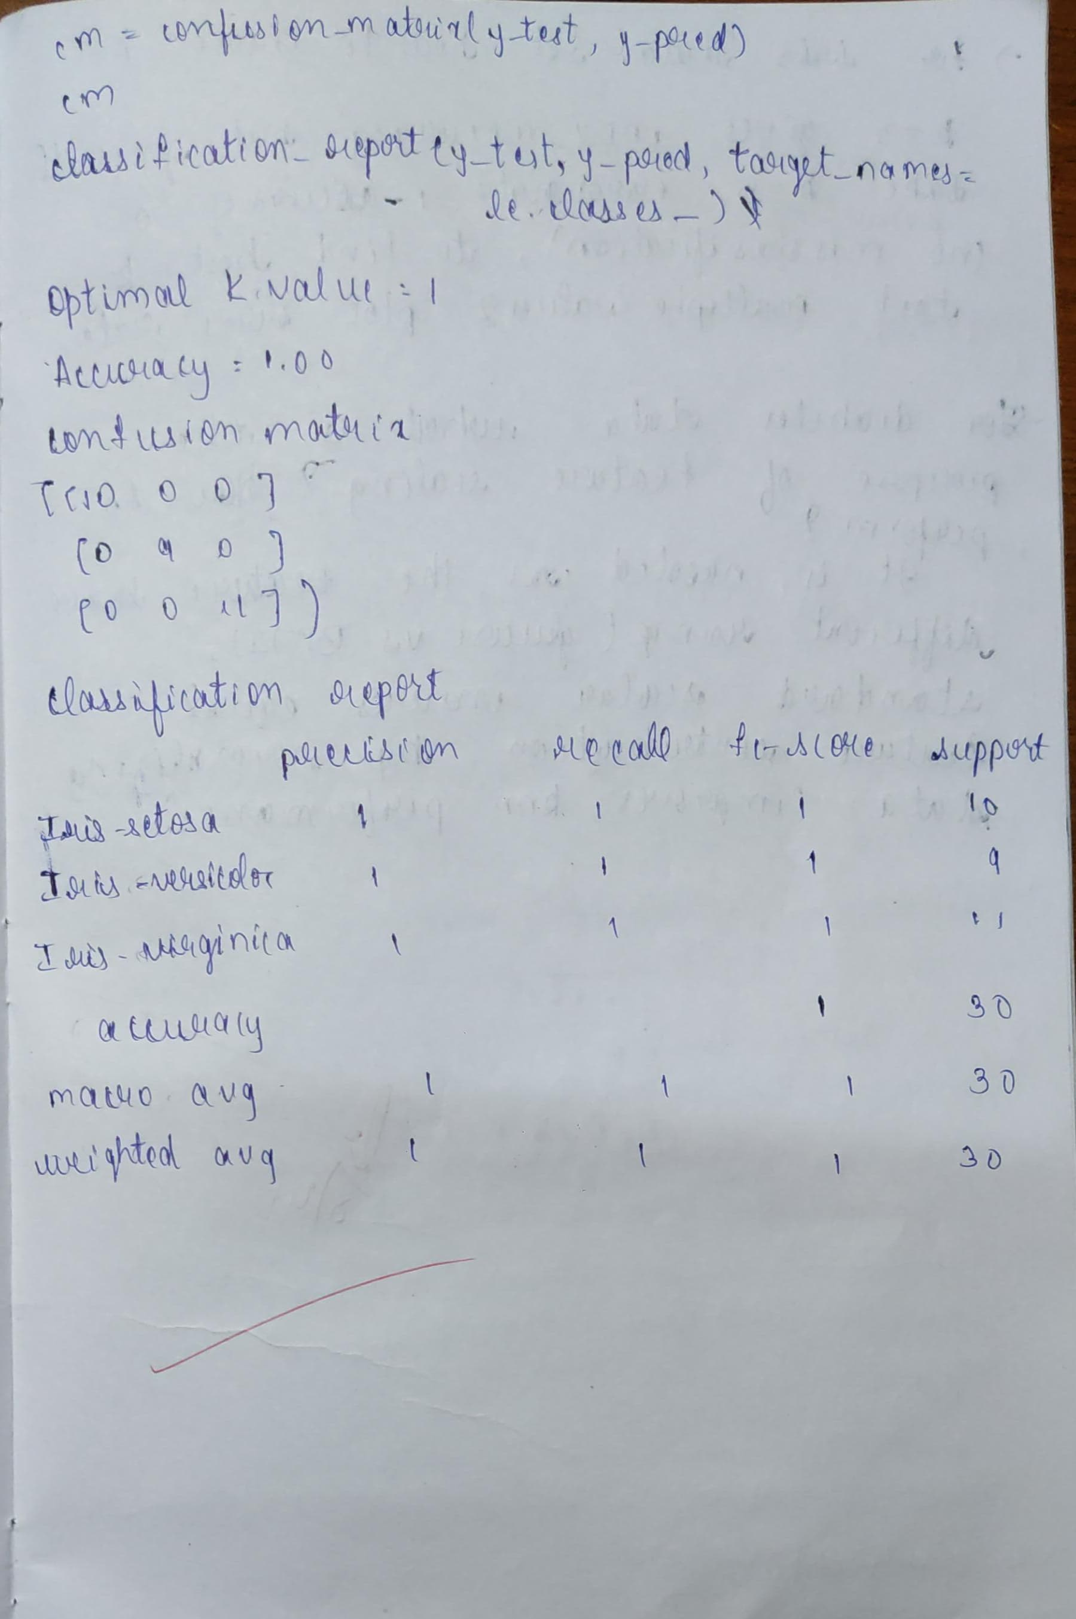

Code

import pandas as pd

from sklearn.model_selection import train_test_split

from sklearn.neighbors import KNeighborsClassifier

from sklearn.metrics import classification_report, confusion_matrix, accuracy_score

import seaborn as sns

import matplotlib.pyplot as plt

try:

data = pd.read_csv('/content/iris (1).csv')

except FileNotFoundError:

print("Error: 'iris.csv' not found. Please upload the file to your Colab environment.")

exit()

X = data.drop('species', axis=1)

y = data['species']

X_train, X_test, y_train, y_test = train_test_split(X, y, test_size=0.2, random_state=42)

knn = KNeighborsClassifier(n_neighbors=3)

knn.fit(X_train, y_train)

y_pred = knn.predict(X_test)

print("Accuracy Score:", accuracy_score(y_test, y_pred))

print("\nConfusion Matrix:")

cm = confusion_matrix(y_test, y_pred)

print(cm)

plt.figure(figsize=(8, 6))

sns.heatmap(cm, annot=True, fmt='d', cmap='Blues',

xticklabels=knn.classes_, yticklabels=knn.classes_)

plt.xlabel('Predicted')

plt.ylabel('Actual')

plt.title('Confusion Matrix')

plt.show()

print("\nClassification Report:")

print(classification_report(y_test, y_pred))

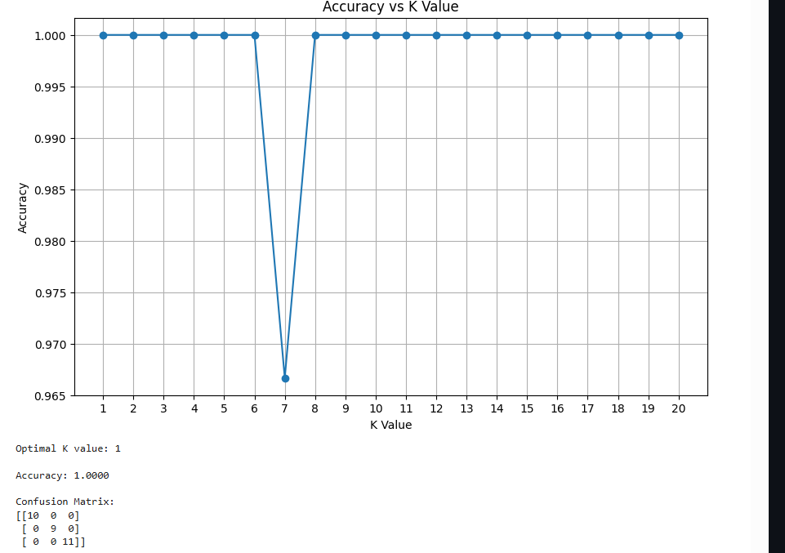

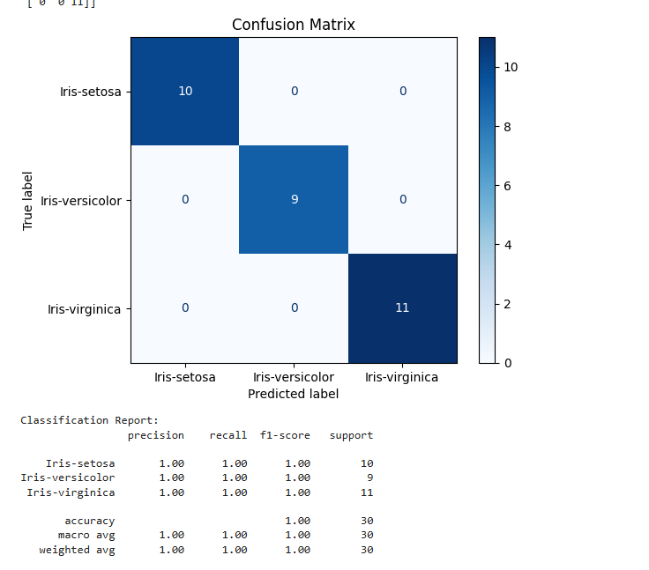

import pandas as pd

from sklearn.model_selection import train_test_split

from sklearn.neighbors import KNeighborsClassifier

from sklearn.metrics import classification_report, confusion_matrix, accuracy_score

from sklearn.preprocessing import StandardScaler

import seaborn as sns

import matplotlib.pyplot as plt

try:

diabetes = pd.read_csv('diabetes.csv')

except FileNotFoundError:

print("Error: 'diabetes.csv' not found. Please ensure the file is in the current directory.")

exit()

X = diabetes.drop('Outcome', axis=1)

y = diabetes['Outcome']

scaler = StandardScaler()

X = scaler.fit_transform(X)

X_train, X_test, y_train, y_test = train_test_split(X, y, test_size=0.2, random_state=42)

knn = KNeighborsClassifier(n_neighbors=5)

knn.fit(X_train, y_train)

y_pred = knn.predict(X_test)

accuracy = accuracy_score(y_test, y_pred)

print(f"Accuracy: {accuracy}")

cm = confusion_matrix(y_test, y_pred)

print("Confusion Matrix:")

print(cm)

sns.heatmap(cm, annot=True, fmt="d")

plt.title('Confusion Matrix')

plt.xlabel('Predicted')

plt.ylabel('True')

plt.show()

print("Classification Report:")

print(classification_report(y_test, y_pred))

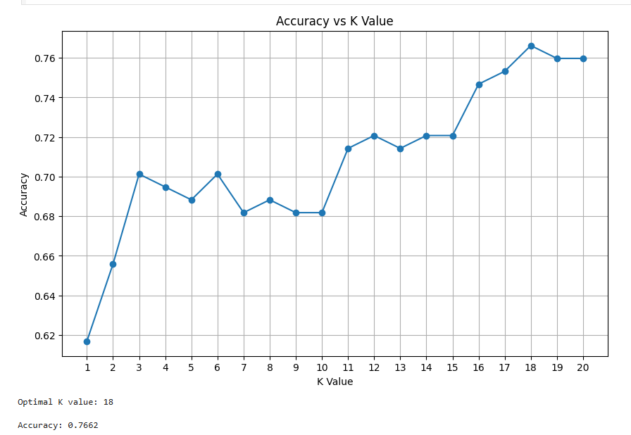

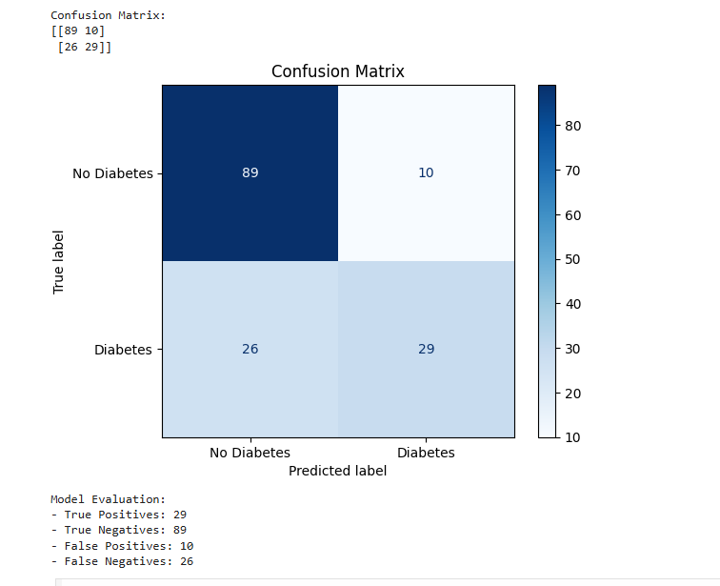

import pandas as pd

from sklearn.model_selection import train_test_split

from sklearn.neighbors import KNeighborsClassifier

from sklearn.metrics import classification_report, confusion_matrix, accuracy_score

import seaborn as sns

import matplotlib.pyplot as plt

from sklearn.preprocessing import StandardScaler

try:

heart = pd.read_csv('heart.csv')

except FileNotFoundError:

print("Error: 'heart.csv' not found. Please ensure the file is in the current directory.")

exit()

X = heart.drop('target', axis=1)

y = heart['target']

scaler = StandardScaler()

X = scaler.fit_transform(X)

X_train, X_test, y_train, y_test = train_test_split(X, y, test_size=0.2, random_state=42)

best_k = 1

best_accuracy = 0

for k in range(1, 21):

knn = KNeighborsClassifier(n_neighbors=k)

knn.fit(X_train, y_train)

y_pred = knn.predict(X_test)

accuracy = accuracy_score(y_test, y_pred)

if accuracy > best_accuracy:

best_accuracy = accuracy

best_k = k

print(f"Best k: {best_k} with accuracy {best_accuracy}")

knn = KNeighborsClassifier(n_neighbors=best_k)

knn.fit(X_train, y_train)

y_pred = knn.predict(X_test)

accuracy = accuracy_score(y_test, y_pred)

print(f"Accuracy: {accuracy}")

cm = confusion_matrix(y_test, y_pred)

print("Confusion Matrix:")

print(cm)

sns.heatmap(cm, annot=True, fmt="d")

plt.title('Confusion Matrix')

plt.xlabel('Predicted')

plt.ylabel('True')

plt.show()

print("Classification Report:")

print(classification_report(y_test, y_pred))

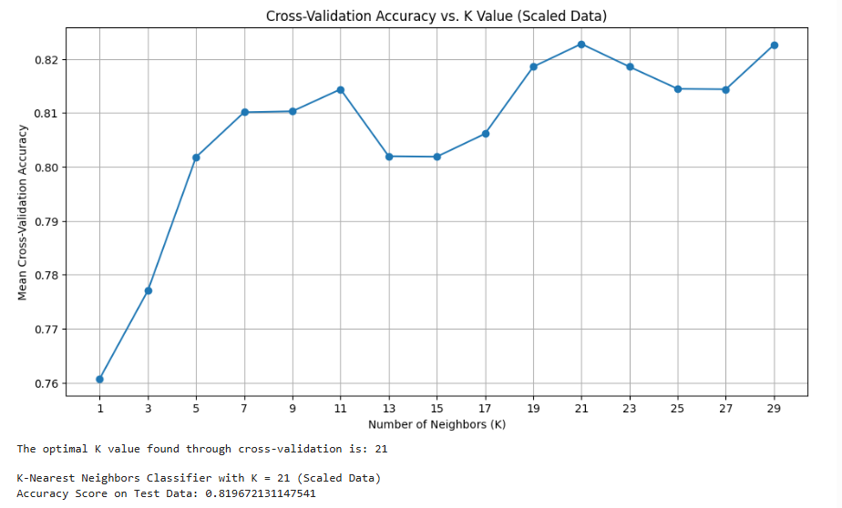

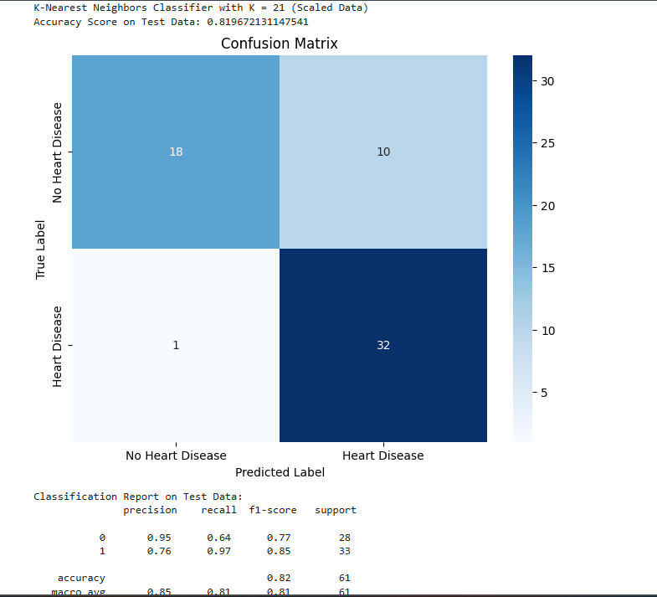

PROGRAM 7 Build Support vector machine model for a given dataset

Screenshot

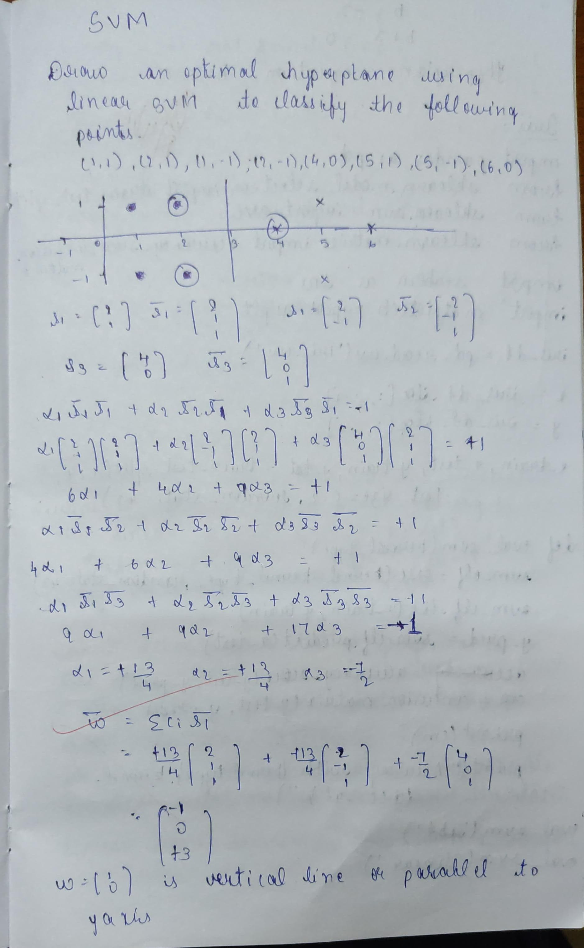

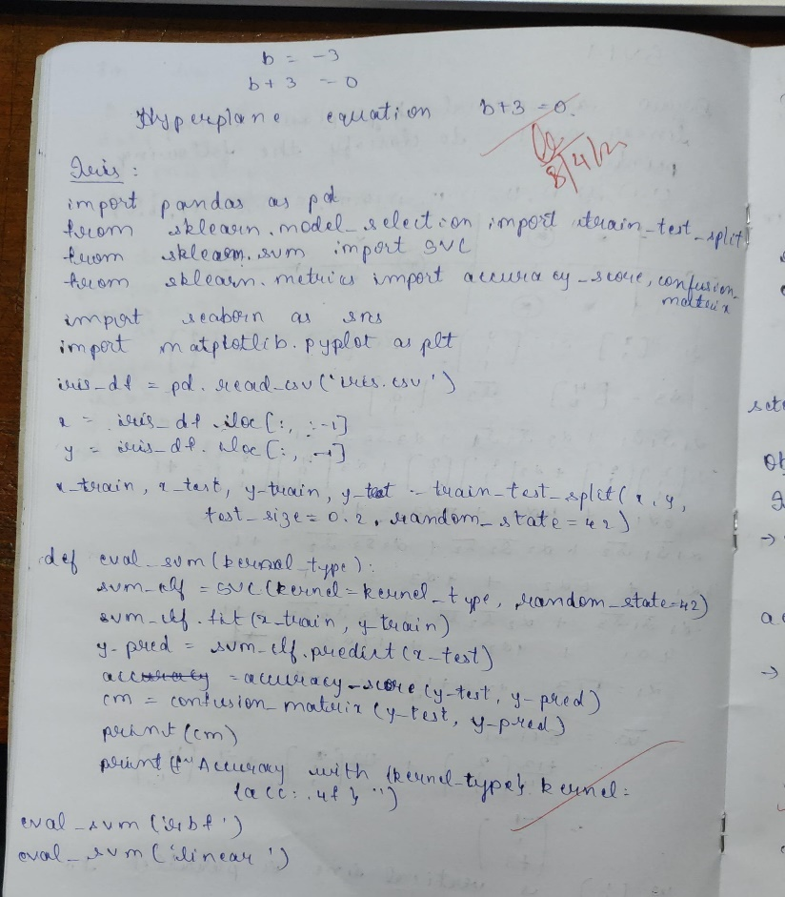

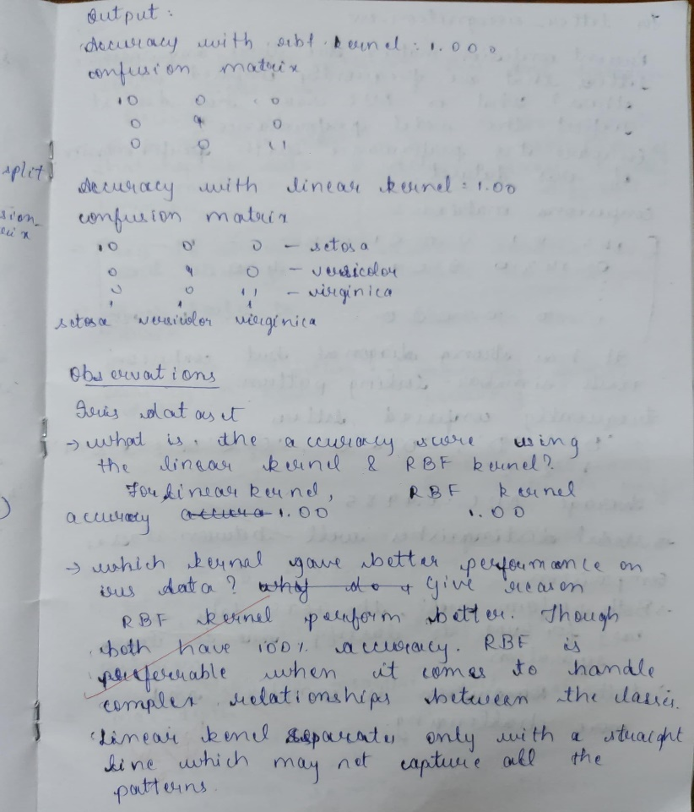

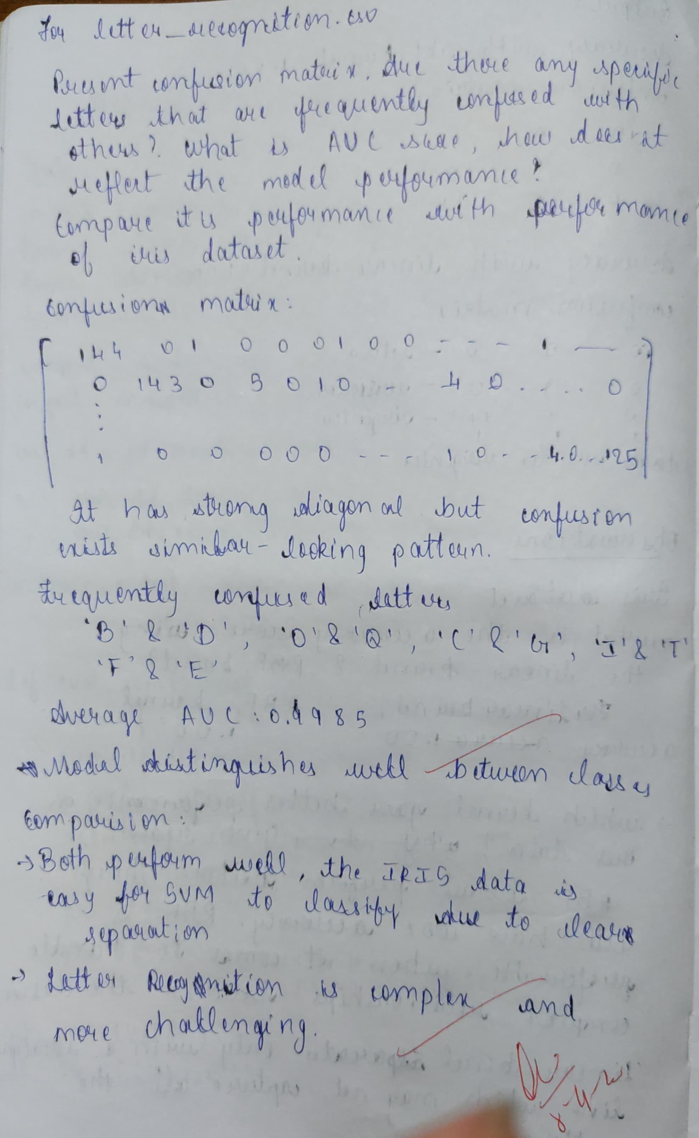

Code

import pandas as pd

import numpy as np

from sklearn.model_selection import train_test_split

from sklearn.svm import SVC

from sklearn.metrics import accuracy_score, confusion_matrix, roc_curve, auc

from sklearn.preprocessing import label_binarize

import matplotlib.pyplot as plt

from itertools import cycle

data = pd.read_csv('letter-recognition.csv')

X = data.drop('letter', axis=1)

y = data['letter']

X_train, X_test, y_train, y_test = train_test_split(X, y, test_size=0.2, random_state=42)

svm = SVC(kernel='rbf', probability=True, random_state=42)

svm.fit(X_train, y_train)

y_pred = svm.predict(X_test)

accuracy = accuracy_score(y_test, y_pred)

print(f"Accuracy: {accuracy:.4f}")

conf_mat = confusion_matrix(y_test, y_pred)

print("\nConfusion Matrix:")

print(conf_mat)

y_test_bin = label_binarize(y_test, classes=np.unique(y))

n_classes = y_test_bin.shape[1]

fpr = dict()

tpr = dict()

roc_auc = dict()

for i in range(n_classes):

fpr[i], tpr[i], _ = roc_curve(y_test_bin[:, i], svm.predict_proba(X_test)[:, i])

roc_auc[i] = auc(fpr[i], tpr[i])

plt.figure(figsize=(10, 8))

colors = cycle(['aqua', 'darkorange', 'cornflowerblue', 'green', 'red', 'purple',

'brown', 'pink', 'gray', 'olive', 'cyan', 'magenta', 'yellow',

'navy', 'lime', 'teal', 'indigo', 'gold', 'darkred', 'darkgreen',

'darkblue', 'darkviolet', 'sienna', 'peru', 'khaki'])

for i, color in zip(range(n_classes), colors):

plt.plot(fpr[i], tpr[i], color=color, lw=2,

label='ROC curve of class {0} (AUC = {1:0.2f})'

''.format(np.unique(y)[i], roc_auc[i]))

plt.plot([0, 1], [0, 1], 'k--', lw=2)

plt.xlim([0.0, 1.0])

plt.ylim([0.0, 1.05])

plt.xlabel('False Positive Rate')

plt.ylabel('True Positive Rate')

plt.title('Multiclass ROC Curve for Letter Recognition')

plt.legend(bbox_to_anchor=(1.05, 1), loc='upper left')

plt.show()

avg_auc = np.mean(list(roc_auc.values()))

print(f"\nAverage AUC: {avg_auc:.4f}")

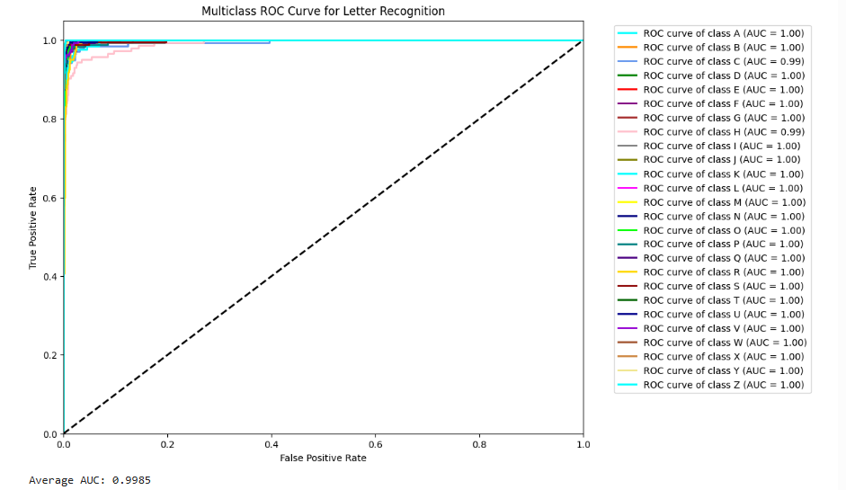

import pandas as pd

from sklearn.model_selection import train_test_split

from sklearn.svm import SVC

from sklearn.metrics import accuracy_score, confusion_matrix

import seaborn as sns

import matplotlib.pyplot as plt

iris_df = pd.read_csv('iris.csv')

X = iris_df.iloc[:, :-1]

y = iris_df.iloc[:, -1]

X_train, X_test, y_train, y_test = train_test_split(X, y, test_size=0.2, random_state=42)

def evaluate_svm(kernel_type):

*# Create SVM classifier*

svm_clf = SVC(kernel=kernel_type, random_state=42)

*# Train the model*

svm_clf.fit(X_train, y_train)

*# Make predictions*

y_pred = svm_clf.predict(X_test)

*# Calculate accuracy*

accuracy = accuracy_score(y_test, y_pred)

*# Generate confusion matrix*

cm = confusion_matrix(y_test, y_pred)

*# Plot confusion matrix*

plt.figure(figsize=(6, 4))

sns.heatmap(cm, annot=True, fmt='d', cmap='Blues',

xticklabels=svm_clf.classes_,

yticklabels=svm_clf.classes_)

plt.title(f'Confusion Matrix ({kernel_type} kernel)')

plt.ylabel('Actual')

plt.xlabel('Predicted')

plt.show()

print(f"Accuracy with {kernel_type} kernel: {accuracy:.4f}")

print("\n")

evaluate_svm('rbf')

evaluate_svm('linear')

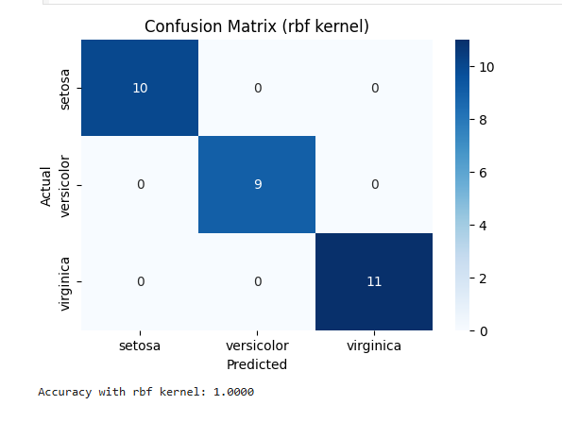

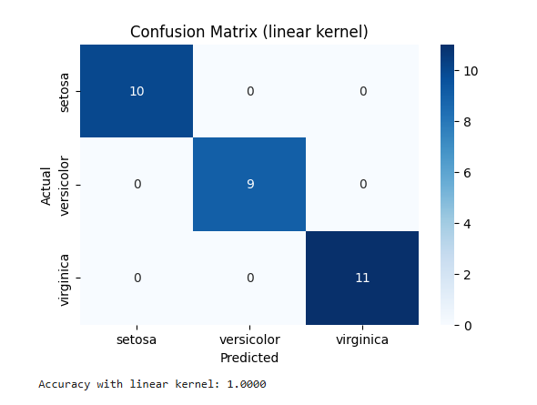

import pandas as pd

import matplotlib.pyplot as plt

from sklearn.svm import SVC

from sklearn.preprocessing import LabelEncoder

df = pd.read_csv("horse_mule_data.csv")

*# Encode 'Horse'=0, 'Mule'=1*

df['Label'] = LabelEncoder().fit_transform(df['Label'])

X = df[['Height', 'Weight']]

y = df['Label']

model = SVC(kernel='linear', C=1000) *# High C -> fewer support vectors*

model.fit(X, y)

support_vectors = model.support_vectors_

accuracy = model.score(X, y)

print("Accuracy:", accuracy)

print("Support Vectors:\n", support_vectors)

print("Number of Support Vectors:", len(support_vectors))

colors = ['red' if label == 0 else 'blue' for label in y]

plt.figure(figsize=(8,6))

plt.scatter(X['Height'], X['Weight'], c=colors, label='Data Points')

plt.scatter(support_vectors[:, 0], support_vectors[:, 1],

s=200, facecolors='none', edgecolors='black', label='Support Vectors')

plt.xlabel("Height")

plt.ylabel("Weight")

plt.title("SVM Classification (3 Support Vectors)")

plt.legend()

plt.grid(True)

plt.show()

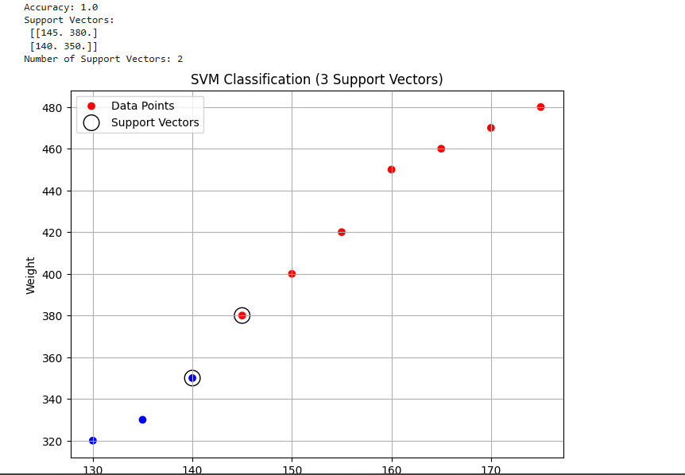

PROGRAM 8 Implement Random forest ensemble method on a given dataset.

Screenshot

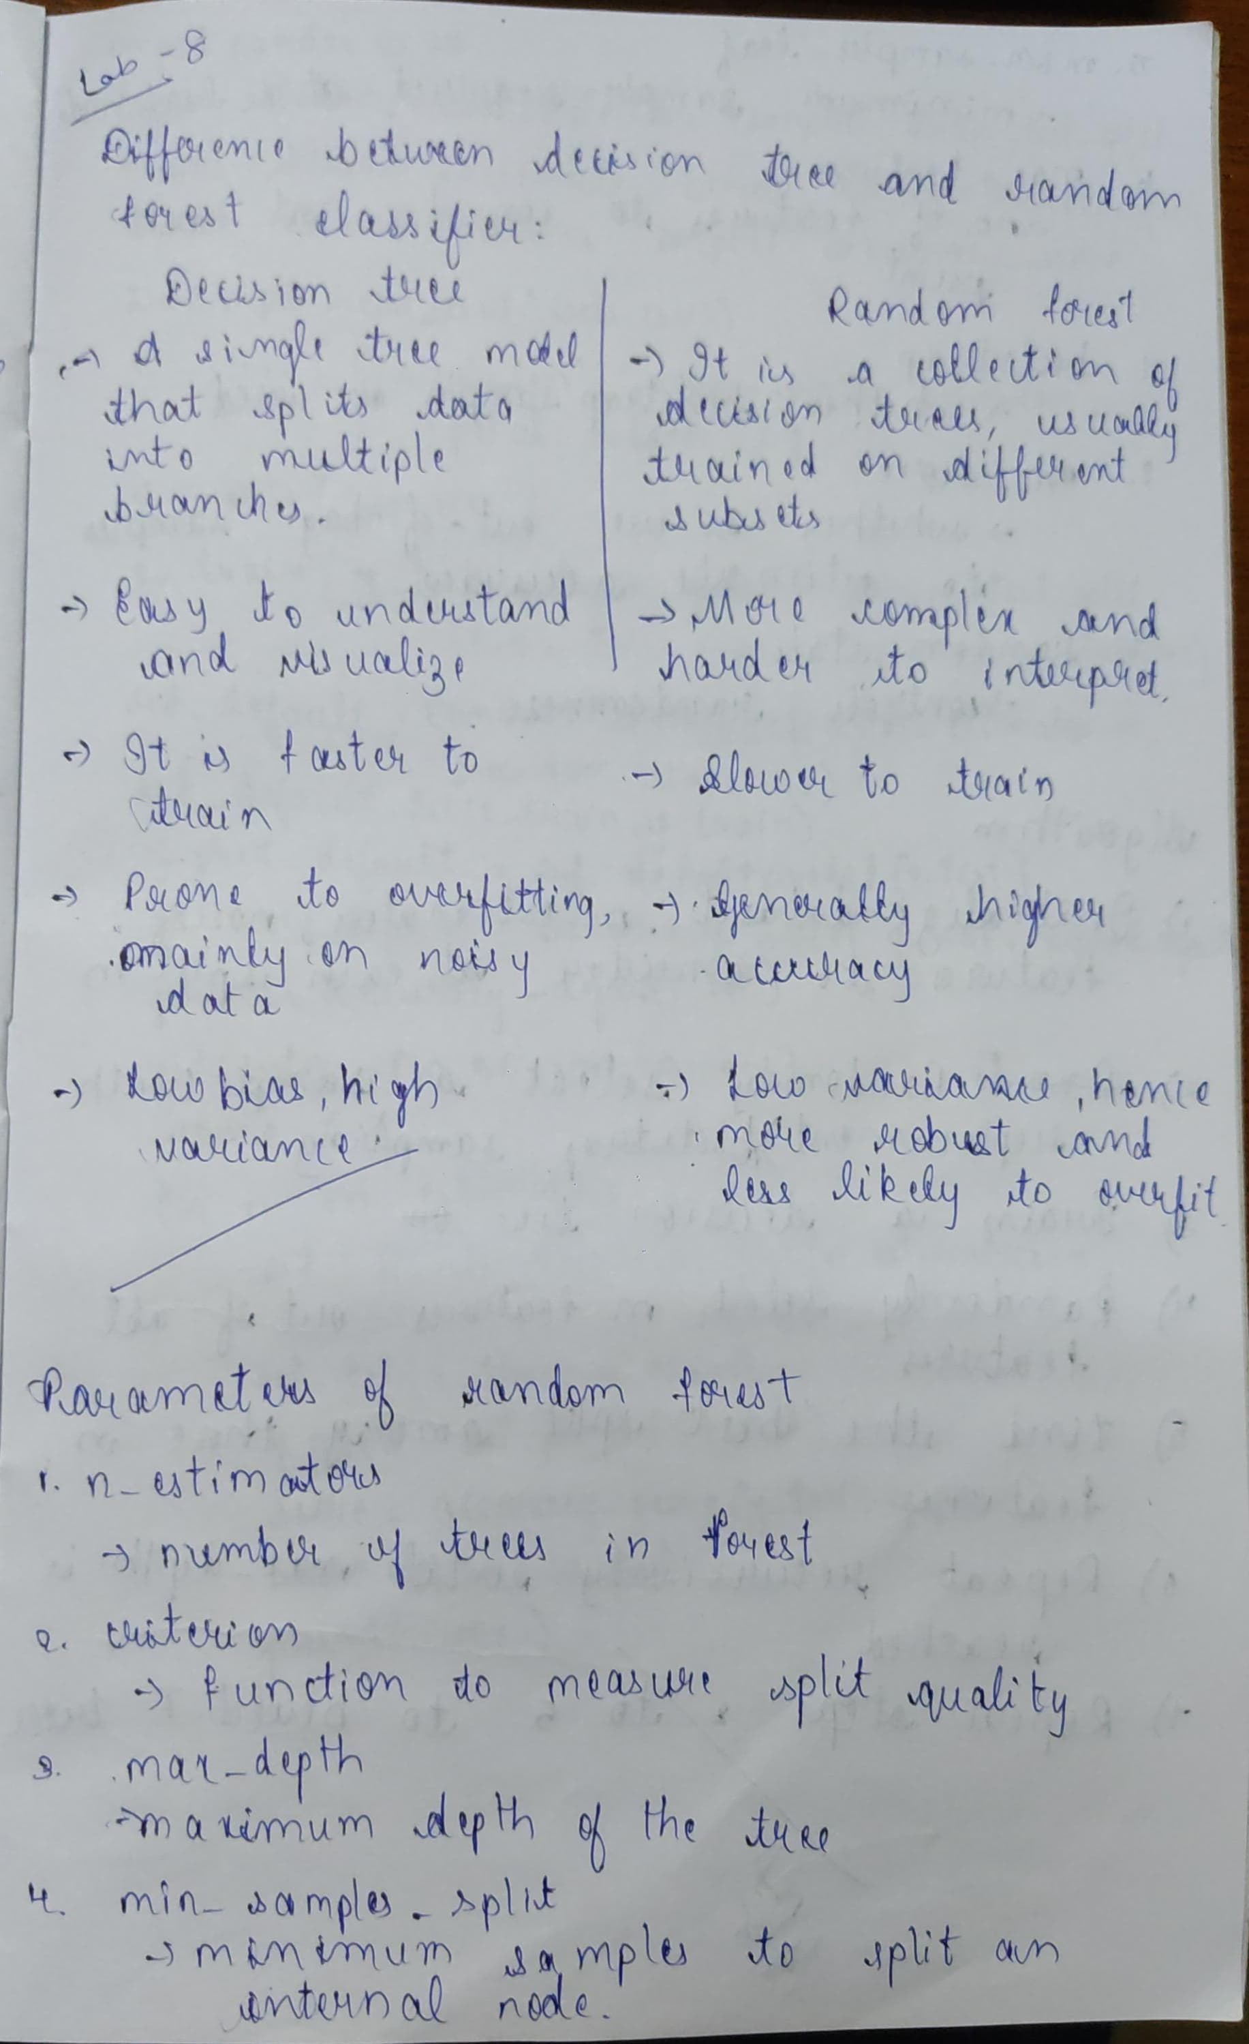

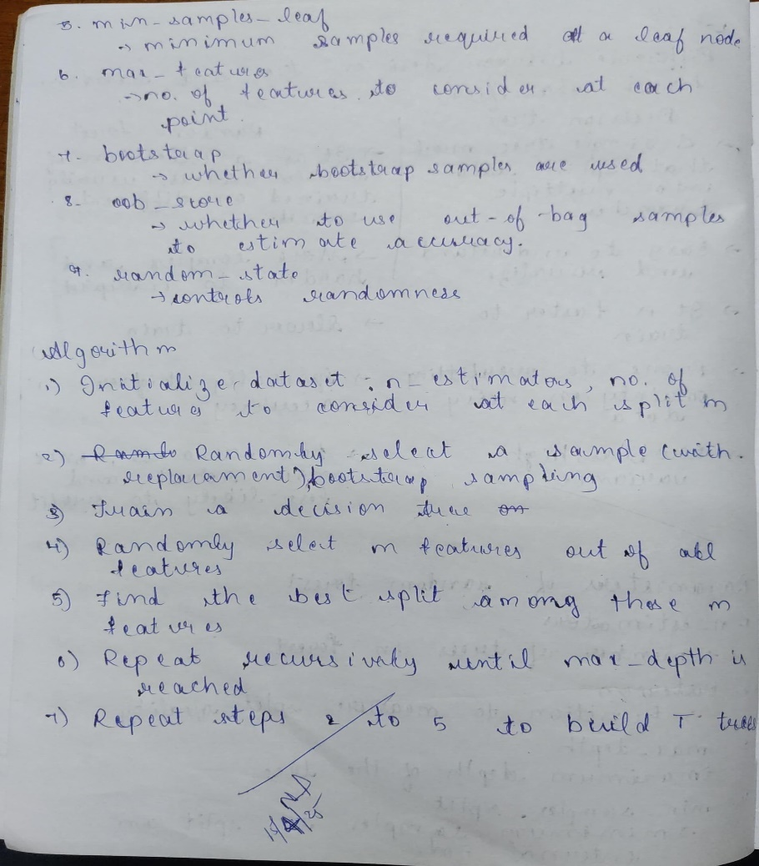

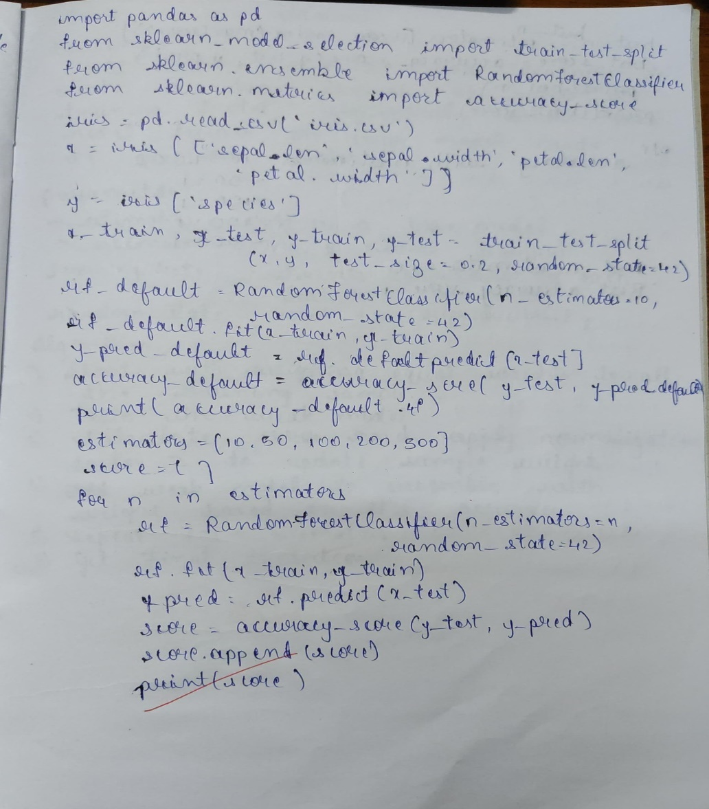

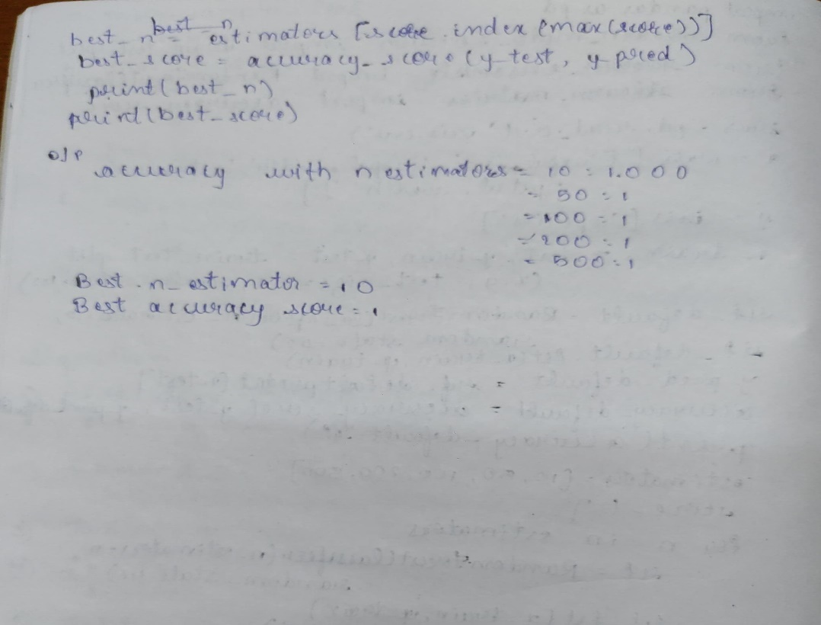

Code

import pandas as pd

from sklearn.model_selection import train_test_split

from sklearn.ensemble import RandomForestClassifier

from sklearn.metrics import accuracy_score, confusion_matrix

from sklearn.preprocessing import LabelEncoder

df = pd.read_csv("train.csv")

df = df.drop(columns=['PassengerId', 'Name', 'Ticket', 'Cabin'])

df['Age'].fillna(df['Age'].median(), inplace=True)

df['Embarked'].fillna(df['Embarked'].mode()[0], inplace=True)

label_encoders = {}

for col in ['Sex', 'Embarked']:

le = LabelEncoder()

df[col] = le.fit_transform(df[col])

label_encoders[col] = le

X = df.drop(columns=['Survived'])

y = df['Survived']

X_train, X_test, y_train, y_test = train_test_split(X, y, test_size=0.2, random_state=42)

model = RandomForestClassifier(random_state=42)

model.fit(X_train, y_train)

y_pred = model.predict(X_test)

accuracy = accuracy_score(y_test, y_pred)

conf_matrix = confusion_matrix(y_test, y_pred)

print(f"Accuracy: {accuracy:.4f}")

print("Confusion Matrix:")

print(conf_matrix)

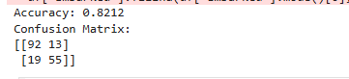

from sklearn.model_selection import train_test_split

from sklearn.ensemble import RandomForestClassifier

from sklearn.metrics import accuracy_score

iris = pd.read_csv("iris.csv")

X = iris.iloc[:,:-1]

y = iris.iloc[:,-1]

X_train, X_test, y_train, y_test = train_test_split(X, y, test_size=0.3, random_state=42)

rf_classifier = RandomForestClassifier(random_state=42)

rf_classifier.fit(X_train, y_train)

y_pred = rf_classifier.predict(X_test)

accuracy = accuracy_score(y_test, y_pred)

print(f"Accuracy with default n_estimators (10): {accuracy:.4f}")

best_accuracy = 0

best_n_estimators = 0

for n_estimators in range(10, 201, 10):

rf_classifier = RandomForestClassifier(n_estimators=n_estimators, random_state=42)

rf_classifier.fit(X_train, y_train)

y_pred = rf_classifier.predict(X_test)

accuracy = accuracy_score(y_test, y_pred)

if accuracy > best_accuracy:

best_accuracy = accuracy

best_n_estimators = n_estimators

print(f"Best accuracy: {best_accuracy:.4f} achieved with n_estimators = {best_n_estimators}")

Accuracy with default n_estimators (10): 1.0000

Best accuracy: 1.0000 achieved with n_estimators = 10

In [12]:

import matplotlib.pyplot as plt

from sklearn.ensemble import RandomForestClassifier

from sklearn.metrics import roc_auc_score

from sklearn.model_selection import train_test_split

from sklearn.datasets import load_iris

from sklearn.preprocessing import label_binarize

from sklearn.multiclass import OneVsRestClassifier

iris = load_iris()

X, y = iris.data, iris.target

y = label_binarize(y, classes=[0, 1, 2])

X_train, X_test, y_train, y_test = train_test_split(X, y, test_size=0.3, random_state=42)

n_estimators_values = [10, 20, 30]

auc_scores = []

for n_estimators in n_estimators_values:

rf_classifier = OneVsRestClassifier(RandomForestClassifier(n_estimators=n_estimators, random_state=42))

rf_classifier.fit(X_train, y_train)

y_pred_proba = rf_classifier.predict_proba(X_test)

auc_scores.append(roc_auc_score(y_test, y_pred_proba, average='weighted', multi_class='ovr'))

print(f"AUC Score for n_estimators = {n_estimators}: {auc_scores[-1]}")

plt.plot(n_estimators_values, auc_scores, marker='o')

plt.xlabel('n_estimators')

plt.ylabel('AUC Score')

plt.title('AUC Score vs. n_estimators for Random Forest (Iris Dataset)')

plt.grid(True)

plt.show()

AUC Score for n_estimators = 10: 1.0

AUC Score for n_estimators = 20: 1.0

AUC Score for n_estimators = 30: 1.0

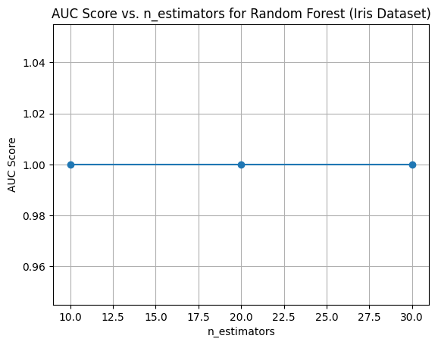

PROGRAM 9 Implement Boosting ensemble method on a given dataset.

Screenshot

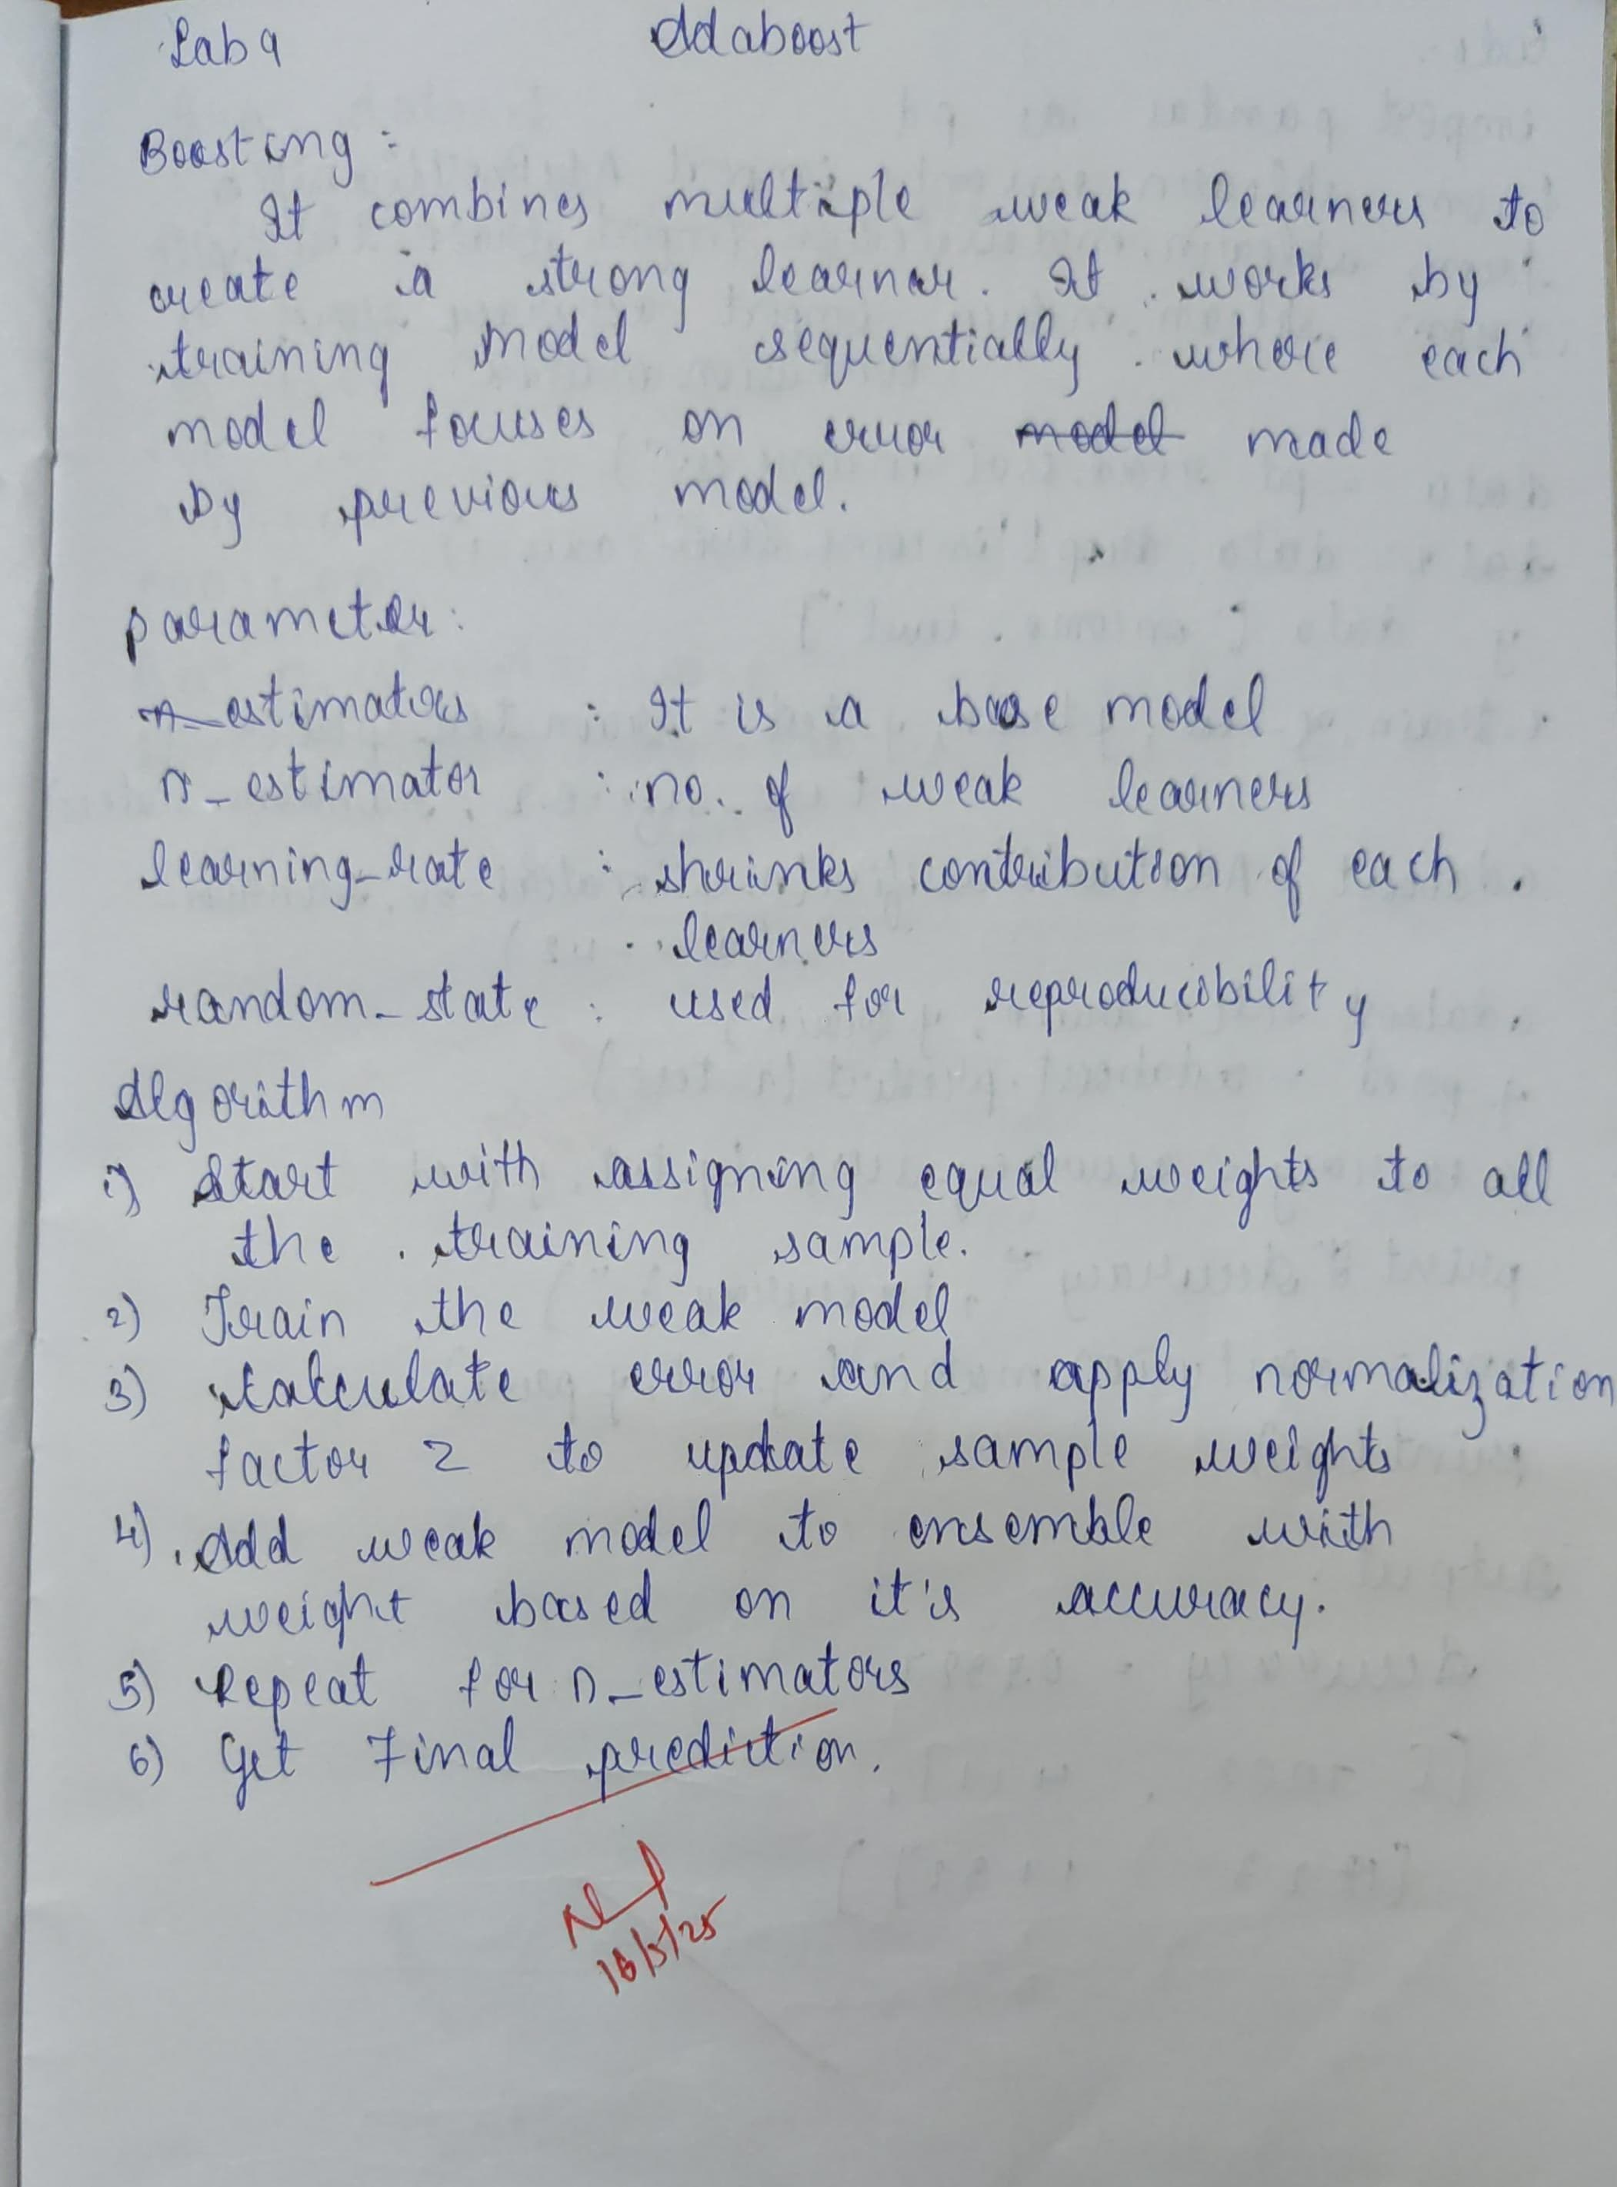

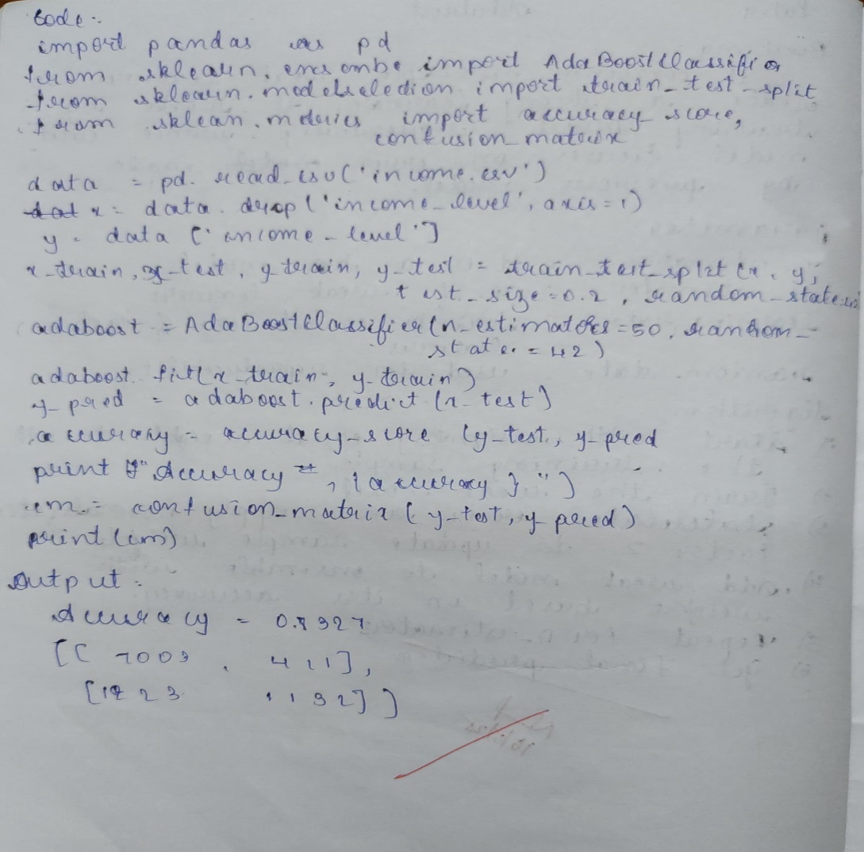

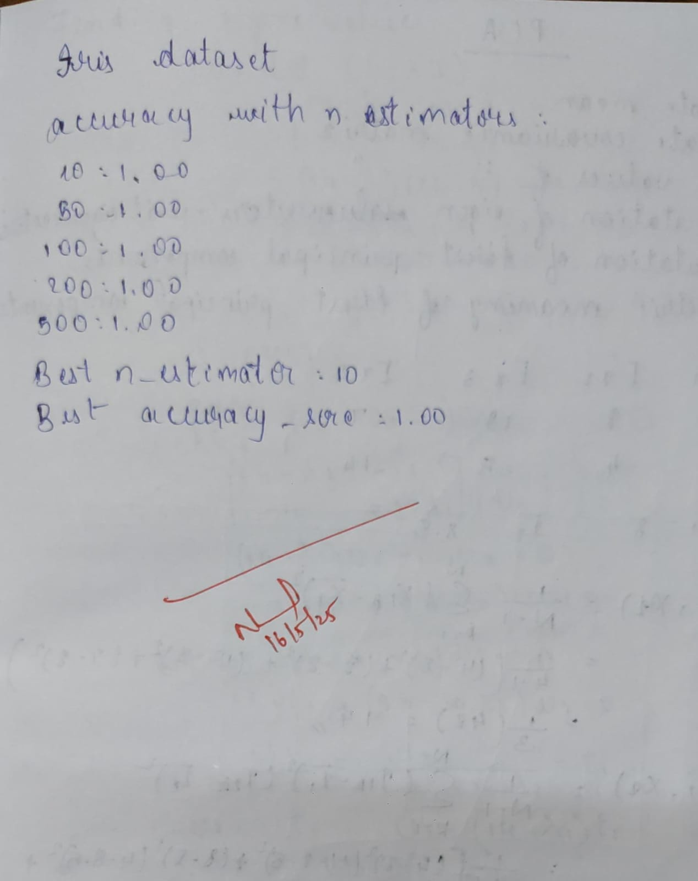

Code

import pandas as pd

import seaborn as sns

import matplotlib.pyplot as plt

from sklearn.model_selection import train_test_split

from sklearn.ensemble import AdaBoostClassifier

from sklearn.metrics import accuracy_score, confusion_matrix

*# Load data*

data = pd.read_csv('income.csv')

*# Preprocess the data (placeholder)*

*# Example: data = pd.get_dummies(data)*

*# Make sure all features are numeric and handle any missing values.*

*# Split features and target*

X = data.drop('income_level', axis=1)

y = data['income_level']

X_train, X_test, y_train, y_test = train_test_split(X, y, test_size=0.2, random_state=42)

*# Train AdaBoost classifier*

ada_boost = AdaBoostClassifier(n_estimators=50, random_state=42)

ada_boost.fit(X_train, y_train)

*# Predictions and evaluation*

y_pred = ada_boost.predict(X_test)

accuracy = accuracy_score(y_test, y_pred)

print(f"Accuracy: {accuracy}")

*# Confusion matrix*

conf_matrix = confusion_matrix(y_test, y_pred)

print(f"Confusion Matrix:\n{conf_matrix}")

*# Plotting the confusion matrix*

plt.figure(figsize=(6, 4))

sns.heatmap(conf_matrix, annot=True, fmt='d', cmap='Blues',

xticklabels=ada_boost.classes_, yticklabels=ada_boost.classes_)

plt.xlabel('Predicted')

plt.ylabel('Actual')

plt.title('Confusion Matrix - AdaBoost')

plt.tight_layout()

plt.show()

Accuracy: 0.8327362063670796

Confusion Matrix:

[[7003 411]

[1223 1132]]

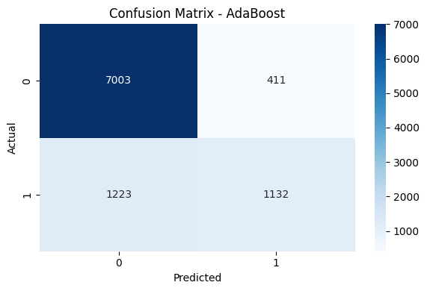

In [4]:

import numpy as np

import pandas as pd

import matplotlib.pyplot as plt

from sklearn.datasets import load_iris

from sklearn.ensemble import AdaBoostClassifier

from sklearn.tree import DecisionTreeClassifier

from sklearn.linear_model import LogisticRegression

from sklearn.model_selection import train_test_split

from sklearn.metrics import accuracy_score

*# Load Iris dataset*

iris = load_iris()

X = iris.data

y = iris.target

*# Split data into training (80%) and test (20%)*

X_train, X_test, y_train, y_test = train_test_split(X, y, test_size=0.2, random_state=42)

*# --- Try different base classifiers and parameters ---*

results = []

*# Parameters to experiment with*

n_estimators_list = [10, 50, 100]

learning_rates = [0.01, 0.1, 1]

*# DecisionTreeClassifier as base estimator*

for n in n_estimators_list:

for lr in learning_rates:

tree_base = DecisionTreeClassifier(max_depth=1)

model = AdaBoostClassifier(estimator=tree_base, n_estimators=n, learning_rate=lr, random_state=42)

model.fit(X_train, y_train)

y_pred = model.predict(X_test)

acc = accuracy_score(y_test, y_pred)

results.append({

'Base': 'DecisionTree',

'n_estimators': n,

'learning_rate': lr,

'Accuracy': acc

})

*# LogisticRegression as base estimator*

for n in n_estimators_list:

for lr in learning_rates:

log_reg_base = LogisticRegression(max_iter=1000)

model = AdaBoostClassifier(estimator=log_reg_base, n_estimators=n, learning_rate=lr, random_state=42)

model.fit(X_train, y_train)

y_pred = model.predict(X_test)

acc = accuracy_score(y_test, y_pred)

results.append({

'Base': 'LogisticRegression',

'n_estimators': n,

'learning_rate': lr,

'Accuracy': acc

})

*# Convert results to DataFrame for easy viewing*

results_df = pd.DataFrame(results)

print(results_df)

*# Optional: Visualize the result*

import seaborn as sns

plt.figure(figsize=(12, 6))

sns.barplot(x='n_estimators', y='Accuracy', hue='Base', data=results_df, ci=None)

plt.title('AdaBoost Accuracy with Different Estimators and n_estimators')

plt.show()

Base n_estimators learning_rate Accuracy

0 DecisionTree 10 0.01 0.633333

1 DecisionTree 10 0.10 0.966667

2 DecisionTree 10 1.00 1.000000

3 DecisionTree 50 0.01 0.633333

4 DecisionTree 50 0.10 1.000000

5 DecisionTree 50 1.00 0.933333

6 DecisionTree 100 0.01 0.966667

7 DecisionTree 100 0.10 1.000000

8 DecisionTree 100 1.00 0.933333

9 LogisticRegression 10 0.01 0.933333

10 LogisticRegression 10 0.10 1.000000

11 LogisticRegression 10 1.00 0.933333

12 LogisticRegression 50 0.01 1.000000

13 LogisticRegression 50 0.10 1.000000

14 LogisticRegression 50 1.00 0.933333

15 LogisticRegression 100 0.01 1.000000

16 LogisticRegression 100 0.10 1.000000

17 LogisticRegression 100 1.00 0.933333

<ipython-input-4-897755f76214>:63: FutureWarning:

The `ci` parameter is deprecated. Use `errorbar=None` for the same effect.

sns.barplot(x='n_estimators', y='Accuracy', hue='Base', data=results_df, ci=None)

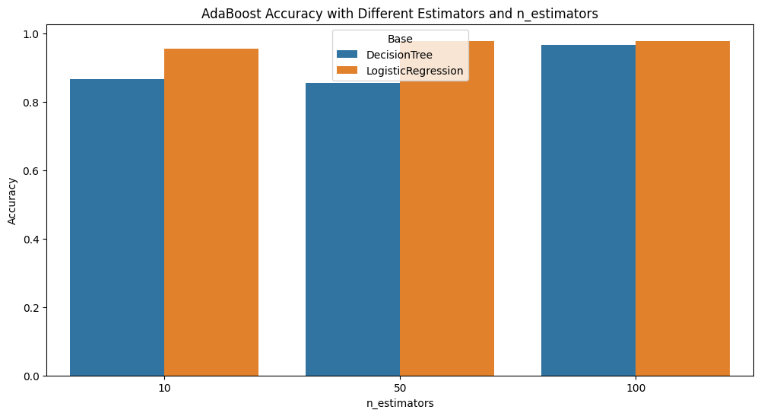

PROGRAM 10 Build k-Means algorithm to cluster a set of data stored in a .CSV file.

Screenshot

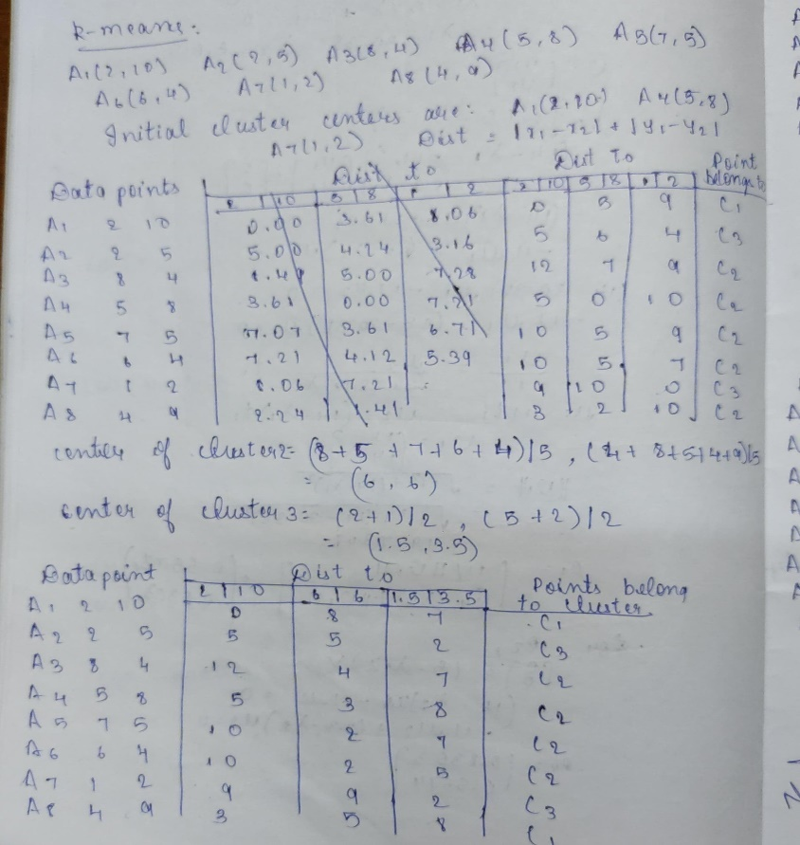\

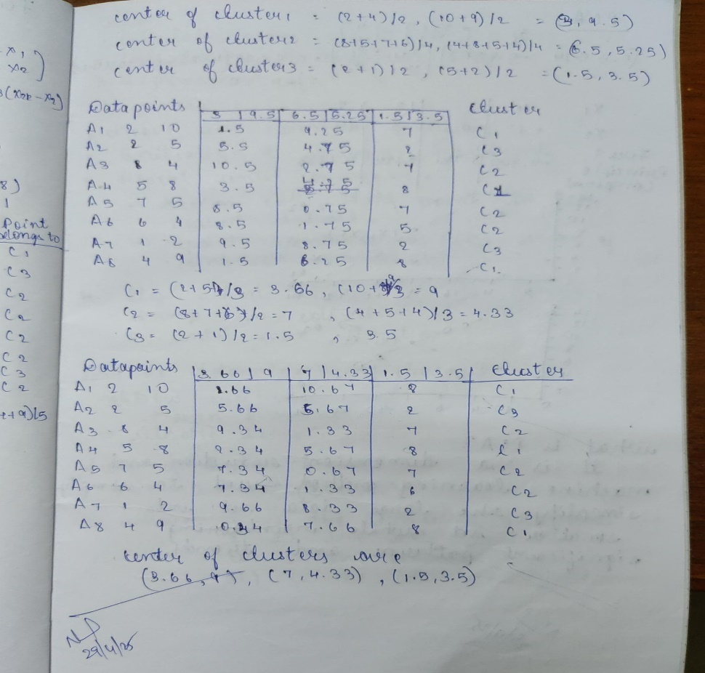

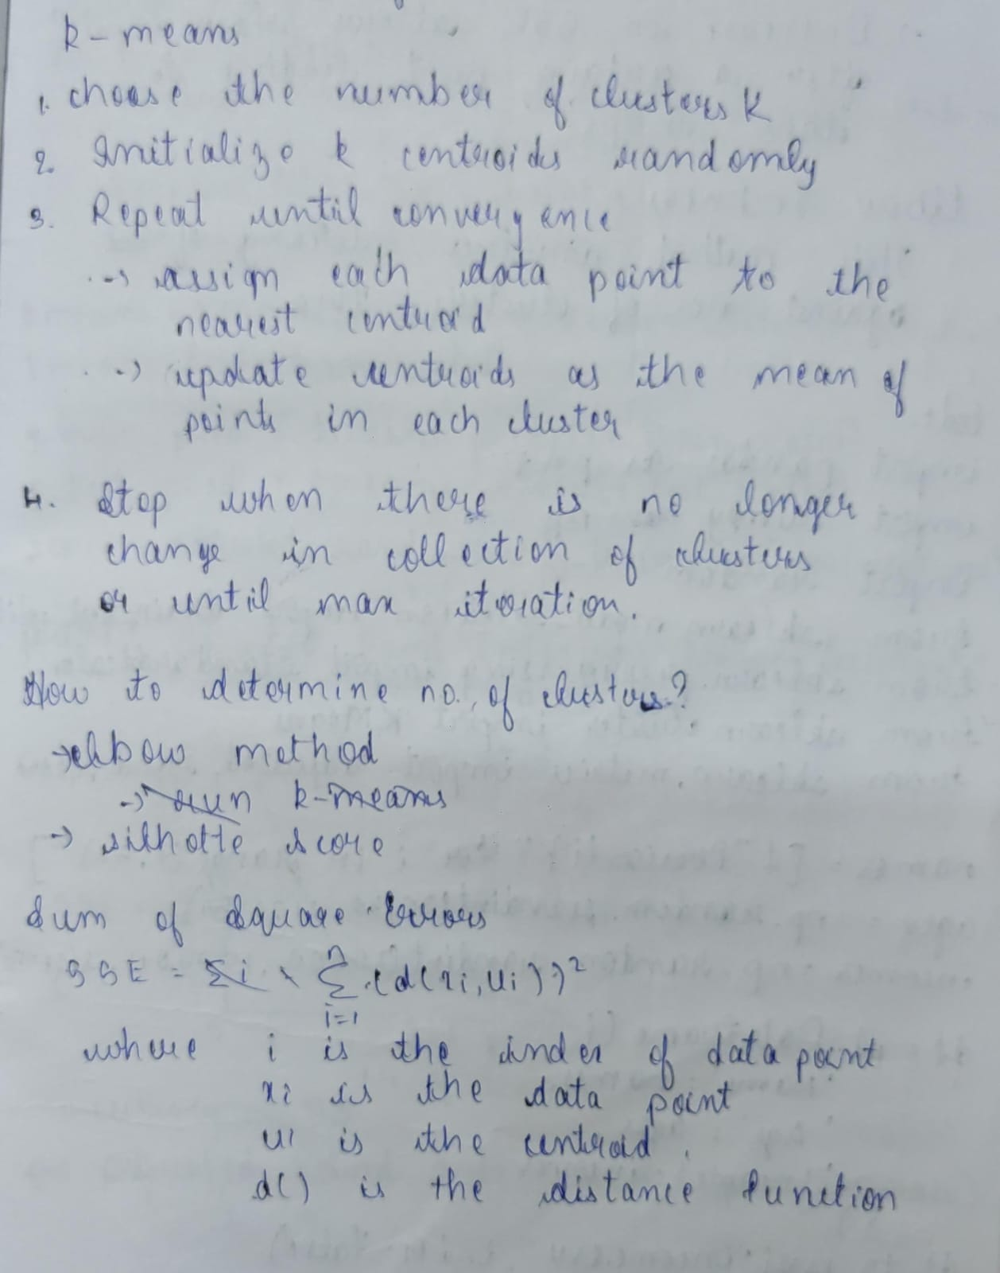

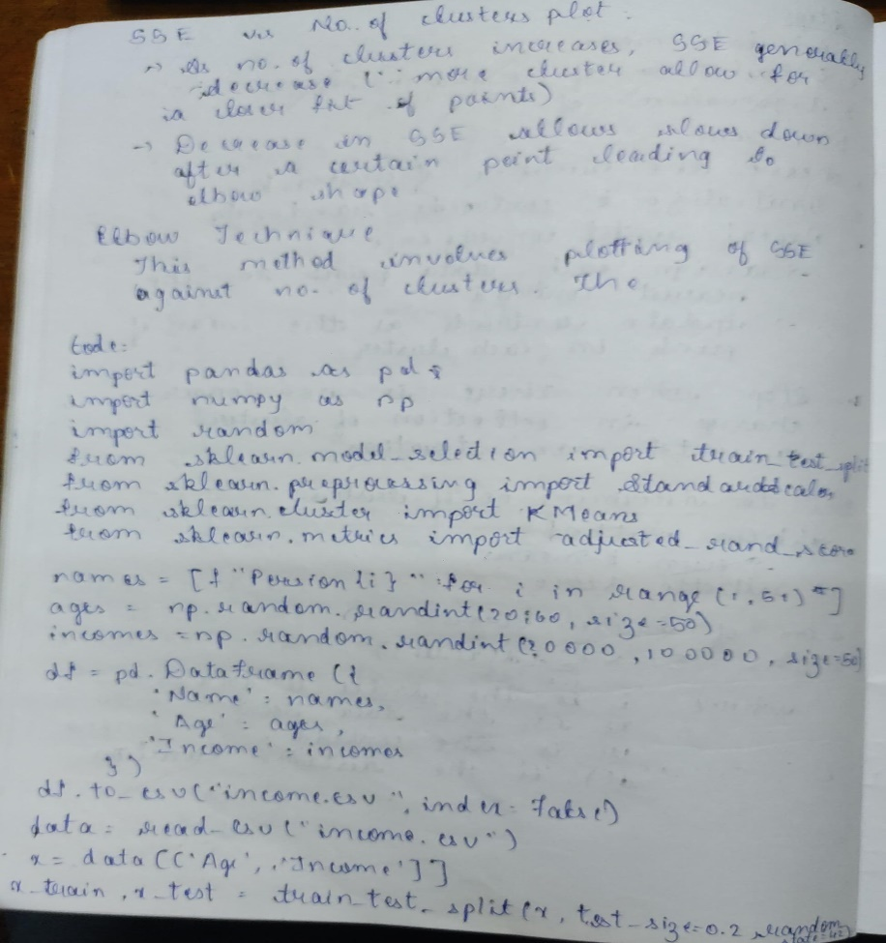

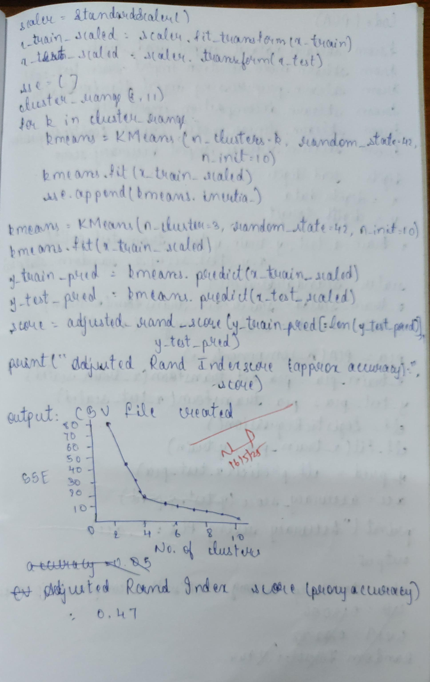

Code

import pandas as pd

import numpy as np

import random

import string

from sklearn.model_selection import train_test_split

from sklearn.preprocessing import StandardScaler

from sklearn.cluster import KMeans

from sklearn.metrics import adjusted_rand_score

import matplotlib.pyplot as plt

*# Step 1: Generate data*

def random_name():

return ''.join(random.choices(string.ascii_uppercase, k=5))

np.random.seed(42)

data = {

'Name': [random_name() for _ in range(50)],

'Age': np.random.randint(20, 60, size=50),

'Income': np.random.randint(30000, 100000, size=50)

}

df = pd.DataFrame(data)

df.to_csv("income.csv", index=False)

print("CSV file 'income.csv' created.")

*# Step 2: Load and preprocess*

df = pd.read_csv("income.csv")

X = df[['Age', 'Income']] *# Drop Name for modeling*

*# Step 3: Train-test split*

X_train, X_test = train_test_split(X, test_size=0.2, random_state=42)

*# Step 4: Scaling*

scaler = StandardScaler()

X_train_scaled = scaler.fit_transform(X_train)

X_test_scaled = scaler.transform(X_test)

*# Step 5: Elbow Method - Plot SSE vs K*

sse = []

K_range = range(1, 11)

for k in K_range:

kmeans = KMeans(n_clusters=k, random_state=42, n_init='auto')

kmeans.fit(X_train_scaled)

sse.append(kmeans.inertia_)

plt.figure(figsize=(8, 4))

plt.plot(K_range, sse, marker='o')

plt.xlabel('Number of Clusters (K)')

plt.ylabel('Sum of Squared Errors (SSE)')

plt.title('Elbow Method for Optimal K')

plt.grid(True)

plt.show()

*# Step 6: Fit and Predict using optimal K (e.g., choose K=3)*

kmeans = KMeans(n_clusters=3, random_state=42, n_init='auto')

kmeans.fit(X_train_scaled)

train_labels = kmeans.labels_

test_labels = kmeans.predict(X_test_scaled)

*# Since we don’t have true labels, simulate labels for "accuracy" proxy*

*# We'll re-cluster the full dataset and use Adjusted Rand Index as proxy*

kmeans_full = KMeans(n_clusters=3, random_state=42, n_init='auto')

X_scaled = scaler.fit_transform(X)

pred_full = kmeans_full.fit_predict(X_scaled)

*# Evaluate clustering consistency (proxy to accuracy)*

X_train_idx = X_train.index

X_test_idx = X_test.index

true_test_labels = pred_full[X_test_idx]

ari_score = adjusted_rand_score(true_test_labels, test_labels)

print(f"Adjusted Rand Index (proxy accuracy): {ari_score:.2f}")

CSV file 'income.csv' created.

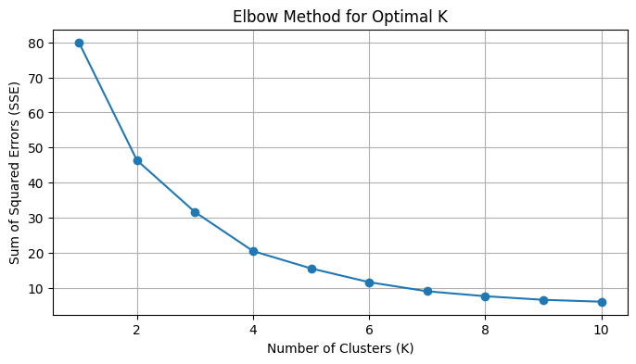

PROGRAM 11 Implement Dimensionality reduction using Principal Component Analysis (PCA) method.

Screenshot

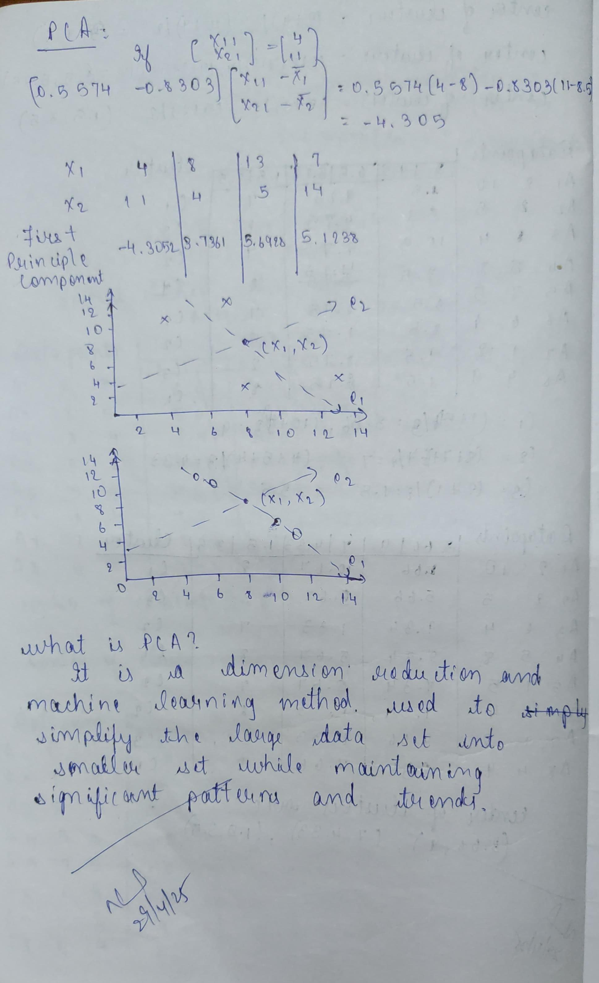

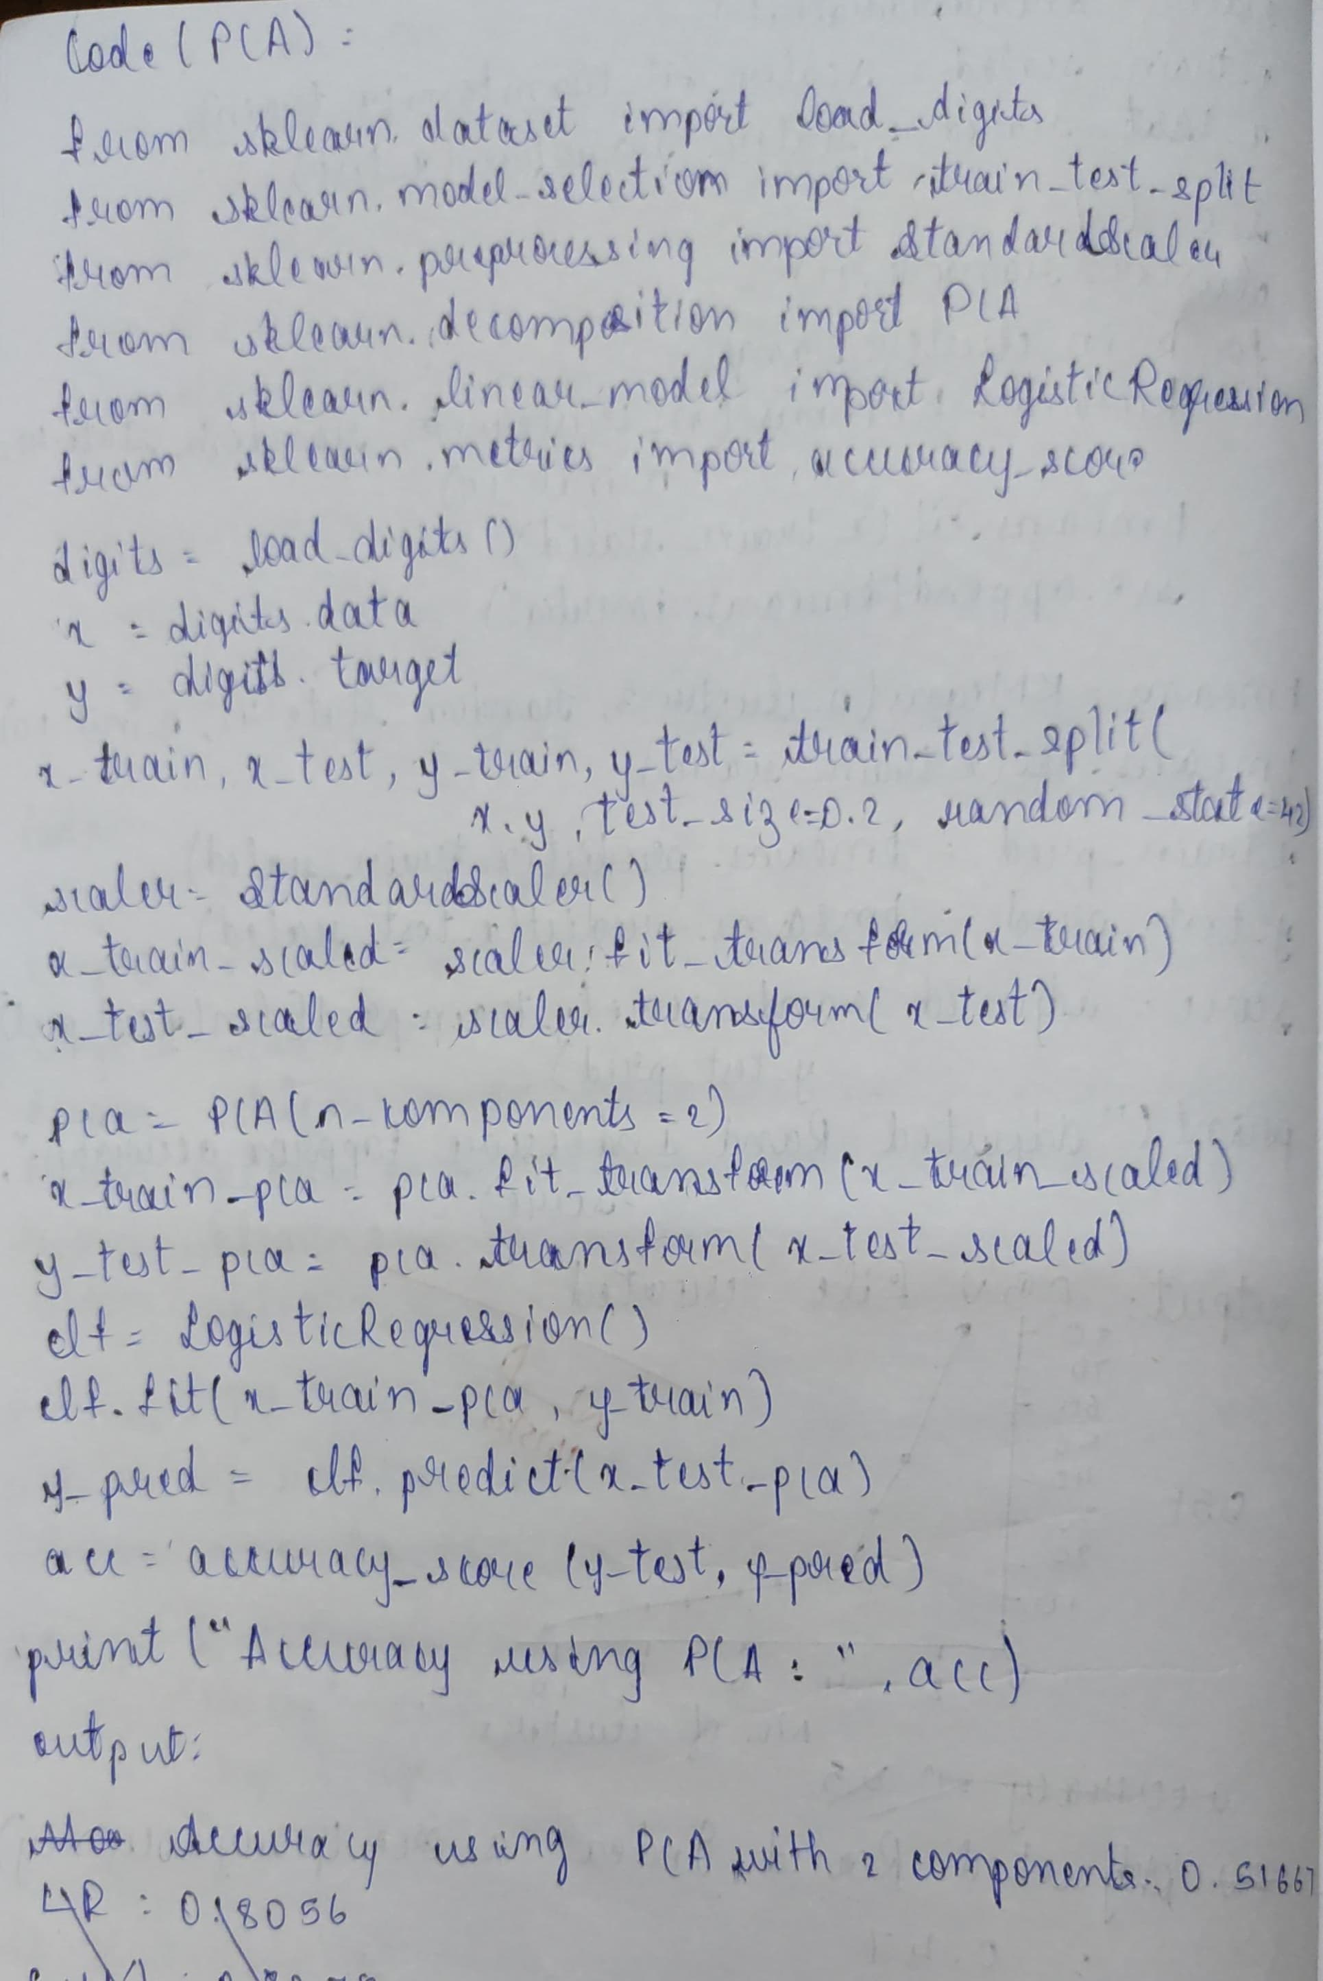

Code

from sklearn.datasets import load_digits

from sklearn.preprocessing import StandardScaler

from sklearn.decomposition import PCA

from sklearn.linear_model import LogisticRegression

from sklearn.model_selection import train_test_split

from sklearn.metrics import accuracy_score

digits = load_digits()

X = digits.data

y = digits.target

X_train, X_test, y_train, y_test = train_test_split(X, y, test_size=0.2, random_state=42)

scaler = StandardScaler()

X_train_scaled = scaler.fit_transform(X_train)

X_test_scaled = scaler.transform(X_test)

pca = PCA(n_components=2)

X_train_pca = pca.fit_transform(X_train_scaled)

X_test_pca = pca.transform(X_test_scaled)

clf = LogisticRegression()

clf.fit(X_train_pca, y_train)

y_pred = clf.predict(X_test_pca)

accuracy = accuracy_score(y_test, y_pred)

print("Accuracy using PCA with 2 components:", accuracy)

Accuracy using PCA with 2 components: 0.5166666666666667

In [1]:

import numpy as np

from sklearn.decomposition import PCA

import matplotlib.pyplot as plt

def apply_pca(data, n_components=None):

"""

Applies Principal Component Analysis (PCA) to the input data.

Args:

data (numpy.ndarray): The input data matrix (n_samples x n_features).

n_components (int, optional): The number of principal components to keep.

If None, all components are kept. Defaults to None.

Returns:

tuple: A tuple containing:

- reduced_data (numpy.ndarray): The data projected onto the principal components.

- pca (sklearn.decomposition.PCA): The fitted PCA object.

"""

pca = PCA(n_components=n_components)

reduced_data = pca.fit_transform(data)

return reduced_data, pca

def visualize_pca(original_data, reduced_data, n_components):

"""

Visualizes the original and reduced data (only for 2D or 3D original data).

Args:

original_data (numpy.ndarray): The original data matrix.

reduced_data (numpy.ndarray): The reduced data matrix (should have 2 or 3 components).

n_components (int): The number of principal components used.

"""

original_n_features = original_data.shape[1]

reduced_n_features = reduced_data.shape[1]

if original_n_features == 2 and reduced_n_features == 2:

plt.figure(figsize=(10, 5))

plt.subplot(1, 2, 1)

plt.scatter(original_data[:, 0], original_data[:, 1])

plt.title("Original Data (2D)")

plt.xlabel("Feature 1")

plt.ylabel("Feature 2")

plt.subplot(1, 2, 2)

plt.scatter(reduced_data[:, 0], reduced_data[:, 1])

plt.title(f"Reduced Data ({n_components} Components)")

plt.xlabel("Principal Component 1")

plt.ylabel("Principal Component 2")

plt.tight_layout()

plt.show()

elif original_n_features == 3 and reduced_n_features in [2, 3]:

from mpl_toolkits.mplot3d import Axes3D

fig = plt.figure(figsize=(12, 6))

ax1 = fig.add_subplot(121, projection='3d')

ax1.scatter(original_data[:, 0], original_data[:, 1], original_data[:, 2])

ax1.set_title("Original Data (3D)")

ax1.set_xlabel("Feature 1")

ax1.set_ylabel("Feature 2")

ax1.set_zlabel("Feature 3")

ax2 = fig.add_subplot(122, projection='3d' if reduced_n_features == 3 else None)

if reduced_n_features == 3:

ax2.scatter(reduced_data[:, 0], reduced_data[:, 1], reduced_data[:, 2])

ax2.set_zlabel("Principal Component 3")

else:

ax2.scatter(reduced_data[:, 0], reduced_data[:, 1])

ax2.set_title(f"Reduced Data ({n_components} Components)")

ax2.set_xlabel("Principal Component 1")

ax2.set_ylabel("Principal Component 2")

plt.tight_layout()

plt.show()

else:

print(f"Visualization is only supported for original data with 2 or 3 features. Original data has {original_n_features} features.")

if __name__ == "__main__":

*# Generate some sample data*

np.random.seed(42)

mean = [0, 0]

cov = [[2, 1], [1, 2]]

data = np.random.multivariate_normal(mean, cov, 100)

*# Apply PCA to reduce to 1 component*

n_components_to_keep = 1

reduced_data_1, pca_1 = apply_pca(data, n_components=n_components_to_keep)

print(f"Original data shape: {data.shape}")

print(f"Reduced data shape (with {n_components_to_keep} component): {reduced_data_1.shape}")

print("\nExplained variance ratio (1 component):", pca_1.explained_variance_ratio_)

*# Apply PCA to reduce to 2 components (which is the original dimension here)*

n_components_to_keep = 2

reduced_data_2, pca_2 = apply_pca(data, n_components=n_components_to_keep)

print(f"\nReduced data shape (with {n_components_to_keep} components): {reduced_data_2.shape}")

print("Explained variance ratio (2 components):", pca_2.explained_variance_ratio_)

*# Visualize the results for 2D original data*

visualize_pca(data, reduced_data_1, n_components=1) *# Changed to 'n_components'*

visualize_pca(data, reduced_data_2, n_components=2) *# Changed to 'n_components'*

*# Example with 3D data*

np.random.seed(123)

mean_3d = [1, 2, 3]

cov_3d = [[1, 0.5, 0.2], [0.5, 1.5, 0.1], [0.2, 0.1, 1]]

data_3d = np.random.multivariate_normal(mean_3d, cov_3d, 100)

reduced_data_3d_2, pca_3d_2 = apply_pca(data_3d, n_components=2)

print(f"\nOriginal 3D data shape: {data_3d.shape}")

print(f"Reduced 3D data shape (to 2 components): {reduced_data_3d_2.shape}")

print("Explained variance ratio (2 components for 3D data):", pca_3d_2.explained_variance_ratio_)

visualize_pca(data_3d, reduced_data_3d_2, n_components=2) *# Changed to 'n_components'*

reduced_data_3d_3, pca_3d_3 = apply_pca(data_3d, n_components=3)

print(f"\nReduced 3D data shape (to 3 components): {reduced_data_3d_3.shape}")

print("Explained variance ratio (3 components for 3D data):", pca_3d_3.explained_variance_ratio_)

visualize_pca(data_3d, reduced_data_3d_3, n_components=3)

Original data shape: (100, 2)

Reduced data shape (with 1 component): (100, 1)

Explained variance ratio (1 component): [0.68856826]

Reduced data shape (with 2 components): (100, 2)

Explained variance ratio (2 components): [0.68856826 0.31143174]

Visualization is only supported for original data with 2 or 3 features. Original data has 2 features.

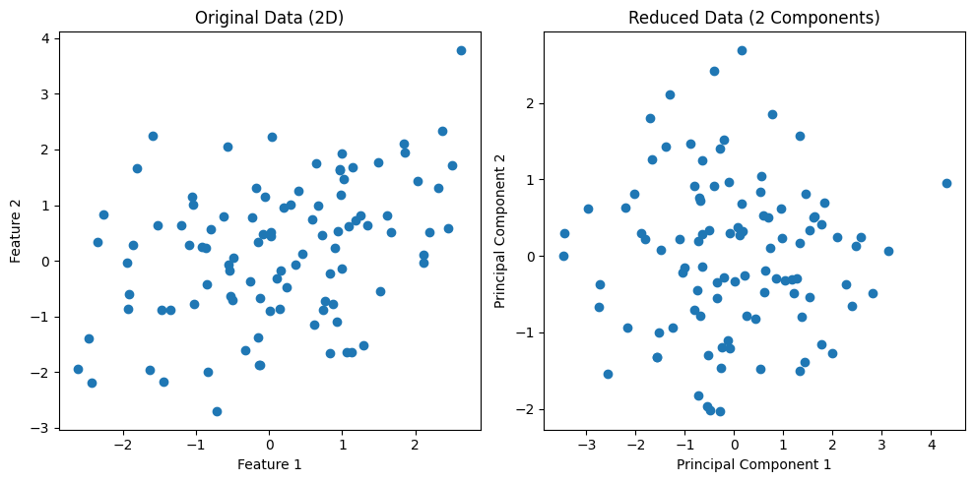

Original 3D data shape: (100, 3)

Reduced 3D data shape (to 2 components): (100, 2)

Explained variance ratio (2 components for 3D data): [0.46031414 0.36523668]

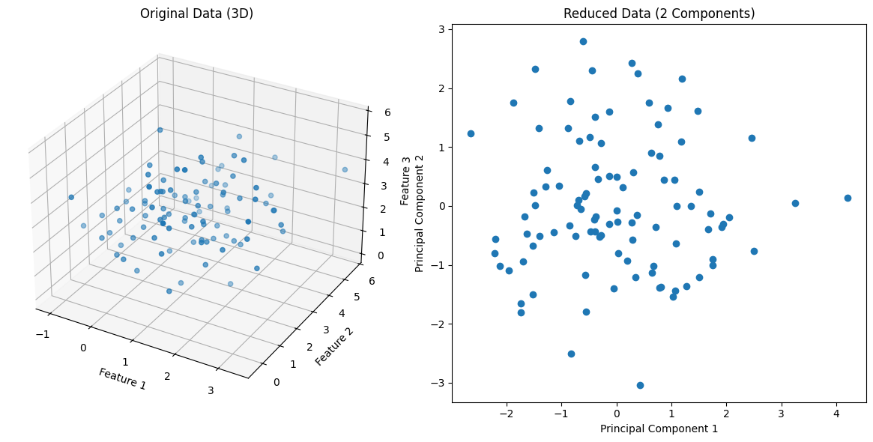

Reduced 3D data shape (to 3 components): (100, 3)

Explained variance ratio (3 components for 3D data): [0.46031414 0.36523668 0.17444918]

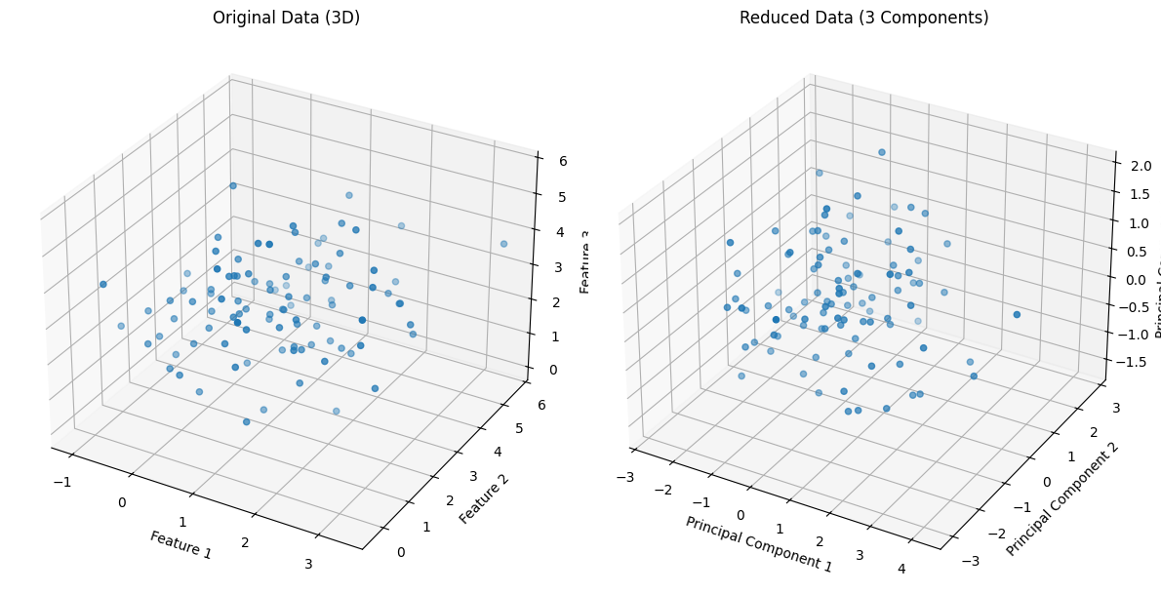

In [2]:

import numpy as np

from sklearn.decomposition import PCA

def reduce_dimensions(data, n_components):

"""Applies PCA to reduce data dimensionality.

Args:

data (numpy.ndarray): Input data (n_samples x n_features).

n_components (int): Number of principal components to keep.

Returns:

numpy.ndarray: Reduced data (n_samples x n_components).

"""

pca = PCA(n_components=n_components)

reduced_data = pca.fit_transform(data)

return reduced_data

if __name__ == "__main__":

*# Example usage*

np.random.seed(42)

data = np.random.rand(100, 5) *# 100 samples, 5 features*

n_components_to_keep = 2

reduced_data = reduce_dimensions(data, n_components_to_keep)

print("Original data shape:", data.shape)

print("Reduced data shape:", reduced_data.shape)

Original data shape: (100, 5)

Reduced data shape: (100, 2)

In [3]:

import numpy as np

from sklearn.datasets import load_digits

from sklearn.model_selection import train_test_split

from sklearn.preprocessing import StandardScaler

from sklearn.decomposition import PCA

from sklearn.linear_model import LogisticRegression

from sklearn.metrics import accuracy_score

*# 1. Download Load_digits from sklearn dataset*

digits = load_digits()

X = digits.data

y = digits.target

*# 2. Split data into training and testing sets (80% train, 20% test)*

X_train, X_test, y_train, y_test = train_test_split(X, y, test_size=0.2, random_state=42)

*# 3. Perform scaling*

scaler = StandardScaler()

X_train_scaled = scaler.fit_transform(X_train)

X_test_scaled = scaler.transform(X_test)

*# 4. Build a PCA model with no_of_components=2*

n_components = 2

pca = PCA(n_components=n_components)

X_train_pca = pca.fit_transform(X_train_scaled)

X_test_pca = pca.transform(X_test_scaled)

*# 5. Predict score using logistic regression on PCA-transformed data*

logistic_regression = LogisticRegression(random_state=42, solver='liblinear', multi_class='ovr')

logistic_regression.fit(X_train_pca, y_train)

y_pred_pca = logistic_regression.predict(X_test_pca)

*# 6. Predict accuracy score using PCA*

accuracy_pca = accuracy_score(y_test, y_pred_pca)

print(f"Accuracy score with {n_components} principal components: {accuracy_pca:.4f}")

*# Optional: Predict score using logistic regression on original scaled data for comparison*

logistic_regression_original = LogisticRegression(random_state=42, solver='liblinear', multi_class='ovr')

logistic_regression_original.fit(X_train_scaled, y_train)

y_pred_original = logistic_regression_original.predict(X_test_scaled)

accuracy_original = accuracy_score(y_test, y_pred_original)

print(f"Accuracy score with original scaled data: {accuracy_original:.4f}")

Accuracy score with 2 principal components: 0.5083

Accuracy score with original scaled data: 0.9667

import pandas as pd

import numpy as np

from scipy.stats import zscore

from sklearn.preprocessing import StandardScaler, OneHotEncoder, LabelEncoder

from sklearn.model_selection import train_test_split

from sklearn.svm import SVC

from sklearn.linear_model import LogisticRegression

from sklearn.ensemble import RandomForestClassifier

from sklearn.metrics import accuracy_score

from sklearn.decomposition import PCA

import kagglehub

import os

*# --- Download dataset using kagglehub ---*

try:

path = kagglehub.dataset_download("fedesoriano/heart-failure-prediction", path=".")

print("Path to downloaded dataset files:", path)

*# Assuming the CSV file is directly in the downloaded folder or a subfolder*

*# Let's try to find the 'heart.csv' file*

heart_csv_path = ""

for root, _, files in os.walk(path):

if 'heart.csv' in files:

heart_csv_path = os.path.join(root, 'heart.csv')

break

if not heart_csv_path:

raise FileNotFoundError("heart.csv not found in the downloaded dataset.")

*# Load the dataset*

df = pd.read_csv(heart_csv_path)

except ImportError:

print("Error: kagglehub library not found. Please install it using: pip install kagglehub")

exit()

except FileNotFoundError as e:

print(f"Error: {e}")

print("Please ensure you are authenticated with Kaggle and the dataset exists.")

exit()

except Exception as e:

print(f"An error occurred during download: {e}")

exit()

*# Display initial info*

print("\nFirst few rows of the dataset:")

print(df.head())

print("\nDataset information:")

df.info()

*# --- 2. Remove Outliers using Z-score ---*

numerical_cols = df.select_dtypes(include=np.number).columns

z_scores = df[numerical_cols].apply(zscore)

df_filtered = df[(z_scores > -3).all(axis=1) & (z_scores < 3).all(axis=1)]

print(f"\nOriginal DataFrame shape: {df.shape}")

print(f"DataFrame shape after outlier removal: {df_filtered.shape}")

*# --- 3. Convert Text Columns to Numbers ---*

categorical_cols = df_filtered.select_dtypes(include='object').columns

binary_cols = []

multi_category_cols = []

for col in categorical_cols:

if df_filtered[col].nunique() == 2:

binary_cols.append(col)

else:

multi_category_cols.append(col)

label_encoders = {}

for col in binary_cols:

label_encoders[col] = LabelEncoder()

df_filtered[col] = label_encoders[col].fit_transform(df_filtered[col])

one_hot_encoder = OneHotEncoder(handle_unknown='ignore', sparse_output=False)

encoded_cols = one_hot_encoder.fit_transform(df_filtered[multi_category_cols])

encoded_df = pd.DataFrame(encoded_cols, columns=one_hot_encoder.get_feature_names_out(multi_category_cols))

df_filtered = df_filtered.reset_index(drop=True)

encoded_df = encoded_df.reset_index(drop=True)

df_processed = pd.concat([df_filtered.drop(multi_category_cols, axis=1), encoded_df], axis=1)

print("\nDataFrame after encoding categorical features:")

print(df_processed.head())

*# --- 4. Apply Scaling ---*

numerical_cols_scaled = df_processed.select_dtypes(include=np.number).drop('HeartDisease', axis=1).columns

scaler = StandardScaler()

df_processed[numerical_cols_scaled] = scaler.fit_transform(df_processed[numerical_cols_scaled])

print("\nDataFrame after scaling numerical features:")

print(df_processed.head())

*# --- 5. Build and Evaluate Classification Models (Without PCA) ---*

X = df_processed.drop('HeartDisease', axis=1)

y = df_processed['HeartDisease']

X_train, X_test, y_train, y_test = train_test_split(X, y, test_size=0.3, random_state=42)

svm_model = SVC(random_state=42)

logistic_model = LogisticRegression(random_state=42, solver='liblinear')

rf_model = RandomForestClassifier(random_state=42)

models = {'SVM': svm_model, 'Logistic Regression': logistic_model, 'Random Forest': rf_model}

baseline_accuracies = {}

print("\n--- Model Performance without PCA ---")

for name, model in models.items():

model.fit(X_train, y_train)

y_pred = model.predict(X_test)

accuracy = accuracy_score(y_test, y_pred)

baseline_accuracies[name] = accuracy

print(f"{name} Accuracy: {accuracy:.4f}")

*# --- 6. Now use PCA to reduce dimensions, retrain your model and see what impact it has ---*

pca = PCA(n_components=0.95) *# Keep components that explain 95% of the variance*

X_train_pca = pca.fit_transform(X_train)

X_test_pca = pca.transform(X_test)

print(f"\nNumber of components before PCA: {X_train.shape[1]}")

print(f"Number of components after PCA: {X_train_pca.shape[1]}")

pca_accuracies = {}

print("\n--- Model Performance with PCA ---")

for name, model in models.items():

model.fit(X_train_pca, y_train)

y_pred_pca = model.predict(X_test_pca)

accuracy_pca = accuracy_score(y_test, y_pred_pca)

pca_accuracies[name] = accuracy_pca

print(f"{name} Accuracy (with PCA): {accuracy_pca:.4f}")

*# --- Comparison of Results ---*

print("\n--- Comparison of Accuracies ---")

for name in models.keys():

print(f"{name}:")

print(f" Without PCA: {baseline_accuracies[name]:.4f}")

print(f" With PCA: {pca_accuracies[name]:.4f}")

Path to downloaded dataset files: /kaggle/input/heart-failure-prediction/.

First few rows of the dataset:

Age Sex ChestPainType RestingBP Cholesterol FastingBS RestingECG MaxHR \

0 40 M ATA 140 289 0 Normal 172

1 49 F NAP 160 180 0 Normal 156

2 37 M ATA 130 283 0 ST 98

3 48 F ASY 138 214 0 Normal 108

4 54 M NAP 150 195 0 Normal 122

ExerciseAngina Oldpeak ST_Slope HeartDisease

0 N 0.0 Up 0

1 N 1.0 Flat 1

2 N 0.0 Up 0

3 Y 1.5 Flat 1

4 N 0.0 Up 0

Dataset information:

<class 'pandas.core.frame.DataFrame'>

RangeIndex: 918 entries, 0 to 917

Data columns (total 12 columns):

# Column Non-Null Count Dtype

--- ------ -------------- -----

0 Age 918 non-null int64

1 Sex 918 non-null object

2 ChestPainType 918 non-null object

3 RestingBP 918 non-null int64

4 Cholesterol 918 non-null int64

5 FastingBS 918 non-null int64

6 RestingECG 918 non-null object

7 MaxHR 918 non-null int64

8 ExerciseAngina 918 non-null object

9 Oldpeak 918 non-null float64

10 ST_Slope 918 non-null object

11 HeartDisease 918 non-null int64

dtypes: float64(1), int64(6), object(5)

memory usage: 86.2+ KB

Original DataFrame shape: (918, 12)

DataFrame shape after outlier removal: (899, 12)

DataFrame after encoding categorical features:

Age Sex RestingBP Cholesterol FastingBS MaxHR ExerciseAngina \

0 40 1 140 289 0 172 0

1 49 0 160 180 0 156 0

2 37 1 130 283 0 98 0

3 48 0 138 214 0 108 1

4 54 1 150 195 0 122 0

Oldpeak HeartDisease ChestPainType_ASY ChestPainType_ATA \

0 0.0 0 0.0 1.0

1 1.0 1 0.0 0.0

2 0.0 0 0.0 1.0

3 1.5 1 1.0 0.0

4 0.0 0 0.0 0.0

ChestPainType_NAP ChestPainType_TA RestingECG_LVH RestingECG_Normal \

0 0.0 0.0 0.0 1.0

1 1.0 0.0 0.0 1.0

2 0.0 0.0 0.0 0.0

3 0.0 0.0 0.0 1.0

4 1.0 0.0 0.0 1.0

RestingECG_ST ST_Slope_Down ST_Slope_Flat ST_Slope_Up

0 0.0 0.0 0.0 1.0

1 0.0 0.0 1.0 0.0

2 1.0 0.0 0.0 1.0

3 0.0 0.0 1.0 0.0

4 0.0 0.0 0.0 1.0

Age Sex RestingBP Cholesterol FastingBS MaxHR \

0 -1.428154 0.515943 0.465900 0.849636 -0.550362 1.384320

1 -0.475855 -1.938199 1.634714 -0.168122 -0.550362 0.752973

2 -1.745588 0.515943 -0.118507 0.793612 -0.550362 -1.535661

3 -0.581666 -1.938199 0.349019 0.149344 -0.550362 -1.141069

4 0.053200 0.515943 1.050307 -0.028064 -0.550362 -0.588640

ExerciseAngina Oldpeak HeartDisease ChestPainType_ASY \

0 -0.822945 -0.855469 0 -1.077524

1 -0.822945 0.137516 1 -1.077524

2 -0.822945 -0.855469 0 -1.077524

3 1.215148 0.634008 1 0.928054

4 -0.822945 -0.855469 0 -1.077524

ChestPainType_ATA ChestPainType_NAP ChestPainType_TA RestingECG_LVH \

0 2.063325 -0.534905 -0.22955 -0.503821

1 -0.484655 1.869492 -0.22955 -0.503821

2 2.063325 -0.534905 -0.22955 -0.503821

3 -0.484655 -0.534905 -0.22955 -0.503821

4 -0.484655 1.869492 -0.22955 -0.503821

RestingECG_Normal RestingECG_ST ST_Slope_Down ST_Slope_Flat ST_Slope_Up

0 0.809702 -0.489898 -0.260184 -0.998888 1.134695

1 0.809702 -0.489898 -0.260184 1.001113 -0.881294

2 -1.235023 2.041241 -0.260184 -0.998888 1.134695

3 0.809702 -0.489898 -0.260184 1.001113 -0.881294

4 0.809702 -0.489898 -0.260184 -0.998888 1.134695

--- Model Performance without PCA ---

SVM Accuracy: 0.8444

Logistic Regression Accuracy: 0.8481

Random Forest Accuracy: 0.8778

Number of components before PCA: 18

Number of components after PCA: 13

--- Model Performance with PCA ---

SVM Accuracy (with PCA): 0.8370

Logistic Regression Accuracy (with PCA): 0.8593

Random Forest Accuracy (with PCA): 0.8259

--- Comparison of Accuracies ---

SVM:

Without PCA: 0.8444

With PCA: 0.8370

Logistic Regression:

Without PCA: 0.8481

With PCA: 0.8593

Random Forest:

Without PCA: 0.8778

With PCA: 0.8259

In [5]:

import numpy as np

from sklearn.decomposition import PCA

from sklearn.preprocessing import StandardScaler

*# Given data from the table*

data = np.array([[4, 11],

[8, 4],

[13, 5],

[7, 14]])

*# 1. Center the data by subtracting the mean of each feature*

mean = np.mean(data, axis=0)

centered_data = data - mean

print("Centered Data:\n", centered_data)

*# 2. Calculate the covariance matrix*

covariance_matrix = np.cov(centered_data, rowvar=False)

print("\nCovariance Matrix:\n", covariance_matrix)

*# 3. Calculate the eigenvalues and eigenvectors of the covariance matrix*

eigenvalues, eigenvectors = np.linalg.eig(covariance_matrix)

print("\nEigenvalues:\n", eigenvalues)

print("\nEigenvectors:\n", eigenvectors)

*# 4. Sort the eigenvalues and eigenvectors in descending order of eigenvalues*

sorted_indices = np.argsort(eigenvalues)[::-1]

sorted_eigenvalues = eigenvalues[sorted_indices]

sorted_eigenvectors = eigenvectors[:, sorted_indices]

print("\nSorted Eigenvalues:\n", sorted_eigenvalues)

print("\nSorted Eigenvectors:\n", sorted_eigenvectors)

*# 5. Select the principal component(s). We want to reduce to 1 dimension, so we take the eigenvector corresponding to the largest eigenvalue.*

principal_component = sorted_eigenvectors[:, 0]

print("\nPrincipal Component (Eigenvector with largest eigenvalue):\n", principal_component)

*# 6. Project the original (centered) data onto the principal component*

reduced_data = np.dot(centered_data, principal_component)

print("\nReduced Data (1 dimension):\n", reduced_data)

*# --- Using scikit-learn's PCA for verification ---*

print("\n--- Using scikit-learn's PCA for Verification ---")

pca = PCA(n_components=1)

pca.fit(data)

sklearn_reduced_data = pca.transform(data)

print("Scikit-learn Principal Component:\n", pca.components_)

print("Scikit-learn Reduced Data (1 dimension):\n", sklearn_reduced_data)

Centered Data:

[[-4. 2.5]

[ 0. -4.5]

[ 5. -3.5]

[-1. 5.5]]

Covariance Matrix:

[[ 14. -11.]

[-11. 23.]]

Eigenvalues:

[ 6.61513568 30.38486432]

Eigenvectors:

[[-0.83025082 0.55738997]

[-0.55738997 -0.83025082]]

Sorted Eigenvalues:

[30.38486432 6.61513568]

Sorted Eigenvectors:

[[ 0.55738997 -0.83025082]

[-0.83025082 -0.55738997]]

Principal Component (Eigenvector with largest eigenvalue):

[ 0.55738997 -0.83025082]

Reduced Data (1 dimension):

[-4.30518692 3.73612869 5.69282771 -5.12376947]

--- Using scikit-learn's PCA for Verification ---

Scikit-learn Principal Component:

[[-0.55738997 0.83025082]]

Scikit-learn Reduced Data (1 dimension):

[[ 4.30518692]

[-3.73612869]

[-5.69282771]

[ 5.12376947]]

In [ ]: